**Connect Study—Chayil Transformation**

The word “Chayil” means “God-fearing, excellent, humble, wise, controlled, brilliant, efficient, strategic, tactical, powerful, strong, creative, artsy, great, a host, mighty, trained, force, an army, courageous, honourable, trustworthy, noble, virtuous, favoured (by God and people), a company, wealthy, able, influential, innovative, etc. in 240 references in the Bible.

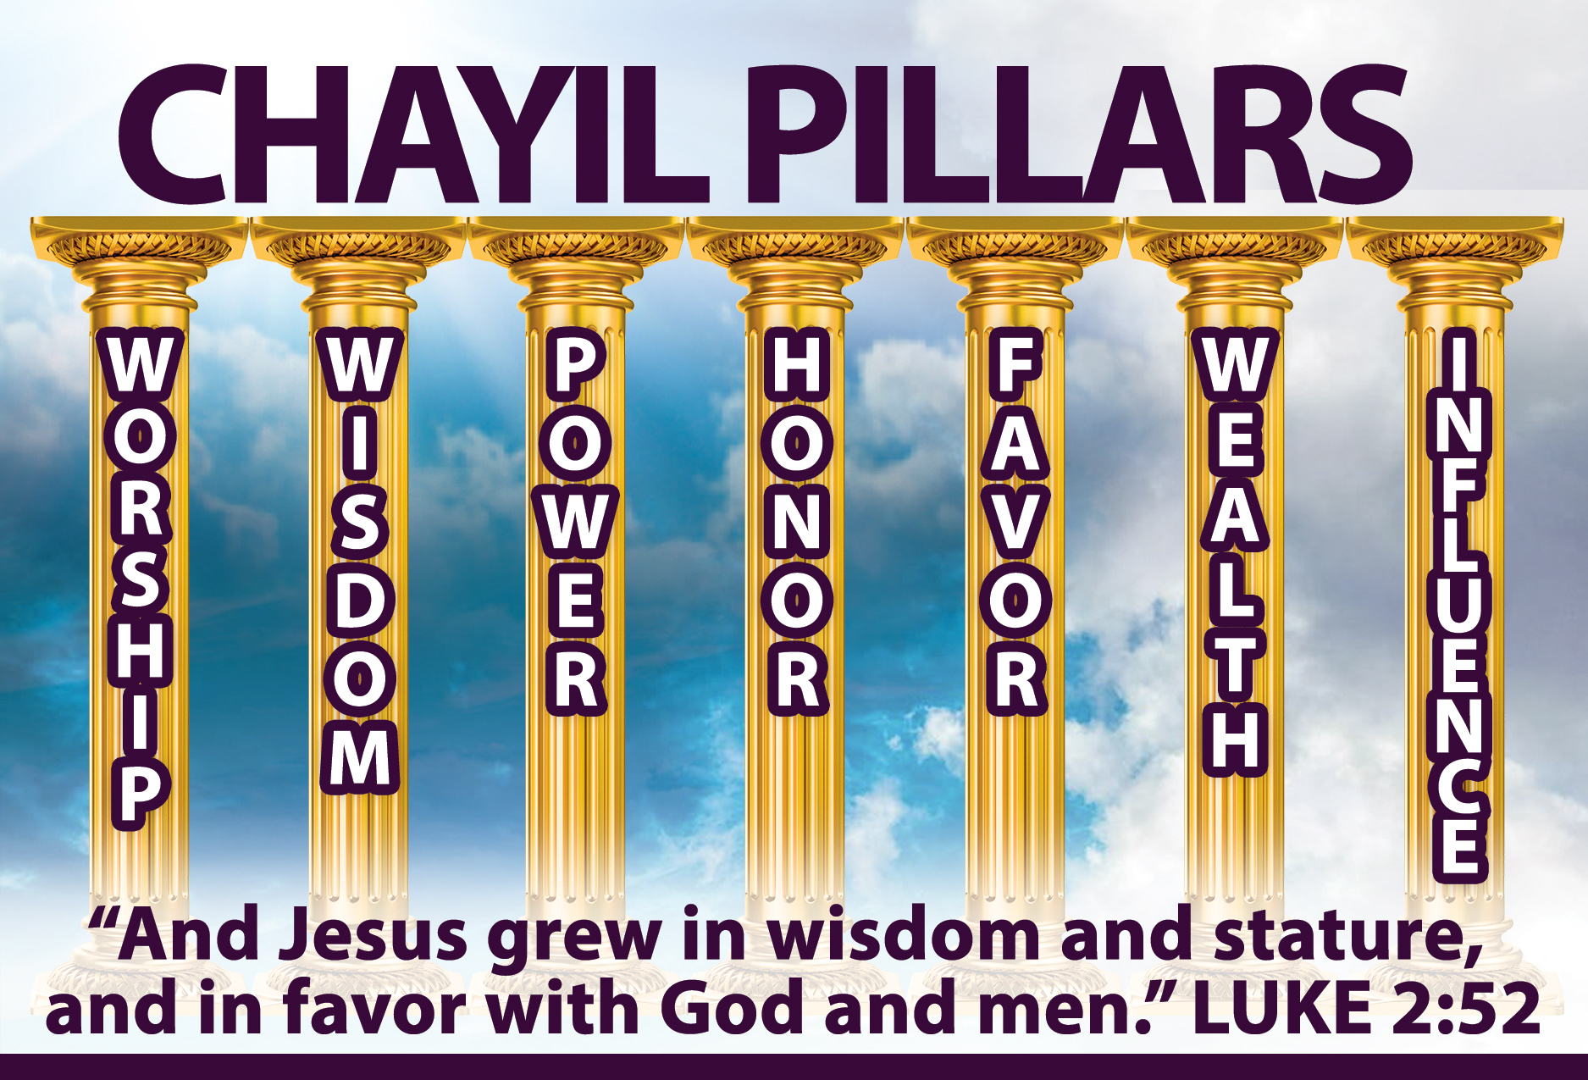

There are two forms of glory: the Shekinah glory which is more like the external glory in corporate setting, and the Chayil glory is the glory within.

Colossians 1:27-28 says “To them God has chosen to make known among the Gentiles the glorious riches of this mystery, which is Christ in you, the hope of glory. He is the one we proclaim, admonishing and teaching everyone with all wisdom, so that we may present everyone fully mature in Christ”. The glory of God is so that we can become mature in Christ.

Romans 2:6-7 “He will judge everyone according to what they have done. He will give eternal life to those who keep on doing good, seeking after the glory and honor and immortality that God offers”. It means we need to seek after the glory of God.

1 Thess 5:23 “Now may the God of peace Himself sanctify you completely; and may your whole spirit, soul, and body be preserved blameless at the coming of our Lord Jesus Christ”.

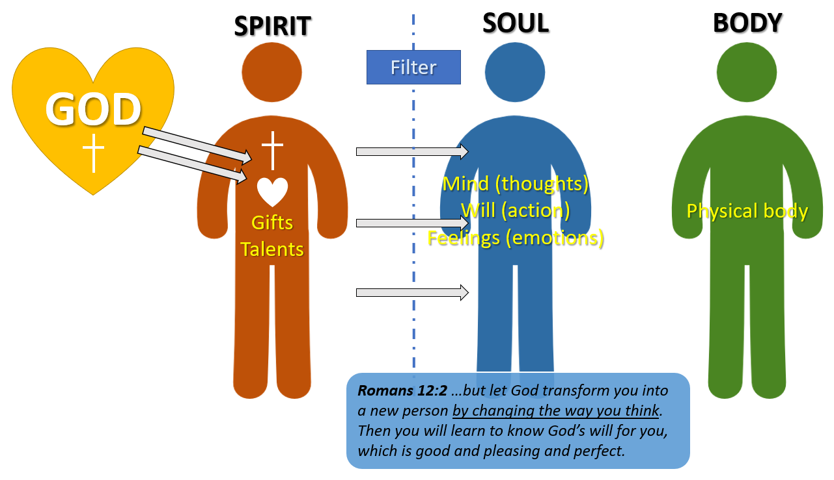

As a human being, we are tripartite being, we have Spirit, soul and body. Before we are born again, our spirits are asleep or in a spiritual coma. Our spirits are unregenerated. But now that we are born again, the spirit of God dwell within us.

The Spirit of God wants to influence our soul—our thoughts, emotions and will. Our soul is like a filter. Just like a dirty air conditioner filter resists the airflow, a congested soul—thoughts, emotions that are caught up with the old thinking and patterns may grieve the breath of the Holy Spirit.

I John 2:20 tells us that we have an anointing within us. This anointing or Chayil glory wants to radiate from within us. Just like the Apostle Peter after the day of Pentecost, prayed and brought healing to the lame man beside the temple gate by declaring: “what I have I give to you…”. What he had was the chayil glory.

Thus we need to die to ourselves just as Galatians 2:20 says “It is no longer I who live but Christ live in me”. We need to die to our own thoughts (Isa 55:8-9), ways (Luke 22:42) and emotions. Then the glory of God can radiate through our unique personality.



**Discussion Questions:**

1. Explain in your own words, what do you understand by “Christ in you, the hope of glory”?

2. How can we increase in the glory of God?

3. If our soul is the filter for the glory of God, how would you describe the condition of your soul filter?

4. What are the things that you need to die to so that the glory of God can radiate freely through you?