Date: | 28th February 2021
Title: | Back to basics – Reading the Bible
Level/Class | Southside
Memory verse: | Matthew 4:4 (NLT)  But Jesus told him, “… People do not live by bread alone, but by every word that comes from the mouth of God.”
Bible story: | Luke (The Boy Jesus in the Temple)
Big Idea: | Spiritual Food
Big Point: | Reading the Bible keeps your spirit healthy
4M Values: | Miracles & Ministry Equipping
Learning outcomes: | At the conclusion of this lesson, children will:  - Learn that spending time with God is priority  - Learn to put away distraction to spend time with God  - Learn that the Bible feeds our spiritual needs
Influencers:
Location: | Runcorn Tavern
LESSON PLAN Week 3 (LCNA)- Southside

7:45am | Set up and lesson run through

Today at a glance

Time | Activity | Influencers
8.30 | Check in:  - Prep extra tab for newcomers’ sign up  - Collect kids’ journals and pile them according to their respective classes.
9.10 | - Welcome kids and newcomers  - Recap the 3Ls (Listen, Learn & Love)
9.15 | Worship:  As the World Shakes  https://www.youtube.com/watch?v=dcAG4PbNXaA  I Love My B-I-B-L-E  https://www.youtube.com/watch?v=LmJIZbDxrKg (with English & bahasa Indonesia lyrics)  https://www.youtube.com/watch?v=n6RUP9tYrSQ (just English lyrics)  Good Good Father  https://www.youtube.com/watch?v=eE_l-Klp2Uk
9.30 | Thanksgiving

9.35 | Game: Bible story Pictionary  Select a few bible stories eg:  Jonah and the Whale  Daniel in the Lion’s Den  Noah’s Ark  Moses separating the sea  Joshua and the wall of Jericho  Boy and the 2 fish and 5 loaves of bread  Draw them on the whiteboard and get the kids to identify them.  At the end of the game, explain that these stories all come from the Bible and they can get a grown up to read it them. There are children’s Bibles that have pictures to help too.  Through these stories we learn how God wants to build our spirit so we make wise choices.  Teacher introduces a few children’s bible and tell them that if they wish to choose a story from the bible they can and they can ask a teacher to help read it to them after their craft activity or you can try to read it yourself.  Items to prepare:  Whiteboard markers & 1 large whiteboard  Bible story books & Children’s bibles.
9.50 | Introduce bible verse: Matthew 4:4 (NLT)  But Jesus told him, “… People do not live by bread alone, but by every word that comes from the mouth of God  - Influencer to learn action beforehand. Refer to: https://open.life.church/items/197755-teaching-segment-mp4 (go to the 11:10 mark)  - Teach the kids the verse with the actions.  - Repeat it a few times with them.
9.55 | Lesson video: The Boy Jesus in the Temple (Luke)  Introduce the lesson video:  - Tell the kids that they are to listen to a story from the Bible and it’s about a little boy who is very wise and clever.  - Answers for them to look for when they watch the video… Who is the little boy? What happened to him? What was he doing?  Lesson Video  https://www.youtube.com/watch?v=SDlS4otedvY  - Recap/summarise story: Highlight how Jesus at a young age was wise and so eager to know God more and to be close to God his father.  - Ask the children if they know something that can help us know God more? A particular book perhaps?
10.10 | J Club Splits into their own class  Activities for J Club Journal:  - Stick memory verse at the back of their journal.  - Print out Appendix 2 - memory verse activity & Challenge card, glue them in the children’s journals for them to take home.
10.10  10.25 | LCNA – morning tea  LCNA Craft : Teacher explains craft  - Kids can colour and decorate the cover and the borders on each strip that has the list of books in the bible.  - Then glue the strip in the inside of the ‘book’ according the sequence of books in the Bible  Appendix 5  Appendix 6  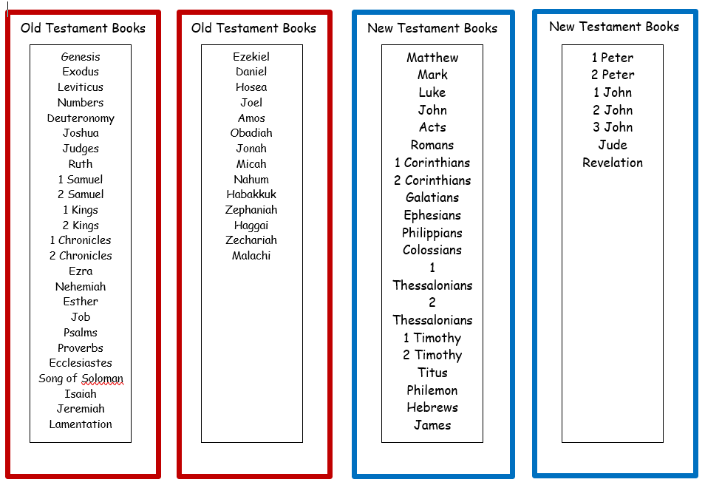  Craft items:  - Print out (Appendix 5 & 6) and cut the strips with the books in the new and old testament (Appendix 6).  - Glue  - Coloured pens/pencils  Extension for Noah’s Ark:  Bible books bingo game (Appendix 7)  - Print and copy as many sets as you need for the number of kids you may have.  - The game comes in a set of 6 so group the kids in groups of 6 or less.  Each kid has a card and then take turns to call out a name of a book in the bible. Everyone will need to look for that book and colour it in. The aim is to have coloured a row diagonally, vertically or horizontally to win.  Activities for Journal:  Stick memory verse at the back of their journal.  Appendix 8 – to cut and paste into the journal book  Print out memory verse activity & Challenge card Appendix 2  Then, cut the A4 printout down the middle to create 2 A5 sheets.  Finally, them in the children’s journals for them to take home.
10.40 | Check Out  Things to remember:  Kids’ journals (with the week’s journaling sheets already glued in).  Snack boxes and water bottles.  Finally:  - Remind children about earning a star or sticker by returning their journal next week with their activities completed.  - When a child leaves and if an opportunity presents itself, say something positive and specific to their family.  - Encourage families to do the journal activities together.

Appendix 7 – NA extension activity
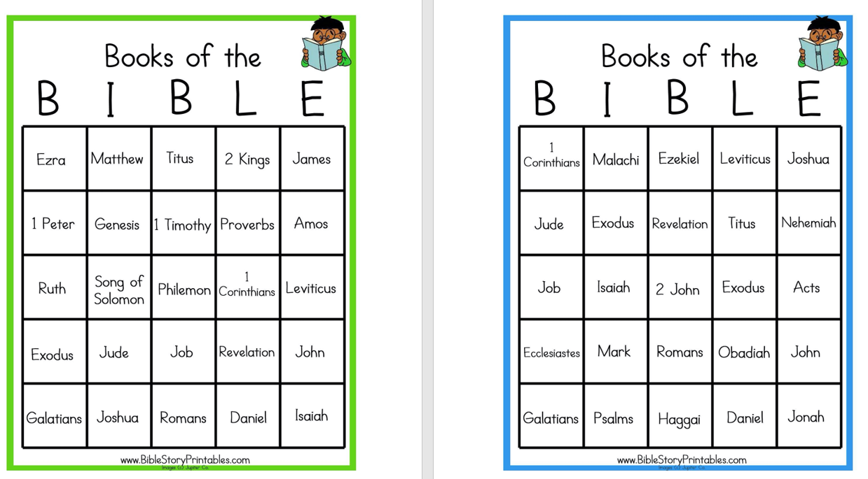

Appendix 8
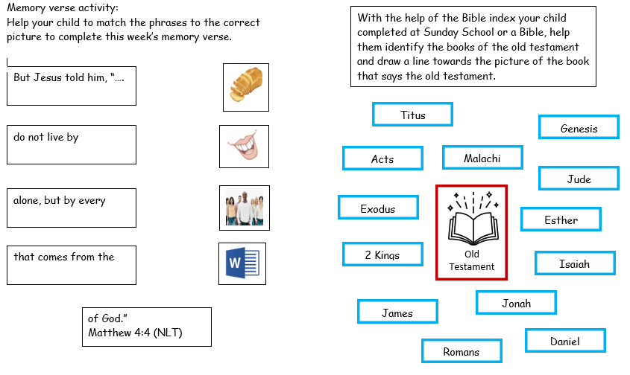

Appendix 2
