Date: | 21st February 2021
Title: | Back to basics – Add More God
Level/Class | Southside
Memory verse: | John 3:30 (NLT)  He must become greater and greater, and I must become less and less.
Bible story: | 1 Samuel 3 (God calling Samuel)
Big Idea: | Distraction
Big Point: | Add more God, subtract more me
4M Values: | Miracles & Ministry Equipping
Learning outcomes: | At the conclusion of this lesson, children will:  - Learn that spending time with God is priority  - Learn to put away distraction to spend time with God
Influencers:
Location: | Runcorn Tavern
LESSON PLAN Week 2- LCNA - Southside

7:45am | Set up and lesson run through

Today at a glance

Time | Activity | Influencers
8.30 | Check in:  - Prep extra tab for newcomers’ sign up  - Collect kids’ journal and pile them according to their respective classes.
9.10 | - Welcome kids and newcomers  - Recap the 3Ls (Listen, Learn & Love)
9.15 | Worship:  Shine a Light  https://www.youtube.com/watch?v=yVqfBEJMWfo  As the world shakes  https://www.youtube.com/watch?v=dcAG4PbNXaA  Who You Say I am  https://www.youtube.com/watch?v=Y0LHTDVy5C0
9.30 | Thanksgiving

9.35 | Snack:  Sanitize hands before eating
9.50 | Game: Distraction Action game (refer to Appendix 8)  To do:  Arrange the kids in a circle and all facing in.  Say:  Let’s play a game to help us ignore distractions when we need to spend time with God. One person will give a signal to pray, and we’ll see how fast you can copy them.  1. Choose a signal kid – he/she will put together his or her hands together and bow their head like they’re praying.  2. Read off one activity from the supplement and give time for kids to do it.  3. Repeat step 2 over and over until the signal kid gives the signal. If you want to make the game trickier, keep reading activities even after the signal is given.  4.The signal kid participates with everyone else until they choose to give the signal.  5.Kids notice the signal, stop doing the activities and copy the signal until everyone is doing it. Let kids notice the signal on their own instead of telling them.  * Team leader and other influencer may want to do the first couple of runs as an example before starting the game proper.  6.  Little Cherubs (Differentiation) Influencer to stand beside each signal kid to help out.  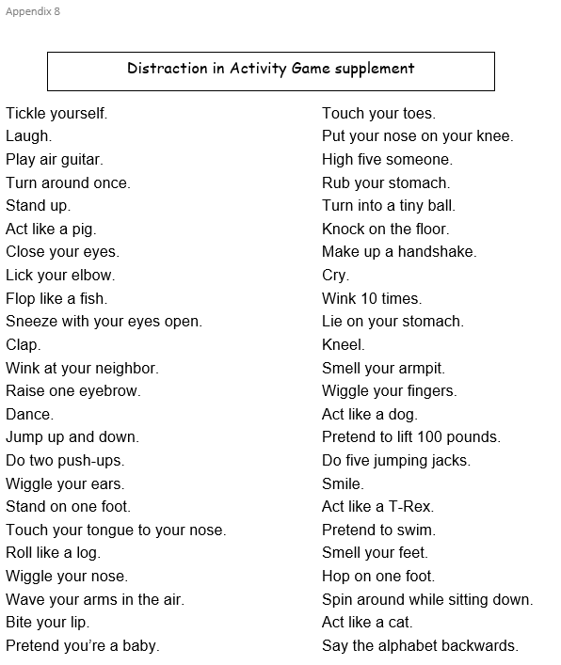
10.05 | Introduce bible verse: John 3:30 (NLT)  He must become greater and greater, and I must become less and less.  - Influencer to learn action before hand. Refer to  https://open.life.church/items/197751-teaching-segment-mp4 (go to the 10.11 minute mark)  - Teach the kids the verse with the actions.  - Repeat it a few times with them.
10.15 | Introduce the lesson video:  - 1 Samuel 3 (God calling to Samuel when he was asleep)  - Tell the kids that they are about to hear the story of a little boy who God wanted to talk to. Ask them to look out for the boy’s name and how he responded to God calling him.  Lesson Video  https://www.youtube.com/watch?v=Nnt_PMEQk0A  Recap/summarise story.  - Highlight that Samuel was ready to listen to God because he knew God had important things to say to him to guide him. Therefore, he even put aside his need for sleep to talk to God.  Then ask another question – What things that may keep them too busy to stop and listen to God or even your mummy and daddy?  Brainstorm why they think it’s important to listen to God or even their mummies and daddies?  Lead them towards, the idea that God wants to guide them and to have a relationship with them.
10.25 | Split into LCNA and J Club
10.25 | LCNA Craft : Teacher explains craft  Craft items:  - Print out (Appendix 1 & 2) and cut.  - Glue  - Coloured pens/pencils  - Kids’ scissor  - Extension for Noah’s Ark:  Kids cut out their own little pieces from Appendix 2  Colouring sheet (Appendix 9) for kids to colour  Activities for LCNA Journal:  If you have time, cut and paste Appendix 6 & 7 into the journaling book.  Stick the memory verses into the books:  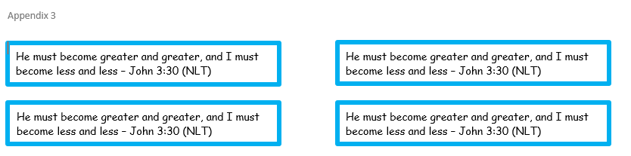
10.25 | J Club Activity and Journaling Sheets  Print out Appendix 3  Then cut the memory verse strips out. Stick one strip on the back of their journal.  Print out Appendix 4 – Activity sheet  -glue 1 A5 sheet in the children’s journals for them to take home.  Glue Challenge Card into the journal books
10.45 | Check Out

Appendix 6 - LCNA
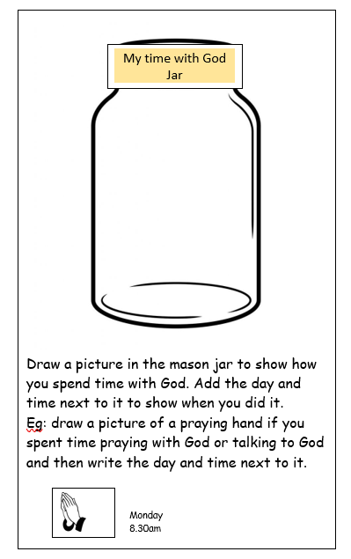

Appendix 7 - LCNA

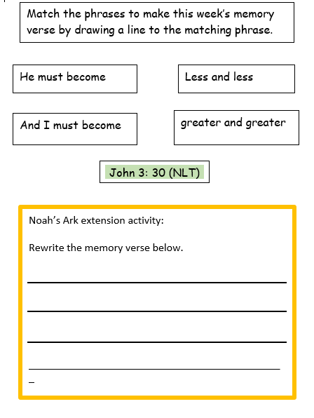

Appendix 9 - LCNA
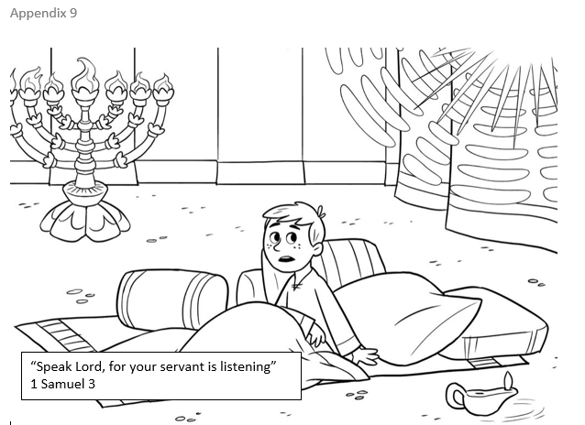

Appendix 4- J Club activity sheet
Challenge Card – J Club 