Ps. Jono
- Malachi 3:2
  - “he is like refiner’s fire and like fullers’ soap”
    - Jesus will be like refiner’s fire that refines metal
      - Thing’s may be heated up in our lives
  - “a strong soap that bleaches clothes”
    - God wants to cleanse us, God wants to do a deep clean in all of us
- God is using this crisis time to purify our Christianity
- 1 Thessalonians 5:23
  - “Now may the God of peace himself sanctify you completely, and may your whole spirit and soul and body be kept blameless at the coming of our Lord Jesus Christ”
  - We need to be cleansed by God inside out
- We have our body, our soul, and our spirit
  - John 3:6
    - “That which is born of the flesh is flesh, and that which is born of the Spirit is spirit”
  - Your body is your flesh
  - Your soul is your personality, will, emotions, mind, conscience
  - Your spirit has a connection with God
    - God can communicated and speak with your spirit
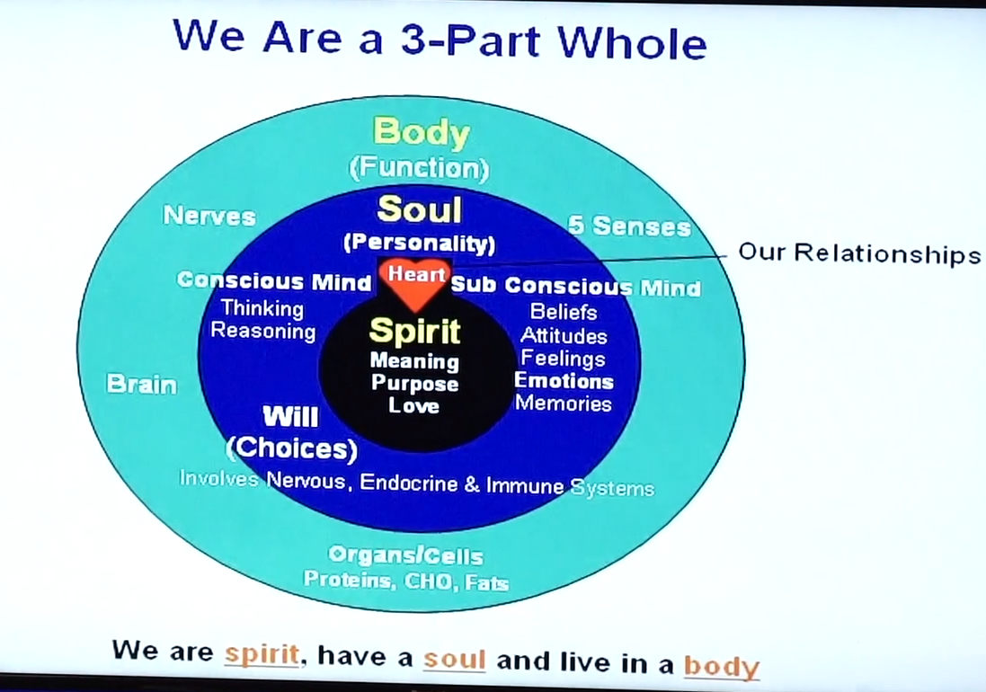
- James 2:6 For as the body apart from the spirit is dead, so also faith apart from works is dead
- The only way to discern what is spiritual truth is through the Bible
- John 6:63 It is the Spirit that quickens. The flesh profits nothing. The words that I speak unto you they are Spirit and they are life.
- James 1:23
  - You need to be a hearer of the word and a doer of the word
- Your soul needs to look into your Spirit, the word of God is the mirror for our soul to look into our Spirit
- To experience this new life, you need to surrender your life
- Your soul is like a valve. You can choose to let your Spirit through, or to close the valve
  - What blocks our valve
    - Negative thoughts
    - Depression
    - Bitterness
    - Unforgiveness
    - Anger
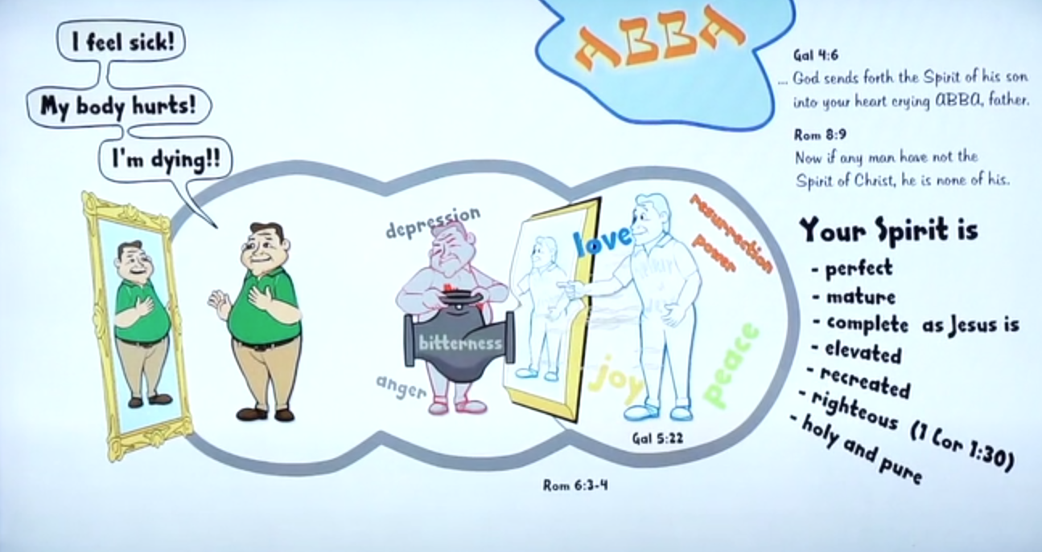
- We need to be renewed in our mind
- What influences our lives
  - External: the World, people
  - Flesh (old nature): can’t be cast out
  - Demonic – can be cast out
  - Holy Spirit
- 3 objectives demons have:
  - Torment and torture
  - To keep you from knowing Christ the saviour
  - To keep you from serving Christ effectively
- Demonic activity
  - Entice (James 1:14)
  - Harass (exploit moments of weakness)
  - Torment – physically with sickness and/or emotions (unforgiveness, 2 Timothy 1:7, 1 John 4:18)
  - Enslave – compel and enslave = addiction (Romans 8:15)
  - Defile (Titus 1:15)
    - They input impure thoughts and words into our minds
    - They do anything to keep you from worshipping God
  - Deceive – doctrines (1 Timothy 4:1-2)
  - Sick and tired (too tired to read the bible and pray)
  - Slumber
- 2 Corinthians 3:18 – 19 So all of us who have had that veil removed can see and reflect the glory of the Lord. And the Lord – who is the Spirit – makes us more and more life him as we are changed into his glorious image
- Renewing your mind
  - Knowledge and understanding of God’s word
  - Thinking spiritually, not carnally
  - Acknowledging every good thing in you
  - A process
- When you believe and begin to see in the Spirit, there is a renewing that occurs
- The spirit of man was created to be the ruler over man’s soul and body
Question:
- What challenges are you facing in your walk? What influence your live now?
- What are the lessons you are leaning through this or what do you think God wants to develop in you?

