Return to Me
A Relationship Series for Sharing Life
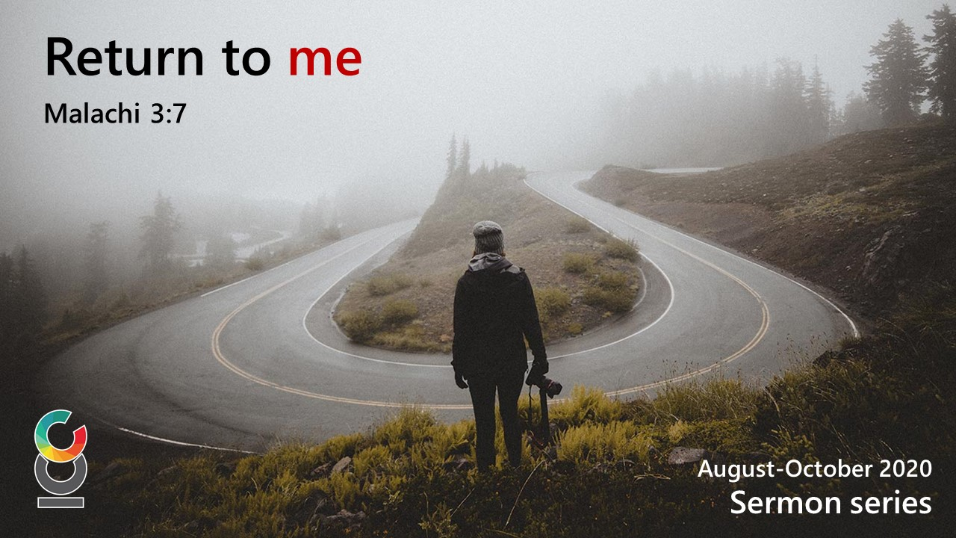

Connect Member’s Notes
OCTOBER & NOVEMBER 2020

TABLE OF CONTENTS

OVERVIEW…………………………………………………………………………………………………………………………3
SESSION 1 TRUTH IN LOVE 6

OVERVIEW

SERIES PASSAGE
“Therefore, be imitators of God, as beloved children; and walk in love, just as Christ also loved us and gave Himself up for us, an offering and a sacrifice to God as a fragrant aroma.” Ephesians 5:1-2 (ESV)

A. THE “Return to Me in Relationship” SERIES
In this new connect group series “Return to Me in Relationship”, we will look at practical ways in which our closest committed relationships can thrive. In living out our relationships, our goal should be to walk in love, reflecting Jesus in our interactions. Ephesians 5:1-2 calls us to “Be imitators of God… and walk in love”. It’s not our Bible knowledge or Christian doctrine that will cause people to realise the benefits of following Christ, but the image of God reflected in how we show our love for one another (John 13:34-25).
This relationship series will draw upon the experiences of different couples in our community. They share honestly about some of the struggles and challenges that have arisen through the course of their relationship with one another. The ways they have learnt to grow together and appreciate one another, although not perfect, are an example that can help us navigate our own relationships with those closest to us. Like our couples, this could be your spouse. For others, this could be relationships between parent and child, siblings or friends. It’s all about your closest relationships and how you communicate and interact together, with the aim that you better show your love to each other, reflecting Christ.

The “Return to Me in Relationship” series aims to provide guidance
for improving your communication with others, leading to stronger
and more harmonious relationships with those closest to us.

BACKGROUND TO PAUL’S LETTER TO THE EPHESIANS
For this Relationship Series we are drawing on Paul’s writings to the Ephesian church. This letter is a classic balance of spiritual theology dealing with our position in Christ Jesus (chapters 1-3) followed by practical application of the truth, i.e. how we reflect that truth in our daily lives (chapters 4-6). Paul teaches how we can walk in unity, purity, harmony and victory. Unity is not uniformity where you become the same as someone else through external pressure. Rather, it is an internal expression of grace and gratitude towards someone else. Like a human body has different parts that all work together, creating a healthy functional body. The scriptural basis is foundational for understanding how we can reflect Christ in what we do in everyday life. Honouring one another in our relationships is a primary way to express our love for God.

B. ABOUT THE SESSIONS
This new relationship series is called “Return to Me in Relationship” and run for five sessions. We will study four core applications that will help us to become more Christ-like in our interactions within our closest committed relationships (spouses, family, friends etc), strengthening and making for happier and healthier relationships.
The closest of all relationships is that of a husband and wife. All good marriages would go through times when things have to be turned around. We have invited five couples to share, each having a good Christian testimony. This is not because nothing bad has happened in their marriages. Things may have happened, and mistakes may have been made, but at some point, they have taken steps to turn their marriages around.
The following table outlines the key application points of each Session:

SESSION | TITLE | KEY APPLICATION POINTS
Session 1 | Truth in Love | - It is important to tell the truth, but speak with intentional kindness  - Understand different personality types: conflict avoiding or confrontational  - Reflect on and discuss how to bring up difficult topics before discussing the actual topic
Session 2 | Conflict & Differences | - Realise “differences” can be a major source of conflict  - Set realistic expectations in what the other person can do for you (don’t expect them to meet all your needs).  - Commit to resolve differences
Session 3 | The Inner Heart | - Negative emotions lead to negative words or actions  - Choose to resolve your anger  - Think positive—rightly assume the other party wants the best for you  - Practice self-talk to “boss your feelings around”
Session 4 | Practicing Generosity | - Being generous is one of the biggest contributing factors in happy, healthy relationships  - Give without expecting something in return  - Keep a positive score (how much the other person has done for you)
Session 5 | Living It Out | • Time for testimonies/discuss your love languages

This series on relationships is meant to be practical. We welcome this series as it’s a chance to talk about things that are common in all close relationships, but we are often reluctant to talk about them openly. While being sensitive to the group and to personal situations, we hope you will take the opportunity to use the series to trigger deeper conversations to help each other grow in their intimate relationships as well as relationships within your group.
For additional reading for this series we recommend the book:
Surprising Secrets of Highly Happy Marriages (2013) by Shaunti Feldhahn.
Published by Multnomah Books (hardcover) or the Crown Publishing Group.

Keywords: Relationship • Building Trust • Intimacy • Sacrifice
F.A.I.T.H. emphasis: I - Intimate Relationally

SESSION 1 TRUTH IN LOVE

The key to speaking truth in love is to treat each other
with intentional kindness.

Key Passage: “Therefore, having put away falsehood, let each one of you speak the truth with his neighbor, for we are members one of another” Ephesians 4:25

A. INTRODUCTION
In the “Return to Me in Relationship” series, we want to offer conversation starters that will help you with your closest relationships. This could be that of a husband and wife, parent and child, between siblings or perhaps best friends. We hope these conversations will lead to positive changes in your closest relationships.
Research into highly successful relationships has shown that if we want to change, improve, or be inspired, we have to study the bright spots, not just the problems. Furthermore, it’s the daily unspoken beliefs, assumptions, and practices that make the difference regardless of the big issues. It is how we handle those issues that determines how much we enjoy the relationship, a marriage or otherwise.
It is imperative that we learn to deal with conflict and not shy away from it. Session 1 looks at the value of being honest, but not brutally honest. In our close relationships, some may be tempted to bury things and hope they won’t be raised by the other person (conflict avoiding) whereas others may have no hesitation in confronting issues thinking “honesty is the best policy”. For healthy, happy relationships there is always a balance. We need to be able to bring up the truth, but at the right time, and with self-control.
Truth telling is essential in relationships as it builds trust and intimacy. The key to speaking truth is not to blurt it out and “tell it how it is”, but it should be done in love and spoken with intentional kindness. Be careful not to be disrespectful or speak in a way that is hurtful. It may feel like you are walking on a narrow path, being sensitive to the other person but not avoiding the issue. This requires prayer, grace and patience, the fruit of which is peace and happiness.

B. READ SCRIPTURE: Ephesians 4:25–32
Additional scriptures (for reference):
Eph 5:1-2, Prov 12:22-23, John 8:44, 1 John 2:21, Rev 22:15

C. DISCUSSION QUESTIONS
These questions are relevant to couples, parents and children and vice versa as well as among close friends. Truly intimate friendships also need to work at discussing difficult topics in a healthy way.

- Think of times when a loved one (spouse, friend, colleague, etc) has brought up a difficult topic with you. Reflect on those times and share some of the things you appreciated about how that person approached the topic.

- How do you bring up a difficult topic with someone you love? Share what are some of the practical things you do before and during the conversation.

- What are some of the benefits of being truthful? Discuss how you can be truthful and still show consideration and kindness.

D. LIVING IT OUT
Reflect on certain areas of your marriage or other close relationships where you find it hard to be truthful with the other person. Choose at least 1 topic each and, over the next couple of weeks, settle on a time to discuss it with the other person. Before discussing the topic, talk about how you can bring it up in a way that gives you both the opportunity to talk more freely about any issue. If you are comfortable, we encourage you to share these things at the next connect group meeting.

E. LOOKING FORWARD
In Session 2, we will look at the keys to managing expectations in relationships.

