SPIRITUAL DISCIPLINES WEEK 3
 | READING THE BIBLE
If you eat healthy food every day, your body gets healthier.  But what about your spirit?  Feed your heart God’s Word to fill it with the healthy truth it needs! |  |  |  | 2  POINTS | COMPLETE THIS ACTIVITY WITH YOUR FAMILY!  Look up each verse in the Bible. If it’s a real verse, draw a line from it to the mouth. If it’s not a real verse, mark it out.
 |  |  |  | 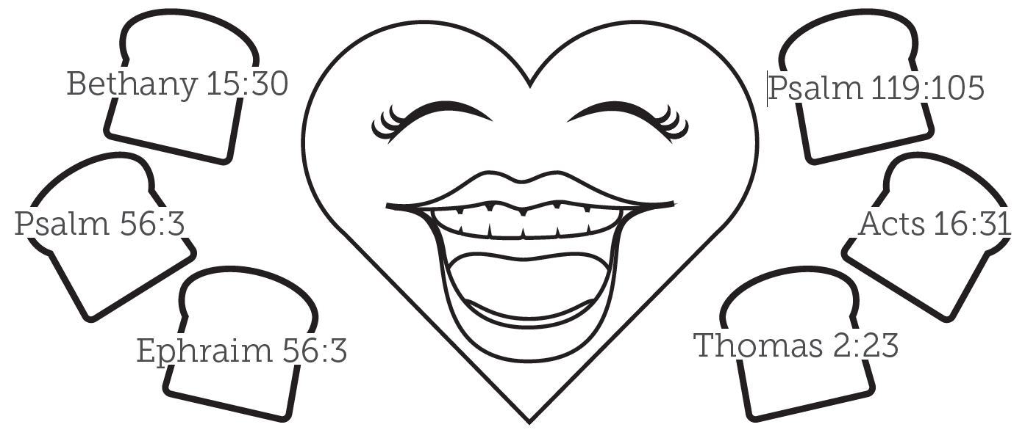
 |  |  |  | 1  POINT | SAY THIS WEEK’S POINT FROM MEMORY!  Reading the Bible keeps your spirit healthy.
 |  |  |  | 2  POINTS | SAY THIS WEEK’S BIBLE VERSE FROM MEMORY!  Matthew 4:4 NLT But Jesus told him, “… ‘People do not live by bread alone, but by every word that comes from the mouth of God.’’’
COMPLETE THIS BIBLE PLAN WITH YOUR FAMILY!
Train Your Spirit
www.go2.lc/KonnectBiblePlans

Complete this Challenge Card with a parent and ask them to sign below.
Bring it to the class to get your points!

Name: _____________________________________________________________

Parent Signature: ____________________________________________________

