Date: | 7th March 2021
Title: | Back to basics – How to pray to God
Level/Class | J Club
Memory verse: | Psalm 55:17 (NLT)  Morning, noon and night… the Lord hears my voice.
Bible story: | Luke (Jesus prays)
Big Idea: | Remember to pray
Big Point: | When I pray at night or during the day, God is listening to what I say.
4M Values: | Miracles (Miracles can happen through prayer)  Ministry Equipping (Praying is a way we can communicate with God to help us in our ministries.)  Missions (We pray for the people we are helping or wish to help and share Jesus with.)  Multicultural (Pray for every nation)
Learning outcomes: | At the conclusion of this lesson, children will know that:  - Prayer is important.  - We should pray every day  - We can pray to God anytime as HE is always listening.
Influencers:
Location: | ICC Newmarket
LESSON PLAN (J Club)

7:30am | Set up and lesson run through (Team Leader)

Today at a glance

Time | Activity | Influencers
8.15 | Check in:  - Prep extra tab for newcomers’ sign up.  - Collect kids’ journal and pile them according to their respective classes.
8.50 | - Welcome kids and newcomers  - Recap the 3Ls (Listen, Learn & Love)
9.00 | Worship:  As the World Shakes  https://www.youtube.com/watch?v=dcAG4PbNXaA  Pray about everything (Philippians 4:6-7)  https://www.youtube.com/watch?v=X05FnYbugIs  Saviour King  https://www.youtube.com/watch?v=F-QQn1uGi0k
9.15 | Thanksgiving

9.20 | Game: Play Simon says  Highlight that this game shows how important it is to listen well. When we pray, God is always listening to us but we also need to train ourselves to listen to him.
9.35 | Introduce bible verse: Morning, noon and night… the lord hears my voice – Psalm 55:17 (NLT)  Influencer to learn action beforehand.  - Refer to:  https://open.life.church/items/197759-teaching-segment-mp4 (Verse actions @ 7:13 – 7:35)  - Teach the kids the verse with the actions.  - Repeat it a few times with them.
9:40 | Lesson video (17 minutes 18 seconds):  https://open.life.church/items/197759-teaching-segment-mp4  Infer before playing the video:  From the memory verse today and the game we played, what do you think the video will be about?  Play video…  Pause at the 2:48 minute mark:  Highlight the main point ie – When I pray at night or during that day, God is listening to what I say.  Resume playing the video…  Pause at the 14:40 minute mark:  Questions to ask the kids…  - What are the prayer questions?  - How does God talk to us? In many different way.  - Is talking to God as hard as it seems? You can talk to God anytime, anywhere, about anything. Praise Him for who He is. Thank him for what he has done.  - Why isn’t God answering my prayer and do I need to keep praying since He is God and already knows everything? God listens and answers prayer but not always how we expect Him to.  Resume playing video to the end…  Recap/summarise story.  Reinforce big point – When I pray at night or during the day, God is listening to what I say.  Tell them that next, they are going into their discussion groups and they will continue to do a discussion on the topic of praying to God.  Divide kids to smaller groups for discussion.
10.00 | Small group discussion.  - Appendixes 1 (1 set for each small group leader).  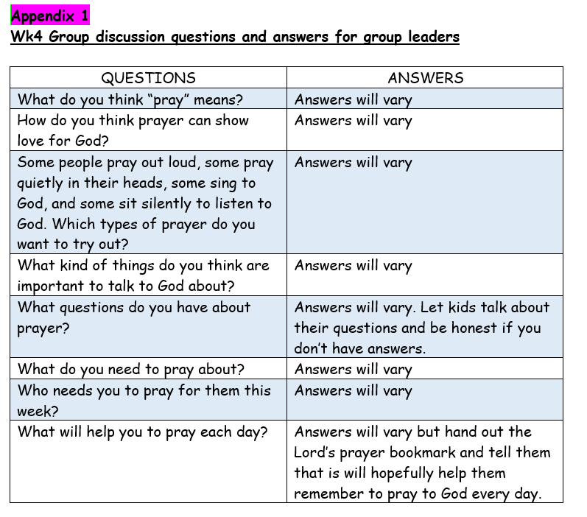  Other items you will need:  - 5 sheets of blank paper (A5) and a marker pen or crayon to write for each child.  - The Lord’s prayer bookmarks (Appendix 2)  Appendix 2  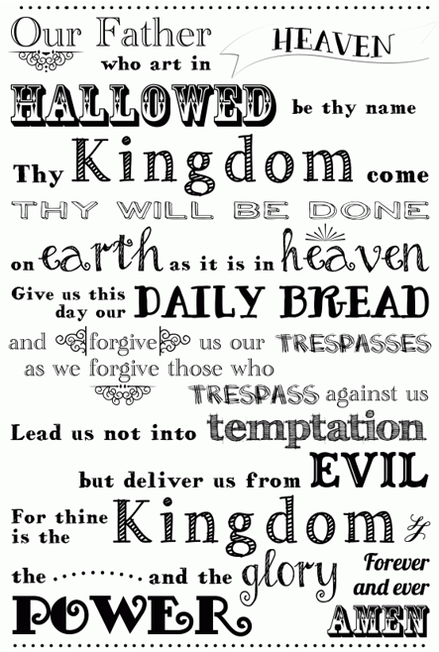  Go through questions during group discussion  - Group facilitators read out a question and give each child around 2 minutes to write out their answers without showing anyone yet.  - Children take turns to share their answers with the rest of the group once the 2 minutes are up. Allow other children to ask them questions if they have any or a need to clarify.  - Repeat the same steps for every question. Group facilitators try to extend and encourage thoughtful thinking according to the age group.  *Complete Appendix 3 in class and paste challenge card into book
10.30 | Prayer (still in small groups):  - Ask kids to share things they’d like to pray about.  - Pray together over their prayer requests.  Pray this too: God, please show us what distracts us from You. Thank you for helping us spend more time focused on You. In Jesus’ name, amen.
10.40 | Check Out  - Talk about earning a star or sticker by returning their journal next week with their activities completed.  - When a child leaves and if an opportunity presents itself, say something positive and specific to their family.  - Encourage families to do the journal activities together.

Activities for Journal:

-Appendix 3
The Lord’s prayer maze. 1 copy for each child to complete in class

-Challenge card
- to paste in the book, for them to complete with their parents at home

Appendix 3

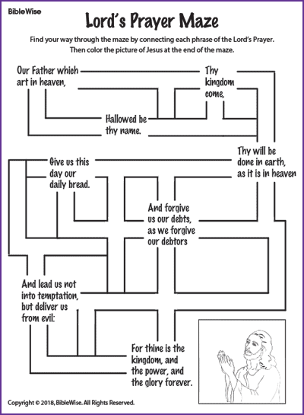

Challenge Card
