Date: | 7th March 2021
Title: | Back to basics – How to pray to God
Level/Class | Little Cherub & Noah’s Ark
Memory verse: | Psalm 55:17 (NLT)  Morning, noon and night… the Lord hears my voice.
Bible story: | Luke (Jesus prays)
Big Idea: | Remember to pray
Big Point: | When I pray at night or during the day, God is listening to what I say.
4M Values: | Miracles (Miracles can happen through prayer)  Ministry Equipping (Praying is a way we can communicate with God to help us in our ministries.)  Missions (We pray for the people we are helping or wish to help and share Jesus with.)  Multicultural (Pray for every nation)
Learning outcomes: | At the conclusion of this lesson, children will know that:  - Prayer is important.  - We should pray every day  - We can pray to God anytime as HE is always listening.
Influencers:
Location: | Runcorn Tavern – G Floor
LESSON PLAN

7:40am  7:45 | Prayer together as a team  Set up and lesson run through  SETUP CHECK LIST  - Fold tables and stack chairs to the back of the room  - Setup the check-in tables and printer  ̈ Mic/Sound/Video setup and test  ̈ Turn on music during check-in for pumped atmosphere. ̈ Craft/Activities/Games resource and props check.  ̈ Journaling sheets & books  ̈ Check class/area for safety and security measures.  ̈ Remove items that are not meant to be there.

Today at a glance

Time | Activity | Influencers
8.15 | Check in:  - Prep extra tab for newcomers’ sign up  - Collect kids’ journals and pile them according to their respective classes.
8.50 | - Welcome kids and newcomers  - Recap the 3Ls (Listen, Learn & Love)
9.00 | Worship:  As the World Shakes  https://www.youtube.com/watch?v=dcAG4PbNXaA  Pray about everything (Philippians 4:6-7)  https://www.youtube.com/watch?v=X05FnYbugIs  A gift to you  https://www.youtube.com/watch?v=n3iG1gkW9R0
9.15 | Thanksgiving  - Share something that you are thankful for  - Encourage children to share  - Pray

9.20 | Game: Play Simon says  Highlight that this game shows how important it is to listen well. When we pray, God is always listening to us but we also need to train ourselves to listen to him.
9.50 | Introduce bible verse: Morning, noon and night… the lord hears my voice – Psalm 55:17 (NLT)  Influencer to learn action beforehand.  - Refer to:  https://open.life.church/items/197759-teaching-segment-mp4 (Verse actions @ 7:13 – 7:35)  - Teach the kids the verse with the actions.  - Repeat it a few times with them.
10.00 | Introduce the lesson video:  - Luke – Jesus Prays  - Tell the kids that they are about to hear the story about Jesus and what He did when he was on earth. Their job is to watch and find out what it is?  Lesson Video  https://www.youtube.com/watch?v=S81k0SCzOCY  Recap/summarise story.  - Highlight that Jesus prayed with other people and also prayed by himself. He prayed to for many people and for many things. He also prayed for us. Therefore, when we are sad, worried or even happy, we can always pray to God just like Jesus.  Then introduce the Lord’s Prayer that Jesus taught the people. (Appendix 5 will be printed in A4 sheets- as visual cards to put on the white board as you read them out. Keep them on the board for the children to refer to during their craft activity.
10.15 | Split into LCNA, J Club  - Morning tea in respective classes  - Activity sheets, craft and colouring sheets explained below
10.18 | NA Craft : Teacher explains craft  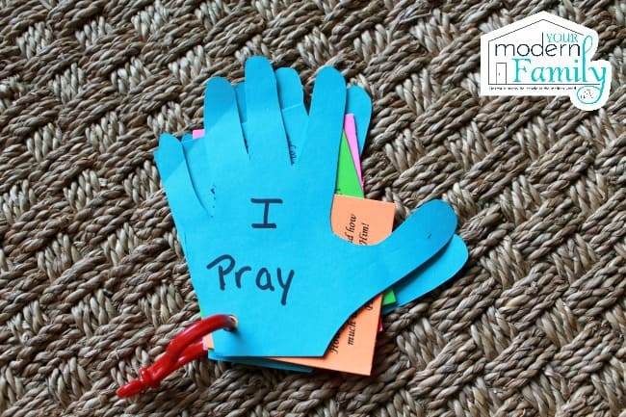  Craft items:  - Appendix 5- teacher help cut them out after they have coloured them in  - Coloured paper (for the children to trace their hand print and cut them out for front 1st page)  - Punch a hole and use a pipe cleaner to hold them together  Colouring sheet for LC:  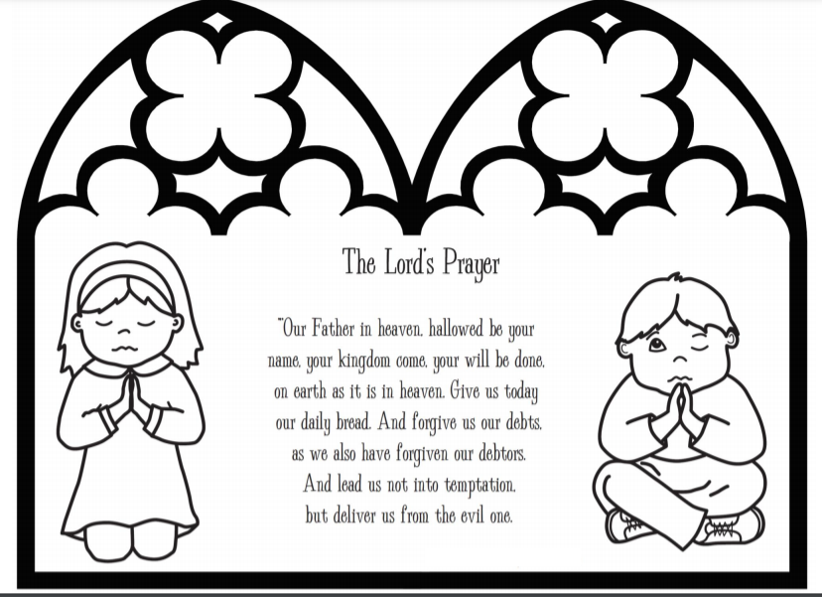
10.18 | Small group discussion.  - Appendixes 1 (1 set for each small group leader).  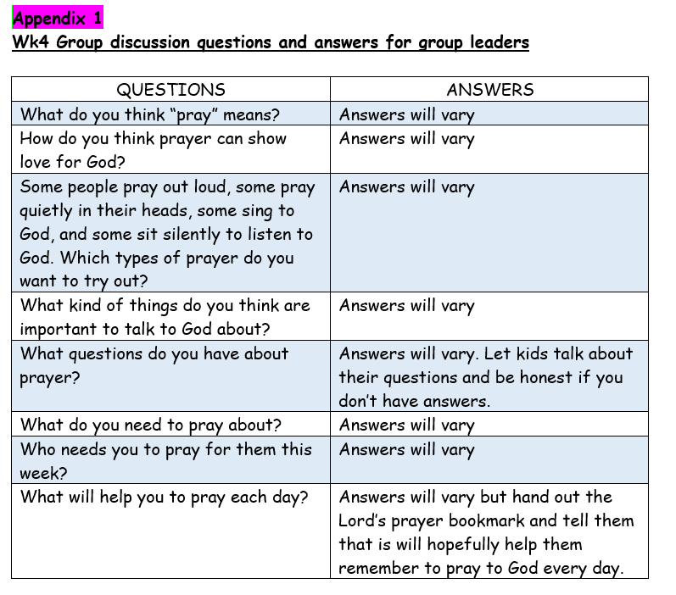  Other items you will need:  - 5 sheets of blank paper (A5) and a marker pen or crayon to write for each child.  - The Lord’s prayer bookmarks (Appendix 2)  Appendix 2  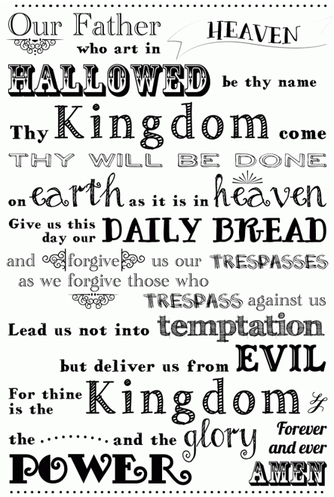  Go through questions during group discussion  - Group facilitators read out a question and give each child around 2 minutes to write out their answers without showing anyone yet.  - Children take turns to share their answers with the rest of the group once the 2 minutes are up. Allow other children to ask them questions if they have any or a need to clarify.  - Repeat the same steps for every question. Group facilitators try to extend and encourage thoughtful thinking according to the age group.  *Complete Appendix 3 in class and paste challenge card into book
10.35 | Check Out  Remember snack bag, journal and today’s craft activity.
Activities for Journal Books:
- Stick memory strip on the last page of their journal (All)
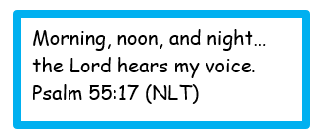
- Appendix 3 & 7 (For Noah’s Ark)
- Ap 3 for in-class activity
- Ap 7 to glue in children’s journals for them to do with parents
- Appendix 7 to glue in book (For Little Cherubs)
- Colouring sheet for in-class activity
- J Club :
Appendix 3- The Lord’s prayer maze to complete in class
Challenge Card
Appendix 5
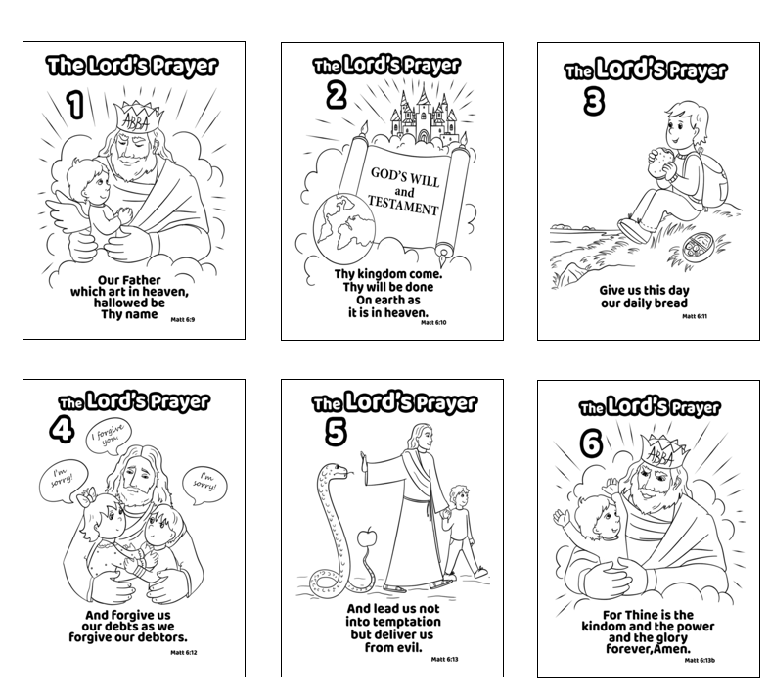

Appendix 3
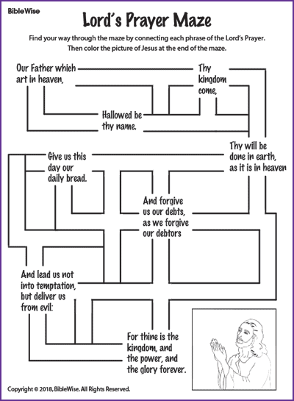

Appendix 7
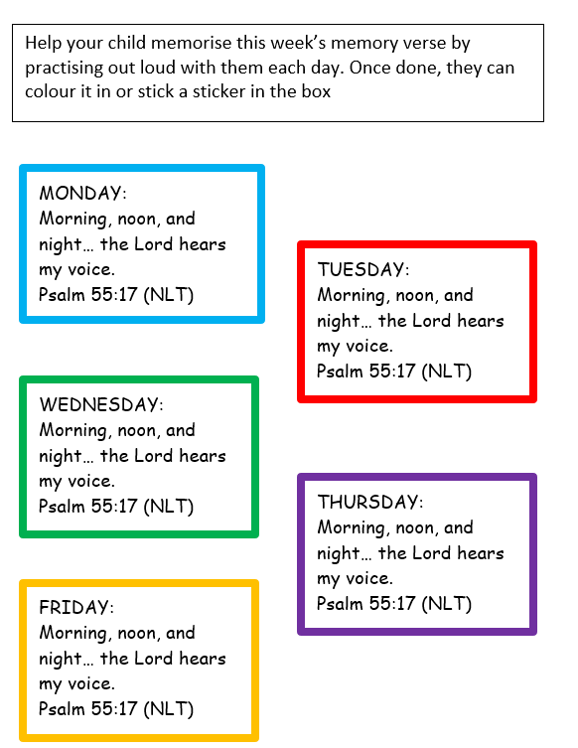

Challenge Card
