Date: | 21st February 2021
Title: | Back to basics – Add More God
Level/Class | J Club
Memory verse: | John 3:30 (NLT)  “He must become greater and greater, and I must become less and less”
Bible story: | 1 Samuel 3 (God calling Samuel)
Big Idea: | Distraction
Big Point: | Add more God, subtract more me.
4M Values: | Miracles & Ministry equipping
Learning outcomes: | At the conclusion of this lesson, children will:  - Learn that spending time with God is priority  - Learn to put away distraction to spend time with God
Influencers:
Location: | ICC Newmarket
LESSON PLAN (J Club)- Week 2 - Newmarket

7:45am | Set up and lesson run through (Team Leader)

Today at a glance

Time | Activity | Influencers
8.30 | Check in:  - Prep extra tab for newcomers’ sign up.  - Collect kids’ journal and pile them according to their respective classes.
9.10 | - Welcome kids and newcomers  - Recap the 3Ls (Listen, Learn & Love)
9.15 | Worship:  Shine a Light  https://www.youtube.com/watch?v=yVqfBEJMWfo  As the world shakes  https://www.youtube.com/watch?v=dcAG4PbNXaA  Who You Say I am  https://www.youtube.com/watch?v=Y0LHTDVy5C0
9.30 | Thanksgiving

9.35 | Game: Distraction Action game (refer to Appendix 8)  To do:  Arrange the kids in a circle and all facing in.  Say:  Let’s play a game to help us ignore distractions when we need to spend time with God. One person will give a signal to pray, and we’ll see how fast you can copy them.  1. Choose a signal kid – he/she will put together his or her hands together and bow their head like they’re praying.  2. Read off one activity from the supplement and give time for kids to do it.  3. Repeat step 2 over and over until the signal kid gives the signal. If you want to make the game trickier, keep reading activities even after the signal is given.  4.The signal kid participates with everyone else until they choose to give the signal.  5.Kids notice the signal, stop doing the activities and copy the signal until everyone is doing it. Let kids notice the signal on their own instead of telling them.  * Team leader and other influencer may want to do the first couple of runs as an example before starting the game proper.  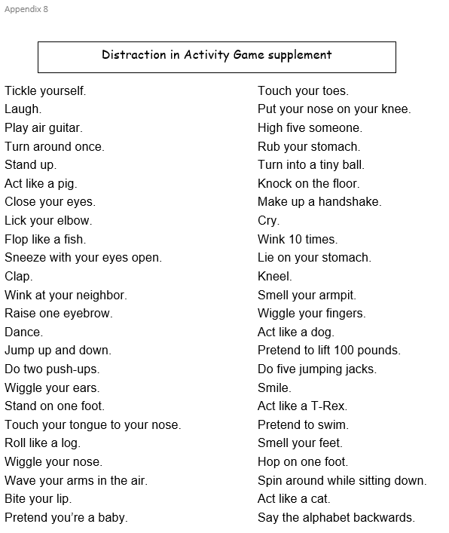
10.05 | Introduce bible verse: John 3:30 (NLT)  He must become greater and greater, and I must become less and less.  - Influencer to learn action before hand. Refer to  https://open.life.church/items/197751-teaching-segment-mp4 (go to the 10.11 minute mark)  - Teach the kids the verse with the actions.  - Repeat it a few times with them.
10.15 | Lesson video (15 minutes 43 Secs):  https://open.life.church/items/197751-teaching-segment-mp4  Infer before playing the video:  From the memory verse today and the game we played, what do you think the video will be about?  Play video…  Pause at the 4:10 minute mark:  Ask the kids to identify the problem the story is trying to highlight?  Resume playing the video…  Pause at the 9:08 minute mark:  Questions to ask the kids…  - What were the distractions in the story?  - What happens when the characters in the story were often distracted?  Resume playing video to the end…  Questions to ask…  - How do we focus more on God and not be distracted?  Recap/summarise story then ask this question “What do you think made Harper choose a game over her responsibilities?” (Answers from children may vary)  Focus point – Add more God, subtract more me.  Divide kids to smaller groups for discussion
10.35 | Small group discussion.  Prep: Print 4/5 sets of Appendixes 10 (1 set for each small group leader).  Other items you will need: 5 sheets of blank paper (A5) and a marker pen or crayon to write for each child.  Go through questions during group discussion  - Group facilitators read out a question and give each child around 2 minutes to write out their answers without showing anyone yet.  - Children take turns to share their answers with the rest of the group once the 2 minutes are up. Allow other children to ask them questions if they have any or a need to clarify.  - Repeat the same steps for every question. Group facilitators try to extend and encourage thoughtful thinking according to the age group.
10.55 | Prayer (still in small groups):  - Ask kids to share things they’d like to pray about.  - Pray together over their prayer requests.  Pray this too: God, please show us what distracts us from You. Thank you for helping us spend more time focused on You. In Jesus’ name, amen.
11.00 | Check Out  - Talk about earning a star or sticker by returning their journal next week with their activities completed.  - When a child leaves and if an opportunity presents itself, say something positive and specific to their family.  - Encourage families to do the journal activities together.

Activities for J Club Journal:

Print out Appendix 3
Then cut the memory verse strips out. Stick one strip on the back of their journal.

Print out Appendix 4
Then, cut the A4 printout down the middle to create 2 A5 sheets.
Finally, glue 1 A5 sheet in the children’s journals for them to take home.

Print out Challenge card Appendix 5
Then, cut the A4 printout down the middle to create 2 A5 sheets.
Finally, stick 1 A5 sheet in the children’s journals for them to take home.

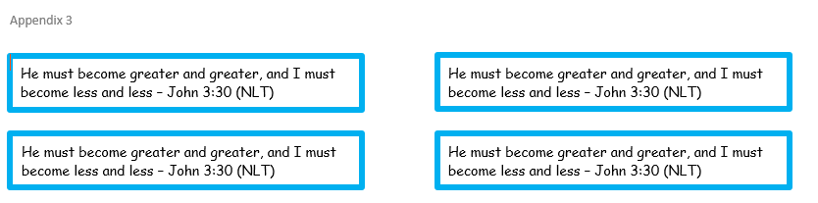

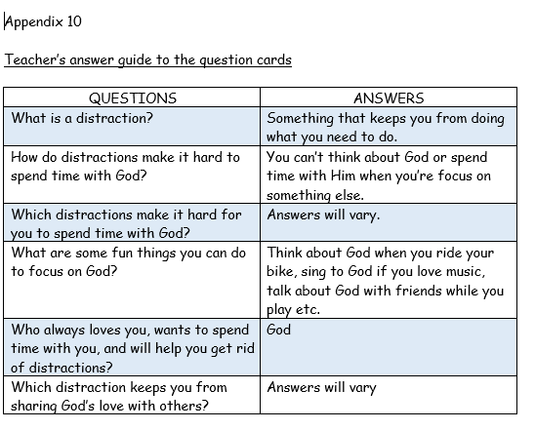

Appendix 5

