LESSON PLAN 1.3 The Kingdom Of Heaven is Like – J Club Newmarket

Date: | 16/05/2021
Memory verse: | “and we know that the Son of God has come, and He has given us understanding so that we can know the true God.” 1 John 5:20a (NLT)
Big Idea: | The Kingdom Of Heaven is Like
Big Point: | I BELONG TO THE KINGDOM OF GOD
4M Values: | Mission & Multicultural  To recognise that we are all citizens of heaven and know that no matter what race and skin colour we have, we are all made in His image and belong to the kingdom of God
Learning outcomes: | At the conclusion of this lesson children will:  - Learn what the kingdom of God is.  - Know that we belong to the kingdom of God.  - Discover the Parables Jesus told that teach us what God’s kingdom is like
Influencers:

7:30am | Prayer, Set up and lesson run through

SETUP CHECK LIST
- Setup tables and chairs in the new room
- Setup the check-in tables and printer outside the room
- Mic/Sound/Video setup and test
- Turn on music during check-in for pumped atmosphere.
- Craft/Activities/Games resource and props check.
- Journaling sheets & books
- Check class/area for safety and security measures.
- Remove items that are not meant to be there.

Time | Activity | Influencers
8.15 | Check in:  - Prep extra tab for newcomers’ sign up  - Collect kids’ journal and pile them according to their respective classes.
8.50 | - Welcome kids and newcomers  - Recap the 3Ls (Listen, Learn & Love)
9.00 | Worship:  Kindly choose 3 songs
9.15 | Thanksgiving

Object Lesson

Teach the children that things can seem backwards in the kingdom of God, by playing videos in reversed footage.
Eg. https://www.youtube.com/watch?v=O-8Ac4M0ea4
Jesus shared parables saying, “the kingdom of heaven is like...” to help his followers understand how this backwards kingdom works. These videos are backwards to how we usually see the world. The kingdom of Heaven is a bit like that. In the kingdom of Heaven some things seem like they are back to front or upside down. Jesus said that in His kingdom the first will be last and the last will be first (Matt. 20:16). He said that whoever wanted to be great would have to be a servant (Matt. 20: 26) And that it is more blessed to give than to receive (Acts 20:35). In a world where people want to be first, not last; people want to be great, not servants; and want to get, not give, God’s kingdom seems back to front. That’s the amazing thing about it, in God’s kingdom if you put Him first in your life you’ll never come second. Luke 12:31 “But seek first His kingdom and these things will be given to you as well.” God’s word gives us wisdom for life. I belong to the kingdom of God.

9.20 | Game (suggestion)-  Supplies Needed:  Supplies needed: Ball and net or bucket. Each word of the verse written on paper.  Set the children the challenge to throw the ball into to the net (or bucket). Each time the ball goes in, they are awarded a word from the Big Word. Help the children to put the words into the correct order and repeat the verse aloud together a number of times. “And we know that the Son of God has come, and he has given us understanding so that we can know the true God.” 1 John 5:20a (NLT)
9.35 | “and we know that the Son of God has come, and He has given us understanding so that we can know the true God.” 1 John 5:20a (NLT)  Come up with actions and repeat the Bible Verse a few times with the children (BIG WORD SONG- https://vimeo.com/539406042/ade8929156)
9.45 | Lesson  Lesson Video - https://vimeo.com/536649879/bf3ee6c689  Extra video - https://vimeo.com/536650276/168f1653e6  Summary  In God’s kingdom there is no divide between country, colour, age or gender. We are family, God the Father and we are His children. All who believe are part of God’s kingdom. Ephesians 2:19 (NIV) “Consequently, you are no longer foreigners and strangers, but fellow citizens with God’s people and also members of his household”. I belong to the kingdom of God.
DISCUSSION QUESTIONS
1. Why is the Kingdom of God sometimes called an upside down kingdom?
Because things are often opposite to what the world says. Jesus came and flipped everything on its head. The first shall be last. The least are the greatest. Pray for your enemies. Even to the world today, this kind of thinking doesn’t make sense. That’s why Jesus said, John 18:36 (NIV) “My kingdom is not of this world”. Jesus life, how He lived and how He loved was radical. The Parables, the stories that He told were revolutionary!

2. How did Jesus describe the Kingdom of heaven?
Read Matthew 13:44 (NIV) “The kingdom of heaven is like treasure hidden in a field. When a man found it, he hid it again, and then in his joy went and sold all he had and bought that field.” In this parable, Jesus shows us that the Kingdom of Heaven is precious and to be valued. Read Matthew 13:31-32 (NIV) He told them another parable: “The kingdom of heaven is like a mustard seed, which a man took and planted in his field. Though it is the smallest of all seeds, yet when it grows, it is the largest of garden plants and becomes a tree, so that the birds come and perch in its branches.” In this parable, Jesus shows us that the Kingdom of Heaven is precious and to be valued.

3. How can we be a part of God’s Kingdom?
When we make God the king in our life, we are part of God’s Kingdom. We are family, God is the father and we are His children. All who believe are part of God’s kingdom. Ephesians 2:19 (NIV) “Consequently, you are no longer foreigners and strangers, but fellow citizens with God’s people and also members of his household”. We belong to the Kingdom of God.

10.40 | Check Out  - Make sure the children collect all belongings and journal books  - Leader to fill up debrief form after service:  http://tiny.cc/8pactz
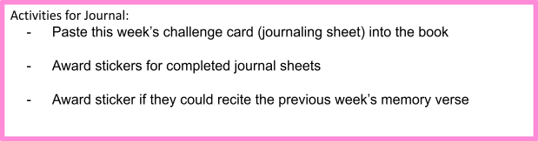

PACK UP CHECK LIST
- Clean out rubbish from tables and floor. (Dispose leftover drinks/coffee/food)
- Neatly store stationery and craft materials back into storage boxes
- Pack up check-in tablet and printer
- Turn off TV/Screens/Sound/Mics
- Rearrange tables in the room (Move it back)
- Inform Kids Pastor or Coordinator if there are any incidents.
- Team Leader to fill up feedback form. (http://tiny.cc/8pactz)

Activity sheets
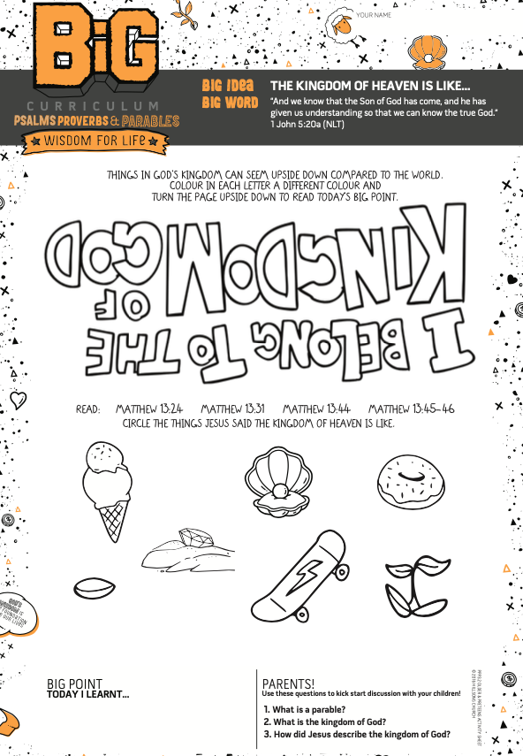
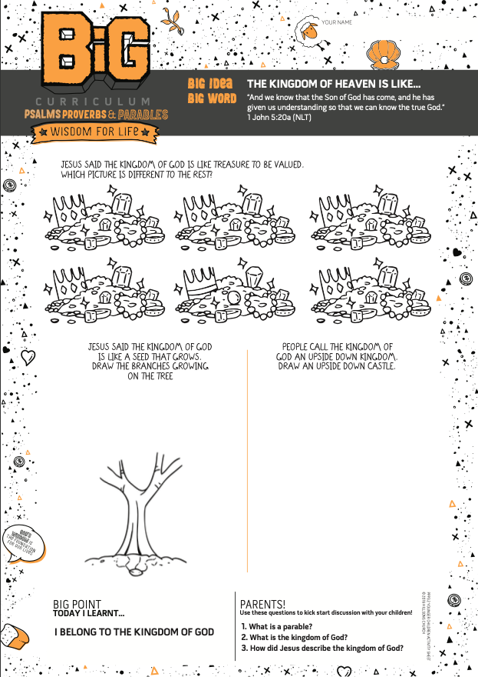

Challenge Cards
- To be attached separately

