LESSON PLAN 2.1 Wise People Ask – LCNA Newmarket

Date: | 30/05/2021
Memory verse: | “TRUST IN THE LORD WITH ALL YOUR HEART; DO NOT DEPEND ON YOUR OWN UNDERSTANDING. SEEK HIS WILL IN ALL YOU DO, AND HE WILL SHOW YOU WHICH PATH TO TAKE.” PROVERBS 3:5-6 (NLT)
Big Idea: | Wise people ask
Big Point: | WE ARE WISE TO ASK GOD FOR WISDOM
4M Values: | Ministry Equipping  To instill in the children from a young age that the Book of Proverbs has a wealth of wisdom that is available and to ask God for wisdom for He will grant it to us
Learning outcomes: | At the conclusion of this lesson children will:  - Discover that God gives us wisdom when we ask for it.  - Understand that there are great benefits to wisdom.  - Learn that Solomon, one of the wisest kings in the Bible, asked God for wisdom.
Influencers:

7:30am | Prayer, Set up and lesson run through

SETUP CHECK LIST
- Setup tables and chairs in the new room
- Setup the check-in tables and printer outside the room
- Mic/Sound/Video setup and test
- Turn on music during check-in for pumped atmosphere.
- Craft/Activities/Games resource and props check.
- Journaling sheets & books
- Check class/area for safety and security measures.
- Remove items that are not meant to be there.

Today at a glance

Time | Activity | Influencers
8.15 | Check in:  - Collect kids’ journal  - To make a list of children names in the class and put a tick if they completed journaling sheets for that week
8.50 | - Welcome kids and newcomers  - Recap the 3Ls (Listen, Learn & Love)
9.00 | Worship Suggestions:  - Rainbow https://www.youtube.com/watch?v=_dQZ2Sb1GPI  Actions: https://www.youtube.com/watch?v=uZU7plvu2aQ&ab_channel=HillsongKidsHillsongKids  -Ask Seek Knock
9.15 | Thanksgiving

Little Cherubs to their room (Red & Blue Room)
Noah’s Ark to stay on or use the yellow room

9.20 | Snack:  Sanitize hands before eating
INTRO
Supplies Needed: Put Wisdom instruction cards supplied in print material files into a PowerPoint
https://drive.google.com/file/d/1hBMQp8bHtmzjBzJRbpX6IOMccnL2ix1C/view?usp=sharing

Psalms, Proverbs, Parables - Wisdom for life. We’re going to learn all about the book of Proverbs. What is a proverb? A proverb is a short saying that gives you wisdom for life. The book of Proverbs in the Bible is a collection of these wise sayings, written by King Solomon. King Solomon was one of David’s sons. He was known as the wisest king to ever live.

I’m going to read some of these wisdom instruction cards, I need you to tell me if these things are wise to do, or not wise. If you think it is a wise instruction I want you to show me a big thumbs up. (Practice thumbs up action.) If you think the instruction is not wise, I want you to give me a big thumbs down. (Practice thumbs down action.)

1. “Walk with wise people and become wise. A companion of foolish people suffers harm.” Proverbs 13:20 (NIRV) (Thumbs up)
2. “Above all else, guard your heart, for everything you do flows from it.” Proverbs 4:23 (NIV) (Thumbs up)
3. “Run very far without tying your shoelaces.” (Thumbs down)
4. “My son, do not forget my teaching, but keep my commands in your heart.” Proverbs 3:1 (NIV) (Thumbs up)
5. “See ice in the water, and swim anyway!” (Thumbs down)
9.20 | Game  Supplies Needed:‘Wisdom Jewels’ printed on bright coloured paper from the print material files, scissors, tape.  Before the lesson, print the ‘Wisdom Jewels’ on bright coloured paper, cut them out and tape them to walls or objects, hiding them around the room. Read this verse about wisdom from Proverbs 2:4 (NIRV) “Look for it as you would look for silver. Search for it as you would search for hidden treasure.”  God’s wisdom is so valuable that the Bible says we should search for it as if it were hidden treasure! Let’s go on a treasure hunt around this room and see if we can find wisdom hidden!  When children have found all the hidden ‘Wisdom Jewels’ around the room, place them all in a pile and read the wise proverbs written on each one.  NA will have 3 types of diamonds shown in file:  https://drive.google.com/file/d/1tViDI9SJHSJqKKLM7lypHG7lXvHwb1GI/view?usp=sharing  Little Cherubs will only have 1 (diamond one) shown below:  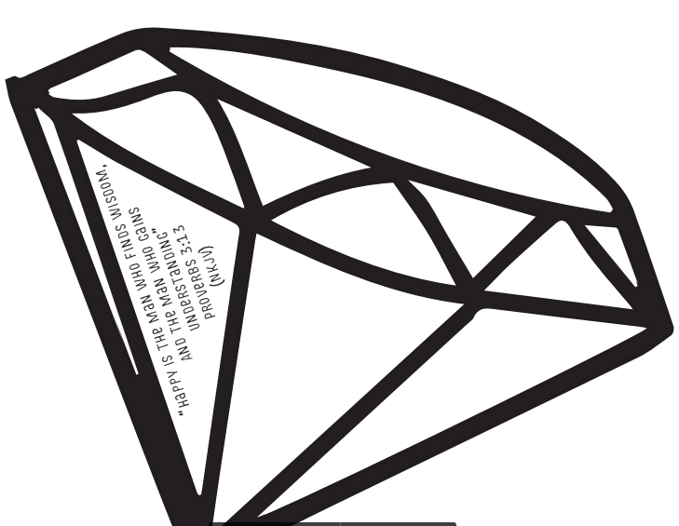
9.35 | Memory Verse  “TRUST IN THE LORD WITH ALL YOUR HEART; DO NOT DEPEND ON YOUR OWN UNDERSTANDING. SEEK HIS WILL IN ALL YOU DO, AND HE WILL SHOW YOU WHICH PATH TO TAKE.” PROVERBS 3:5-6 (NLT)  BIG WORD SONG- https://vimeo.com/553274930/5195d585ef
9.45 | Lesson  Lesson Video - https://vimeo.com/553273557/5ae4d4dec9  Extra videos to choose from  - https://drive.google.com/file/d/1WsQv3yQBjasRDR94lw3WxqBm4GKEAmVe/view?usp=sharing  - https://youtu.be/5dfMVW1UhW8  - https://youtu.be/R7cD_MLJ-ss  Summary  If you could ask for anything in the entire universe and it would be given to you, what would you ask for? A never ending tub of choc chip fudge ice cream? A waterslide in your back yard? 25 puppy dogs? I might ask for a shiny new red sports car and 25 puppy dogs!  In the Old Testament we read that God appeared to Solomon and said to him, “Ask for whatever you want and I’ll give it to you”. At that moment Solomon could have asked for ANYTHING, he could have asked God for fame and riches. He could have asked for a long life or the death of his enemies. What did he ask for? Wisdom!  2 Chronicles 1:9-10 (NIV) “You have made me king over a people who are as numerous as the dust of the earth. Give me wisdom and knowledge, that I may lead this people, for who is able to govern this great people of yours?”  God gave Solomon wisdom in abundance and because Solomon asked only for wisdom and not wealth and fame, God granted him wealth and fame also. Solomon needed wisdom to lead God’s people and make good decisions. God may not tell us exactly what to do in every situation or make our decisions for us, but with wisdom we can make good choices. We are wise to ask God for wisdom, and He will give it to us.
NA QUESTION
1. Who did we learn about today?
King Solomon. King Solomon was one of David’s sons and became the wisest king to ever live. The book of Proverbs in the Bible is a collection of wise sayings, written by king Solomon.

2. What did Solomon ask God for?
Wisdom! God gave Solomon so much wisdom and because Solomon asked only for wisdom and didn’t ask for wealth and fame, God granted him wealth and fame also. Solomon needed wisdom to lead God’s people and make good decisions.

3. Where can we find wisdom?
We can ask God for wisdom! We find wisdom in God’s Word. The book of Proverbs was penned by the wise king Solomon, who has gone before us on the journey of life.
LCNA – Colouring sheet
optional craft :
Crown template printed for each child from print material files. Jewel coloured stickers, pencils, stapler, staples, scissors.
Purpose: Make a crown to remember that wisdom is valuable, king Solomon asked God for wisdom and we can too!
10.40 | Check Out  - Make sure the children collect all belongings and journal books  - Leader to fill up debrief form after service:  http://tiny.cc/8pactz
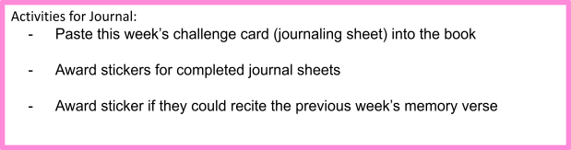

PACK UP CHECK LIST
- Clean out rubbish from tables and floor. (Dispose leftover drinks/coffee/food)
- Neatly store stationery and craft materials back into storage boxes
- Pack up check-in tablet and printer
- Turn off TV/Screens/Sound/Mics
- Rearrange tables in the room (Move it back)
- Inform Kids Pastor or Coordinator if there are any incidents.
- Team Leader to fill up feedback form. (http://tiny.cc/8pactz)

Coloring sheet
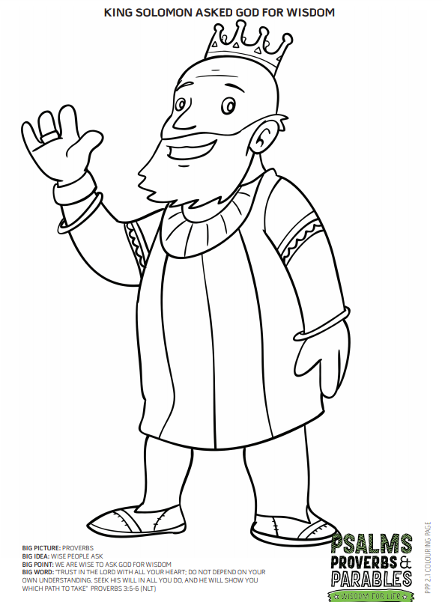

Extra activity for Noah’s Ark:
