LESSON PLAN 1.4 The Lost Things– J Club Newmarket

Date: | 23/05/2021
Memory verse: | “and we know that the Son of God has come, and He has given us understanding so that we can know the true God.” 1 John 5:20a (NLT)
Big Idea: | THE LOST THINGS
Big Point: | I HAVE BEEN FOUND BY GOD
4M Values: | Mission  To bring our friends and family into the Kingdom of God and celebrate when they do
Learning outcomes: | At the conclusion of this lesson children will:  - Discover the parables of the lost sheep, lost coin and lost son.  - Know that we have been found by God.  - Learn that when someone finds Jesus we should celebrate!
Influencers:

7:30am | Prayer, Set up and lesson run through

SETUP CHECK LIST
- Setup tables and chairs in the room
- Setup the check-in tables and printer outside the room
- Mic/Sound/Video setup and test
- Turn on music during check-in for pumped atmosphere.
- Craft/Activities/Games resource and props check.
- Journaling sheets & books
- Check class/area for safety and security measures.
- Remove items that are not meant to be there.

Time | Activity | Influencers
8.15 | Check in:  - Prep extra tab for newcomers’ sign up  - Collect kids’ journal and pile them according to their respective classes.
8.50 | - Welcome kids and newcomers  - Recap the 3Ls (Listen, Learn & Love)
9.00 | Worship:  Ask Seek Knock  Kindly choose 2 more songs
9.15 | Thanksgiving

Object Lesson
Take a look at these images and see if you can find what is lost in each picture.

(Show image 1.) Can you see the ant in all the snails ?
Show image 2.) Can you see the fish in all the starfish?
(Show image 3.) Can you see the lollipop in all the keys ?
To find each of the lost things in these pictures we had to search to find them. Without Jesus we are all lost. We are like a sheep going our own way lost and apart from our shepherd. Isaiah 53:6 (NIV) “We all, like sheep, have gone astray, each of us has turned to our own way; and the Lord has laid on him the iniquity of us all.” We are found in Christ. Through Jesus we are no longer lost! The three parables Jesus told about the lost things show us that we can be found. God searches after people and when one who was lost is found, there is a celebration like no other! Luke 15:10 (CEV) “Jesus said, “In the same way God’s angels are happy when even one person turns to him.” I have been found by God.

9.20 | Game (suggestion)-  Supplies Needed: 2 pairs of mittens, individually wrapped candy?  Candy Relay - Divide your small group into two equal teams and have them form lines. Give the first child in each line a pair of mittens and give everyone a wrapped candy. When you say “Go” the first player in each line puts on the mittens, unwraps the candy and puts the candy in another bowl. Then they quickly take the mittens off and pass them to the next player in the line. The first team to have each player unwrap a candy while wearing mittens are the winners.  Or  Scavenger Hunt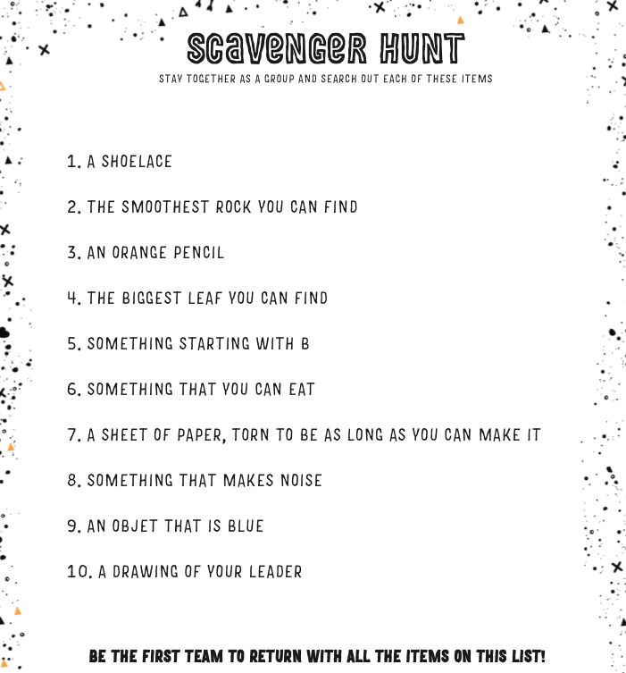  Purpose: To remind the children that we have been found by God.  Directions: Give the children a Scavenger Hunt page and set them the challenge to find each of the items on the list. Set clear boundaries for safe areas to search and ensure children are well supervised.  Explanation: Jesus told three parables about lost things. The lost sheep, the lost coin and the lost son. In each of these stories, something or someone very valuable and important was lost. Jesus said, Luke 15:4 (NIV) “Suppose a shepherd has a hundred sheep and loses one of them. Won’t he leave the ninety-nine in the open field while he goes in search of the lost sheep until he finds it? You and I are a bit like lost sheep but through Christ we are found. I have been found by God.
9.35 | “and we know that the Son of God has come, and He has given us understanding so that we can know the true God.” 1 John 5:20a (NLT)  Come up with actions and repeat the Bible Verse a few times with the children (BIG WORD SONG- https://vimeo.com/539406042/ade8929156)
9.45 | Lesson:  Lesson Video - https://vimeo.com/548259309/816e0c590d  Extra video - https://vimeo.com/548259055/7c614eab3f  Summary  1. The Lost Things.  How do you feel when you lose something really valuable and important to you? I know when I’ve lost my car keys, I search high and low. I check every drawer in the kitchen, I check behind the couch cushions. I make everyone in my family help me! I empty every bag I’ve ever used and every pocket of the jeans I wear. I even check in the refrigerator and under my bed. I don’t give up until I’ve found those keys. Without my car keys, I can’t use the car! When I do find them, I’m so happy! I do a happy dance! (Do a quick happy dance.)  Jesus told three parables about lost things. The lost sheep, the lost coin and the lost son. In each of these stories, something or someone very valuable and important was lost. Jesus said, Luke 15:4 (NIV) “Suppose a shepherd has a hundred sheep and loses one of them, won’t he leave the ninety-nine in the open field while he goes in search of the lost sheep until he finds it?” You and I are a bit like lost sheep. At one time we have all been lost and away from God. Isaiah 53:6 (NIV) “We all, like sheep, have gone astray, each of us has turned to our own way; and the Lord has laid on him the iniquity of us all.”  When the man in Jesus’ story finds his lost sheep, he has great joy! He calls his friends together to celebrate! Jesus said, Luke 15:7 (NIRV) “I tell you, it will be the same in heaven. There will be great joy when one sinner turns away from sin. Yes, there will be more joy than for 99 godly people who do not need to turn away from their sins.” There’s a party in heaven when a lost person is found. God searches for the lost. He knows us by name and wants to bring us home. John 10:3 (NIV) “The gatekeeper opens the gate for him, and the sheep listen to his voice. He calls his own sheep by name and leads them out.”  2. Be Found.  In 1997 there was a devastating landslide at the famous Australian ski field, Thredbo. In the landslide a hotel collapsed. After two days of searching for people in the wreckage, the rescue team were doing one last check of the site. The rescue team called out, “Can anyone hear us? Is anyone there?”  A little voice whispered back; “I can hear you.” This little whisper belonged to a man named Stuart. It took a whole day to rescue Stuart from below three huge concrete slabs. Stuart had been lying there, in cold melting snow for almost three full days. The rescuers worked hard to find Stuart and rescue him. When he was carried out of the wreckage still alive, people all over Australia who had been watching their televisions cried with happiness and cheered because a man who was lost had been found.  God does not give up when lost people need to be found. He loves every person so much, that though they are lost from Him, He has rescued them. Romans 5:8 (NIV) “But God demonstrates his own love for us in this: While we were still sinners, Christ died for us.”  Jesus put it like this, in His second parable about lost things; Luke 15:8-10 (NIRV) “Suppose a woman has ten silver coins and loses one. Won’t she light a lamp and sweep the house? Won’t she search carefully until she finds the coin? And when she finds it, she will call her friends and neighbours together. She will say, ‘Be joyful with me. I have found my lost coin.’ I tell you, it is the same in heaven. There is joy in heaven over one sinner who turns away from sin.” We have been found by God. God searches after those who are lost from Him. He wants to find them and celebrate!  3. Celebrate!  Jesus didn’t hang out with the VIP’s of the day. He spent time with all kinds of people. This cheesed off the religious leaders a whole lot. They grumbled, “He takes in sinners and eats meals with them, treating them like old friends.” That’s why Jesus told the parables of the lost sheep, lost coin and lost son. Jesus was showing them that when lost people are found, we should celebrate!
CONNECT TIME / Ice-breaker
Have you ever lost something really important? How did you feel when you found it?
Discussion Questions:
1. Why do you think Jesus told three stories about lost things?
Each of the stories Jesus told about the lost things had the same elements; something or someone was lost then they were found. Each story ends with a celebration! Jesus told these stories to show that there is a celebration when the lost are found!
2. How are we lost and now found?
Without Jesus we are all lost and separated from God. We are like a sheep going our own way lost and apart from our shepherd. Isaiah 53:6 (NIV) “We all, like sheep, have gone astray, each of us has turned to our own way; and the Lord has laid on him the iniquity of us all.” We are found in Christ. Through Jesus we are no longer lost! The three parables Jesus told about the lost things show us that we can be found. God searches after people and when one who was lost is found, there is a celebration like no other! Luke 15:10 (CEV) “Jesus said, ‘In the same way God’s angels are happy when even one person turns to him.’” I have been found by God.
3. How should we respond when someone who was lost is found?
With these parables Jesus was making His point to the pious religious men who were angry about the kind of people Jesus was spending time with. He finished the story of the lost son like this; Luke 15:31-32 (NIV) “‘My son,’ the father said,‘you are always with me, and everything I have is yours. But we had to celebrate and be glad, because this brother of yours was dead and is alive again; he was lost and is found.’” At times, you and I might be like that older brother. The attitude Jesus would want us to have is one of celebration! When a lost person is found, we should be over the moon with excitement. What was lost is now found! I have been found by God.
Activity Sheets

10.40 | Check Out  - Make sure the children collect all belongings and journal books  - Leader to fill up debrief form after service:  http://tiny.cc/8pactz

PACK UP CHECK LIST
- Clean out rubbish from tables and floor. (Dispose leftover drinks/coffee/food)
- Neatly store stationery and craft materials back into storage boxes
- Pack up check-in tablet and printer
- Turn off TV/Screens/Sound/Mics
- Rearrange tables in the room (Move it back)
- Inform Kids Pastor or Coordinator if there are any incidents.
- Team Leader to fill up feedback form. (http://tiny.cc/8pactz)

Activity sheets
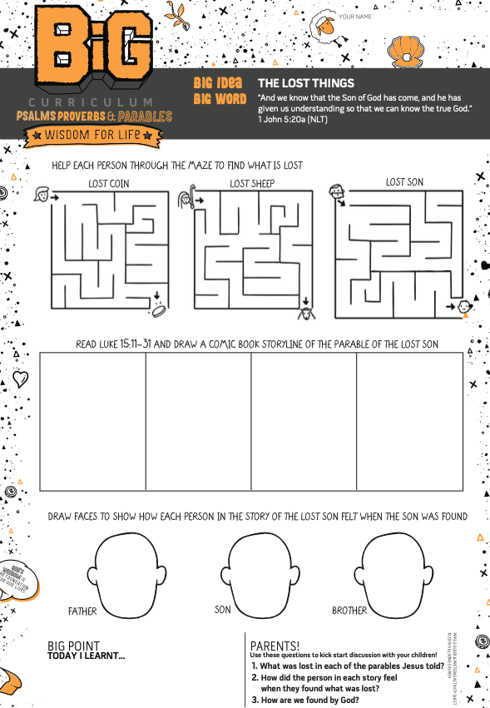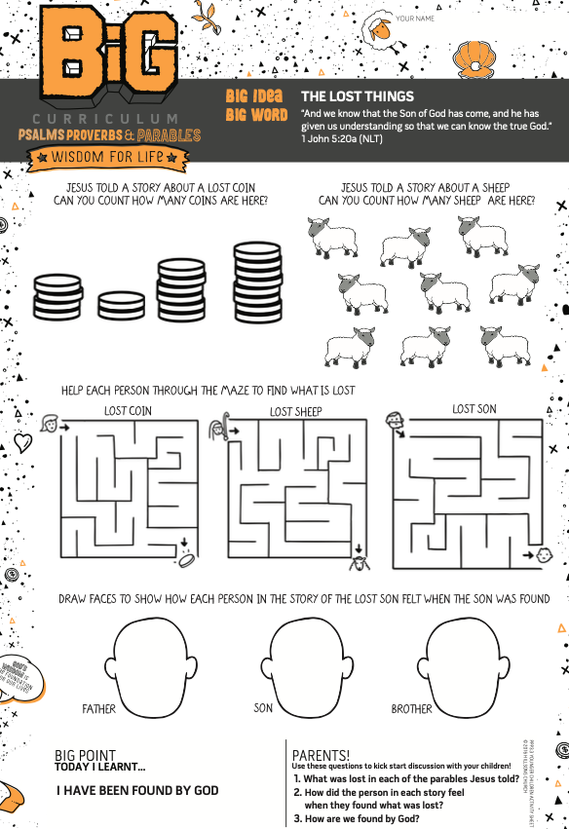

Challenge Cards
- To be attached separately

