LESSON PLAN 2.1 Wise People Ask – Southside

Date: | 30/05/2021
Memory verse: | “TRUST IN THE LORD WITH ALL YOUR HEART; DO NOT DEPEND ON YOUR OWN UNDERSTANDING. SEEK HIS WILL IN ALL YOU DO, AND HE WILL SHOW YOU WHICH PATH TO TAKE.” PROVERBS 3:5-6 (NLT)
Big Idea: | Wise people ask
Big Point: | WE ARE WISE TO ASK GOD FOR WISDOM
4M Values: | Ministry Equipping  To instill in the children from a young age that the Book of Proverbs has a wealth of wisdom that is available and to ask God for wisdom for He will grant it to us
Learning outcomes: | At the conclusion of this lesson children will:  - Discover that God gives us wisdom when we ask for it.  - Understand that there are great benefits to wisdom.  - Learn that Solomon, one of the wisest kings in the Bible, asked God for wisdom.
Influencers:

SETUP CHECK LIST
- Setup tables and chairs in the new room
- Setup the check-in tables and printer outside the room
- Mic/Sound/Video setup and test
- Turn on music during check-in for pumped atmosphere.
- Craft/Activities/Games resource and props check.
- Journaling sheets & books
- Check class/area for safety and security measures.
- Remove items that are not meant to be there.

Today at a glance

Time | Activity | Influencers
7:30am | Prayer, Set up and lesson run through
8.15 | Check in:  - Collect kids’ journal  - To make a list of children names in the class and put a tick if they completed journaling sheets for that week
8.50 | - Welcome kids and newcomers  - Recap the 3Ls (Listen, Learn & Love)
9.00 | Worship - Kindly choose 3 songs  (Some Suggestions):  - Rainbow https://www.youtube.com/watch?v=_dQZ2Sb1GPI  Actions: https://www.youtube.com/watch?v=uZU7plvu2aQ&ab_channel=HillsongKidsHillsongKids  -Ask Seek Knock
9.15 | Thanksgiving

9.20 | Snack:  Sanitize hands before eating  Play this video for J Club :  - https://drive.google.com/file/d/1WsQv3yQBjasRDR94lw3WxqBm4GKEAmVe/view?usp=sharing  - https://www.youtube.com/watch?v=mQF9ptJXF3Q (optional)
INTRO
Supplies Needed: Put Wisdom instruction cards supplied in print material files into a PowerPoint https://drive.google.com/file/d/1hBMQp8bHtmzjBzJRbpX6IOMccnL2ix1C/view?usp=sharing

Psalms, Proverbs, Parables - Wisdom for life. We’re going to learn all about the book of Proverbs. What is a proverb? A proverb is a short saying that gives you wisdom for life. The book of Proverbs in the Bible is a collection of these wise sayings, written by King Solomon. King Solomon was one of David’s sons. He was known as the wisest king to ever live.

I’m going to read some of these wisdom instruction cards, I need you to tell me if these things are wise to do, or not wise. If you think it is a wise instruction I want you to show me a big thumbs up. (Practice thumbs up action.) If you think the instruction is not wise, I want you to give me a big thumbs down. (Practice thumbs down action.)

1. “Walk with wise people and become wise. A companion of foolish people suffers harm.” Proverbs 13:20 (NIRV) (Thumbs up)
2. “Above all else, guard your heart, for everything you do flows from it.” Proverbs 4:23 (NIV) (Thumbs up)
3. “Run very far without tying your shoelaces.” (Thumbs down)
4. “My son, do not forget my teaching, but keep my commands in your heart.” Proverbs 3:1 (NIV) (Thumbs up)
5. “See ice in the water, and swim anyway!” (Thumbs down)
9.20 | Game  Supplies Needed:‘Wisdom Jewels’ printed on bright coloured paper from the print material files, scissors, tape.  Before the lesson, print the ‘Wisdom Jewels’ on bright coloured paper, cut them out and tape them to walls or objects, hiding them around the room. Read this verse about wisdom from Proverbs 2:4 (NIRV) “Look for it as you would look for silver. Search for it as you would search for hidden treasure.”  God’s wisdom is so valuable that the Bible says we should search for it as if it were hidden treasure! Let’s go on a treasure hunt around this room and see if we can find wisdom hidden!  When children have found all the hidden ‘Wisdom Jewels’ around the room, place them all in a pile and read the wise proverbs written on each one.  NA will have 3 types of diamonds shown in file:  https://drive.google.com/file/d/1tViDI9SJHSJqKKLM7lypHG7lXvHwb1GI/view?usp=sharing  example:  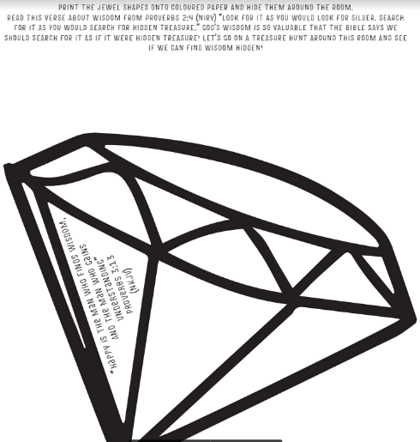
9.35 | “TRUST IN THE LORD WITH ALL YOUR HEART; DO NOT DEPEND ON YOUR OWN UNDERSTANDING. SEEK HIS WILL IN ALL YOU DO, AND HE WILL SHOW YOU WHICH PATH TO TAKE.” PROVERBS 3:5-6 (NLT)  BIG WORD SONG- https://vimeo.com/553274930/5195d585ef
9.45 | Lesson  Lesson Video - https://vimeo.com/536649879/bf3ee6c689  Extra videos to choose from  - https://drive.google.com/file/d/1WsQv3yQBjasRDR94lw3WxqBm4GKEAmVe/view?usp=sharing  - https://youtu.be/5dfMVW1UhW8  - https://youtu.be/R7cD_MLJ-ss  Summary  If you could ask for anything in the entire universe and it would be given to you, what would you ask for? A never ending tub of choc chip fudge ice cream? A waterslide in your back yard? 25 puppy dogs? I might ask for a shiny new red sports car and 25 puppy dogs!  In the Old Testament we read that God appeared to Solomon and said to him, “Ask for whatever you want and I’ll give it to you”. At that moment Solomon could have asked for ANYTHING, he could have asked God for fame and riches. He could have asked for a long life or the death of his enemies. What did he ask for? Wisdom!  2 Chronicles 1:9-10 (NIV) “You have made me king over a people who are as numerous as the dust of the earth. Give me wisdom and knowledge, that I may lead this people, for who is able to govern this great people of yours?”  God gave Solomon wisdom in abundance and because Solomon asked only for wisdom and not wealth and fame, God granted him wealth and fame also. Solomon needed wisdom to lead God’s people and make good decisions. God may not tell us exactly what to do in every situation or make our decisions for us, but with wisdom we can make good choices. We are wise to ask God for wisdom, and He will give it to us.
J Club Discussion Questions
1. Do you think there is a difference between being smart and having wisdom?

You might think of being smart as having a high IQ. IQ stands for intelligence quotient, it’s a score designed to show how smart someone is based on some standard tests. While someone may have a high IQ they may not have wisdom.

2. Why is wisdom so valuable?

A life following God’s wisdom brings us (from Proverbs 3:13-4:20) happiness, long life, riches and honour, peace, safety, a stumble-free walk, a worry free life, sweet sleep, protection, confidence, healing and health. Wisdom is described as being more valuable than silver, gold and precious ruby stones. Proverbs 3:14-15 (NKJV) “For her proceeds are better than the profits of silver, And her gain than fine gold. She is more precious than rubies, And all the things you may desire cannot compare with her.”

3. How can we have wisdom?

We can ask God for wisdom! We find wisdom in God’s word. The book of Proverbs was penned by the wise king Solomon, who has gone before us on the journey of life. Here’s what you’ll find in the book of Proverbs: Proverbs 1:2-7 (CEV) “Proverbs will teach you wisdom and self-control and how to understand sayings with deep meanings. You will learn what is right and honest and fair. From these, an ordinary person can learn to be smart, and young people can gain knowledge and good sense. If you are already wise, you will become even wiser. And if you are smart, you will learn to understand proverbs and sayings, as well as words of wisdom and all kinds of riddles. Respect and obey the Lord! This is the beginning of knowledge. Only a fool rejects wisdom and good advice. If there is wisdom available to me, I want to take hold of it and learn all I can. God’s wisdom shows us the way, keeps us safe and shows us how we can live the best life we can.”

LCNA – Colouring sheet & craft (optional)
Crown template printed for each child from print material files. Jewel coloured stickers, pencils, stapler, staples, scissors.
Purpose: Make a crown to remember that wisdom is valuable, king Solomon asked God for wisdom and we can too!

J Club - Activity Sheets
10.40 | Check Out  - Make sure the children collect all belongings and journal books  - Leader to fill up debrief form after service:  http://tiny.cc/8pactz
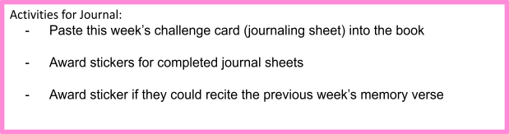

PACK UP CHECK LIST
- Clean out rubbish from tables and floor. (Dispose leftover drinks/coffee/food)
- Neatly store stationery and craft materials back into storage boxes
- Pack up check-in tablet and printer
- Turn off TV/Screens/Sound/Mics
- Rearrange tables in the room (Move it back)
- Inform Kids Pastor or Coordinator if there are any incidents.
- Team Leader to fill up feedback form. (http://tiny.cc/8pactz)

LCNA Coloring sheet
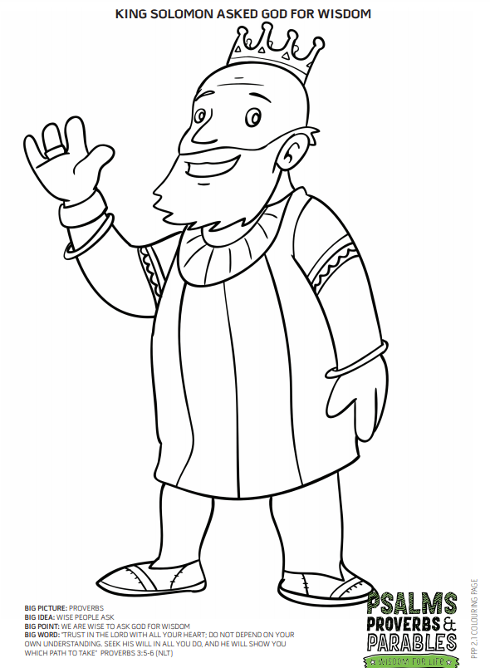

Extra activity for Noah’s Ark & JClub:

