13 June 2021 LESSON PLAN 2.3– Southside
Proverbs: Wise Words
Big Point | We are wise when we know the power of our words.
Memory Verse | “TRUST IN THE LORD WITH ALL YOUR HEART; DO NOT DEPEND ON YOUR OWN UNDERSTANDING. SEEK HIS WILL IN ALL YOU DO, AND HE WILL SHOW YOU WHICH PATH TO TAKE.” PROVERBS 3:5-6 (NLT)
4 M Values | Ministry Equipping: We have to follow God’s guidelines to be wise to build others up with our words.  Missions: Words are powerful, with our words we can tell the world and lead others to Christ.
Learning Outcomes | At the conclusion of this lesson children will:  - Know that our tongue has the power of life or death.  - Understand that we are wise when we know the power of our words.  - Discover that Solomon shared wise words in the book of Proverbs.
Influencers

SETUP CHECK LIST
- Setup the check-in tables and printer outside the room
- Mic/Sound/Video setup and test
- Craft/Activities/Games resource and props check.
- Journaling sheets & handouts
- Check class/area for safety and security measures.
- Remove items that are not meant to be there.

Today at a glance

Time | Activity | Influencers
7:30am | Prayer, Set up and lesson run through
8.30 | Check in:  - Collect kids’ journal  - To make a list of children names in the class and put a tick if they completed journaling sheets for that week
8.50 | - Welcome kids and newcomers  - Recap the 3Ls (Listen, Learn & Love)  - Introduce the Big Point
9.00 | Worship - Guide children through three praise and worship songs.  1. Voices of Freedom – Hillsong kids https://www.youtube.com/watch?v=XQsJ8uAT1gk  2.  3.
9.15 | Thanksgiving  Ask the children what they are thankful for. Invite a child to pray

9.20 | Snack:  Sanitize hands before eating. Invite a child to bless the food  Play this video for J Club : https://vimeo.com/554993338/560af938bf
9.35 | Game: Taste Test  **Leaders note: be aware of children’s food allergies and make the solutions weaker than you would for an adult or older child.  Supplies needed: 4 Plastic cups or containers numbered 1 through 4, water, salt, sprite, lemon juice, tonic water.  Cup number 1 Salt Taste: Salty water.  Cup number 2 Sweet Taste: Sugary water/ lemonade.  Cup number 3 Sour Taste: Lemon juice.  Cup number 4 Bitter Taste: Tonic water.  Plastic spoons (4 per child).  Directions: Using plastic spoons, children can scoop up some liquid from each cup (once the spoon has been in their mouth, they can dispose of it and use a fresh spoon for the next cup). After tasting each one, children can say if they think it is salty, sweet, sour or bitter.  When everyone has completed their taste test, let them know the correct answers.  Explanation: The human tongue has on average 3,000 - 10,000 taste buds. There are five elements that the tongue can taste: salty, sour, bitter, sweet, and savoury.  The tongue is the strongest muscle in the entire body. However, it is at the same time, one of the most sensitive muscles as well. The tongue is more important than we think. Not only does it help us to taste food but also helps to talk, to spit and to swallow. God’s Word shows us that the tongue is so powerful it has the power of life and death. Proverbs 18:21 (NIRV) “Your tongue has the power of life and death.” We can tear down and destroy with our words or we can build up and bring life with our words. We are wise when we know the power of our words.
9.50 | Intro/Object Lesson  Prepare 2 plants - one slightly wilting, another green and healthy  We’ve got some great indoor plants in our house. They’re lush and green and stand in pots. Here’s the thing, if I left them alone and ignored them, they would soon droop, dry up and die. To keep them growing and flourishing, I need to water them!  When I forget to give it some water, it literally looks like this (Show plant, drop shoulders and droop head. Encourage children to do the action with you.). Then I pour a glass of fresh water in the pot and slowly the leaves lift up and it stands up straight (stand up  straight, shoulders back, head up. Encourage children to do the action with you.) and begin to look more like this plant! (Show plant.) Alive, well, fit and flourishing!  The Bible says that our words are powerful. If someone depended on your words for nourishment, would they flourish or starve? Like that plant, a person who is discouraged (droop shoulders and head. Encourage the children to do the action with you) needs nourishment. They need to be encouraged! (stand up straight,  shoulders back, head up. Encourage children to do the action with you.) Wise king Solomon wrote in Proverbs 18:21 (NIRV) “Your tongue has the power of life and death.” Our words can bring life to others, they can be like water to dry soil. Think about people that you know, do you speak words that nourish them and help them grow?
10.00 | Read Memory Verse together:  “TRUST IN THE LORD WITH ALL YOUR HEART; DO NOT DEPEND ON YOUR OWN UNDERSTANDING. SEEK HIS WILL IN ALL YOU DO, AND HE WILL SHOW YOU WHICH PATH TO TAKE.” PROVERBS 3:5-6 (NLT)  Play BIG WORD SONG- https://vimeo.com/553274930/5195d585ef
10.05 | Lesson  Play Big story https://vimeo.com/557447552/de080e85e4 or  Big Message Jr. video: https://vimeo.com/557450894/b1af2cffc4  Solomon knew the power of words and the power of prayer. He spoke words of great wisdom that we read in the book of Proverbs. Proverbs 18:21 (NIV) “The tongue has the power of life and death, and those who love it will eat its fruit.” We are wise when we know the power of our words. God’s Word gives us wisdom for life.  King Solomon spoke about how important our words are.  Kind words are like honey. Honey is sweet and it’s yummy on toast. Honey is also really good for our bodies! When you have a cold or a sore throat you can make a warm drink with honey and it reduces pain and swelling. The sweet nectar of honey is loaded in antioxidants that help our brain and make our memory better. Honey is an excellent source of all-natural energy and it even helps us sleep better! Honey can even disinfect and treat burns or wounds.  Wise king Solomon knew how good honey was, he says in Proverbs 16:23-24 (NIRV) “The hearts of wise people guide their mouths. Their words make people want to learn more. Kind words are like honey. They are sweet to the spirit and bring healing to the body.” Kind words taste great, they bring comfort to the sick and healing to wounds. Kind words give life and energy to others and put their worries at ease. We are wise when we know the power of our words.  Q: Can you think of any kind words you can say to others?  (optional extra video: “Kid President’s 20 things we should say more often” - https://www.youtube.com/watch?v=m5yCOSHeYn4 )
10.20 | Discussion Groups – J Club  Optional to play “The Power of Words (James 3)” with tabs– Jhttps://www.youtube.com/watch?v=HdCUg6o5MGE Or  Big Message Live: https://vimeo.com/557449989/c0ddea16d4  Questions:  1. What did Solomon say about the power of words?  Read together from Proverbs 16:23-24 and Proverbs 18:21.  Proverbs 16:23-24 (NIRV) “The hearts of wise people guide their mouths. Their words make people want to learn more. Kind words are like honey. They are sweet to the spirit and bring healing to the body.”  Proverbs 18:21 (NIRV) “Your tongue has the power of life and death.”  2. Why are our words so powerful?  Our words are powerful, they can build up or tear down. Our words set us on course, they may seem small but they are very powerful. James 3:4-5 (NIRV) “How about ships? They are very big. They are driven along by strong winds. But they are steered by a very small rudder. It makes them go where the captain wants to go. In the same way, the tongue is a small part of a person’s body. But it talks big.” Our tongue and the words we speak, direct our path. We are wise when we know the power of our words.  3. How can we be wise with our words?  We can use our words to encourage others and build them up. We can use our words to tell people about God. If someone depended on your words for nourishment would they flourish or starve? Like that plant that needs water and nourishment, a person who is discouraged needs nourishment too. They need to be encouraged! Wise king Solomon wrote in Proverbs 18:21 (NIRV) “Your tongue has the power of life and death.” Our words can bring life to others, they can be like water to dry soil. Think about people that you know, do you speak words that nourish them and help them grow?  Quick Summary of lesson.  Solomon valued wisdom, he valued it above riches and fame. Solomon could have asked God for anything in the whole world and God would have given it to him. Solomon asked God for wisdom. Solomon wrote the book of Proverbs to pass on this vast wisdom to others.  Solomon had wise sayings about the power of words. Our words are powerful, they can build up or tear down. We can use our words to encourage others and build them up. We can use our words to tell people about God.  Close in prayer  - Activity Sheets  - Challenge Cards pasted into books  - Award stickers for previous week’s challenge card.
LCNA – Colouring sheet
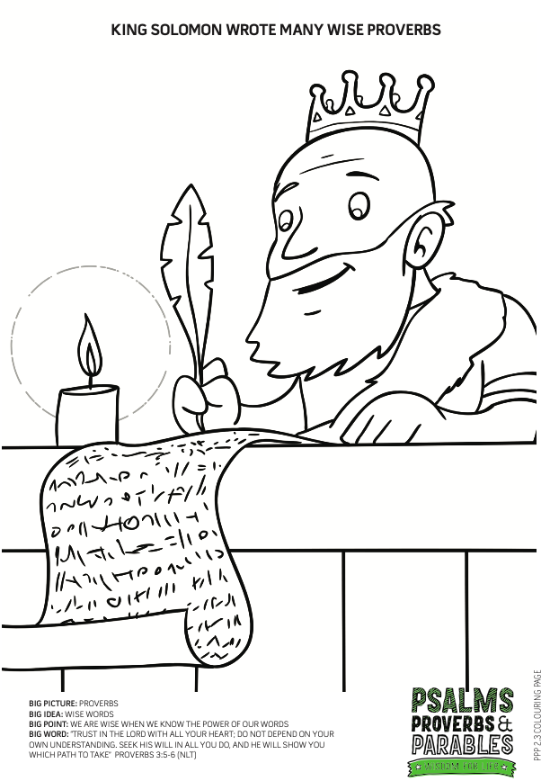

NA Discussion Questions:
1. What types of words do you like to hear the most?
We like to hear kind, gracious, nice words. We like to hear words that encourage us and make us happy!
I also like to hear words like “chocolate” or “ice cream”!
2. Why did Solomon say that kind words are like honey?
Because honey is sweet and is good for the body. Kind words are like honey. Wise king Solomon knew how good honey was, he says in Proverbs 16:23-24 (NIRV) “The hearts of wise people guide their mouths. Their words make people want to learn more. Kind words are like honey. They are sweet to the spirit and bring healing to the body.” Kind words taste great, they bring comfort to the sick and healing to wounds. Kind words give life and energy to others and put their worries at ease. We are wise when we know the power of our words.
3. How can we be wise with our words?
We can use our words to encourage others and build them up. We can use our words to tell people about God. If someone depended on your words for nourishment, would they flourish or starve? Like that plant that needs water and nourishment, a person who is discouraged needs nourishment too. They need to be encouraged! Wise king Solomon wrote in Proverbs 18:21 (NIRV) “Your tongue has the power of life and death.” Our words can bring life to others, they can be like water to dry soil. Think about people that you know, do you speak words that nourish them and help them grow?
Additional colouring sheet
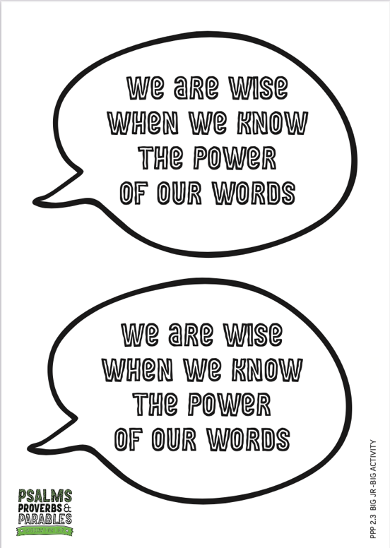
10.40 | Check Out  - Make sure the children collect all belongings and journal books  - Leader to fill up debrief form after service:  http://tiny.cc/8pactz

PACK UP CHECK LIST
- Clean out rubbish from tables and floor. (Dispose leftover drinks/coffee/food)
- Neatly store stationery and craft materials back into storage boxes
- Pack up check-in tablet and printer
- Turn off TV/Screens/Sound/Mics
- Rearrange tables in the room (Move it back)
- Inform Kids Pastor or Coordinator if there are any incidents.
- Team Leader to fill up feedback form. (http://tiny.cc/8pactz)

