20 June 2021 LESSON PLAN PR Part 1– Southside
Date: | 20th June 2021
Title: | Peer Relationships Part 1 – Love Everyone
Memory verse: | Matthew 5:44  “…Love your enemies. Pray for those who hurt you.”
Bible story: | Romans
Big Idea: | People come in all shapes, sizes and personality
Big Point: | Love everyone because God loves you
4M Values: | Miracles (Prayer can turn animosity into friendship)  Ministry Equipping (Develop patience understanding and love for others is a step towards serving God in his ministry.)  Multicultural (We need to know about other cultures so we can understand them better and share Jesus with them without accidentally insulting them.)
Learning outcomes: | At the conclusion of this lesson, children will know that:  - Even those who are mean to us need our love and compassion.  - We need to love and be kind to everyone
Influencers:
Location: | ICC Southside

SETUP CHECK LIST
- Setup the check-in tables and printer outside the room
- Mic/Sound/Video setup and test
- Craft/Activities/Games resource and props check.
- Journaling sheets & handouts
- Check class/area for safety and security measures.
- Remove items that are not meant to be there.

Today at a glance
Time | Activity | Influencers
8.30 | Check in:  - Prep extra tab for newcomers’ sign up  - Collect kids’ journals and pile them according to their respective classes.
9.10 | - Welcome kids and newcomers  - Recap the 3Ls (Listen, Learn & Love)  - Introduce Topic - Share big point
9.15 | Worship:  - Every Move I Make  https://www.youtube.com/watch?v=MPvnZILn6EY  Team leader chooses another 2 songs.  another suggestion:  https://www.youtube.com/watch?v=LYlkcoAfLU4  motion - https://www.youtube.com/watch?v=xaGTmbLkC5g
9.30 | Thanksgiving. Invite a child to pray.

9.35 | Snack:  Sanitize hands before eating. Invite a child to pray for the food.
9.50 | Game: A Great Wind Blows  To start – Form a circle around the class.  Influencers says: “Blow wind Blow”  Kids reply: “ Blow what?”  Influencers: chooses a physical trait/ a hobby or a preference of food, colour, books , television show… eg “ Blow those who have long hair”  Kids with long hair have to switch positions  Highlight that this game shows us how similar or different each of us can be. Not everyone is the same or likes the same things. Those differences if not understood or respected makes it difficult to form friendships or accept each other.
10.05 | Object Lesson  - Get a few types of balls into the class. Eg. Baseball, Basketball, ping pong ball, soccer ball  First, ask the children to name the games that these balls are used in.  Then, explain that these are all balls but they all function differently and the games are also played differently.  Therefore, friends may also come in all shapes, sizes and personality. Some may prefer to play soccer, some basketball, etc.
10.10 | Memory Verse: “…Love your enemies. Pray for those who hurt you.” Matthew 4:44 (NIRV)  Influencer to learn action beforehand.  - Refer to:  https://open.life.church/items/199721-teaching-segment-mp4  (Verse actions @ 11:23 – 11:35)  - Teach the kids the verse with the actions.  - Repeat it a few times with them.
10.15 | Introduce the lesson video:  Romans  Tell the kids that the bible teachers us a lot of things. It’s one of the ways God uses to guide us to make good choices. Let them know that today, they are about to hear the story from the bible about how to be a good friend and how to know the person you meet is a good friend because God wants us to find good friends and also be a good friend to others.  Lesson Video  https://www.youtube.com/watch?v=vLYzxRxwigw  https://www.youtube.com/watch?v=pZ2hRq-ei0U  Recap/summarise story. Highlight the important things to remember. Just choose 3 points below for emphasise:  - Love others (from the heart)  - Run from evil  - Hold on with all of your might to do what is good  - Be good friends  - Practice putting others first  - Don’t be lazy but be enthusiastic and cheerful when you serve Jesus with a glad heart.  - Be ready to help.  - When things get hard, keep going… Don’t give up. Pray even harder  - Laugh and cry with them  - Friends with everybody  - Be nice and say kind things  - Be someone people can count on no matter what  - Don’t let evil get the best of you, instead overcome evil with good.  Teacher to write down each point on an A4 paper in as big a print as you can.  Draw 2 columns on a PowerPoint (How I should be a friend) & (the qualities I look for in a friend). Someone to type it in:  Get the kids to read out the cards and on which column that they think it should go.  The objective/conclusion is: the realisation that the qualities the bible says that we should be to be a good friend is also what they should look for in their good friend.  Keep them on the screen for the children to refer to during their craft activity.
10.25 | Prayer
10.30 | Craft : Friendship card  Create a friendship card for a friend. Choose a quality or 2 from the board to tell them how you appreciate it. Eg. “Dear x, thank you for laughing and crying with me always. You are a good friend. From y”  (* Little Cherubs will need help with the writing – influencer to write for them their choice of quality)  Craft items:  - Blank cards and envelopes  - Stickers for decorating  - Coloured pens/pencils  - Kids’ scissor (Noah’s Ark)  Extension for Noah’s Ark:  Group discussion: Explain that it was easy to write a friendship card to someone who they like and is nice to them. Ask the kids to think if it is just as easy to do it for someone who is mean to them.  Pick 2-3 discussion cards.  This group discussion will give them someone questions to think about and to talk about with an adult (influencer) and together, we’ll figure out what God wants us to do by looking and thinking about today’s lesson so far.  Discussion cards  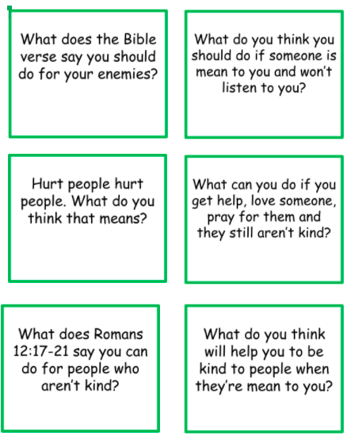
Small group discussion.

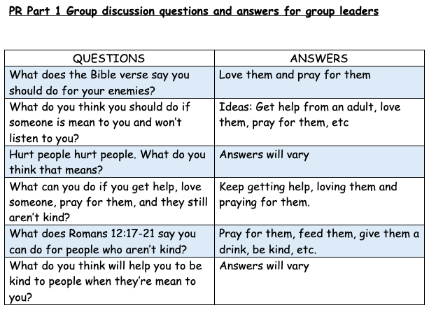
Go through questions during group discussion
- Group facilitators share a friendship that they had.
- Pick 2-3 questions to discuss
- Group facilitators try to extend and encourage thoughtful thinking.
Prayer (still in small groups):
- Ask kids to share things they’d like to pray about.
- Pray together over their prayer requests.

Additional Craft (optional):
Friendship card

Create a friendship card for a friend. Choose a quality or 2 and write to tell them how you appreciate it. Eg. “Dear x, thank you for laughing and crying with me always. You are a good friend. From y”

Explain that it was easy to write a friendship card to someone who they like and is nice to them. Ask the kids to think if it is just as easy to do it for someone who is mean to them.

Craft items:
- Blank cards and envelopes
- Stickers for decorating
- Coloured pens/pencils
- Kids’ scissor

10.45 | Check Out  Remember snack bag, journal and today’s craft activity.  - Remind the kids about earning their stickers by returning their journal next week with their activities completed.  - When a child leaves and if an opportunity presents itself, say something positive and specific to their family.  - Encourage families to do the journal activities together.

