Date: | 27^{h} June 2021
Title: | Peer Relationships Part 2 – How to Make Friends
Level/Class | J Club
Memory verse: | Proverbs 12:26 (NLT)  The Godly give good advice to their friends, the wicked lead them astray.
Bible story: | Matthew 7
Big Idea: | Treasure friends who give good advice but beware of those that lead you astray.
Big Point: | Be choosy when you’re choosing best friends
4M Values: | Mission (Know the right way to make friends so we can take God to many nations)  Ministry Equipping (Know the bible and spend time with God so we can give good Godly advice when needed and we are sensitive to the Holy Spirit guiding us)  Multicultural (How we choose friends is not about culture, the colour of their skin or what they have but by their words and actions)
Learning outcomes: | At the conclusion of this lesson, children will be able to:  - Understand how to be a good friend  - Identify qualities of a good friend  - Be patient when looking for a friend
Influencers:
Location: | ICC Newmarket
LESSON PLAN (J Club)

7:45am | Set up and lesson run through (Team Leader)

Today at a glance

Time | Activity | Influencers
8.30 | Check in:  - Prep extra tab for newcomers’ sign up.  - Collect kids’ journal and pile them according to their respective classes.
9.10 | - Welcome kids and newcomers  - Recap the 3Ls (Listen, Learn & Love)
9.15 | Worship:  - Every Move I Make  https://www.youtube.com/watch?v=MPvnZILn6EY  Team leader chooses another 2 songs.
9.30 | Thanksgiving

9.35 | Game: Good fruit, bad fruit (Appendix 1)  To start – kids form a straight line facing the team leader/influencer who will be reading out the “fruit”. Form as many rows as needed. Make sure that each kid leaves a 2 step space between the kid in front and the kid behind.  - Read “fruit” in any order you wish.  - Kids take 1 step towards you when you read out a good fruit.  - Kids take 2 steps away from you when you read out a bad fruit.  Highlight that this game shows us 2 things to think about:  - We are able to identify what is good fruit and bad fruit therefore, we should be able to identify them in our friends or the people we meet.  - However, sometimes we still don’t choose wisely. Why do you think that is? It is something they can think about and take that to their group leaders or an adult they respect to discuss further if they so wish.
9.50 | Introduce bible verse: “The Godly give good advice to their friends, the wicked lead them astray” – Proverbs 12:26 (NLT)  Influencer to learn actions beforehand.  - Refer to:  https://open.life.church/items/199725-teaching-segment-mp4  (Verse actions @ 10:23 – 10:43)  - Teach the kids the verse with the actions.  - Repeat it a few times with them.
10:00 | Lesson video (14 minutes 22 seconds):  https://open.life.church/items/199725-teaching-segment-mp4  Infer before playing the video:  From the memory verse today and the game we played, what do you think the video will be about?  Tell the kids that before you play the video there may be a few questions they may what to keep in their mind.  - Why is it important to choose good friends?  - What are the qualities you should look for?  - Should you also have those qualities?  - How does Matthew chapter 7 help you to identify a good friend?  Play video…  Pause at the 8:30 minute mark:  How do you figure out that someone is a good friend?  Resume playing the video…  Pause at the 9:50 minute mark:  Can you identify the dos and don’ts of making friends?  Dos – respect the other person  - Ask them about themselves  - Really listen to what they have to say  Don’t’s – don’t talk only about yourself  - Don’t brag or try too hard to be funny  - Don’t boss them around  Resume playing the video…  Pause at the 11:43 minute mark:  Jeff realised that he did something that didn’t make him such a good friend. What was it? And why was it bad?  Resume playing video to the end…  Recap/summarise story.  Reinforce big point – be choosy when you’re choosing your best friend.  Remember to look for the good fruit and also to practice having those qualities too.  Tell them that next, they are going into their discussion groups and they will continue to do a discussion on the topic.  Divide kids to smaller groups for discussion. Preferably according to similar age groups.
Object Lesson: Identify a Good Friend
3 Jars
1 Main jar -empty
1 Jar with clean water and 1 jar with dirty water (a few drops of food colouring).

Steps
- Fill the main jar with the water from the good friend.
- Say how your good friend can build you up.
- Then fill the main jar with the bad friend.
- Say how when you choose the bad friend jar, you will learn to do bad things as well and you can become dirty.
- So ask them what kind of friend that they want to choose.
10.30 | Small group discussion.  Prep: Print 4/5 sets of Appendixes 2 & 2a (1 set for each small group). Cut out the cards (Appendix 2a)  Appendix 2  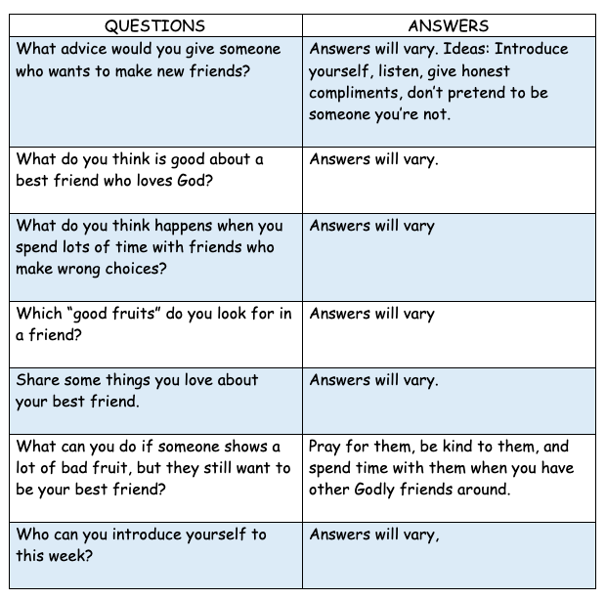  Appendix 2A  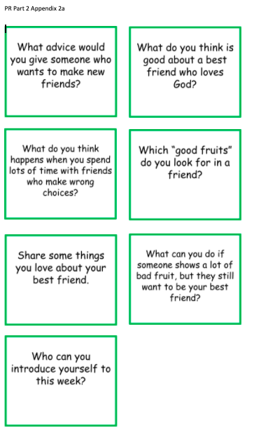  Go through question cards during group discussion  - Face question cards down.  - Students take turns to pick a card and read it out to the group.  - Any group member is encouraged to answer the question.
10.40 | Prayer (still in small groups):  - Ask kids to share things they’d like to pray about.  - Pray together over their prayer requests.  Pray this too: God, thank You for helping us be godly best friends and for helping us make new friends. In Jesus’ name, amen.  Optional Activity:  Design a bookmark that is personalised - one for you and another for your best friend. Below are examples:  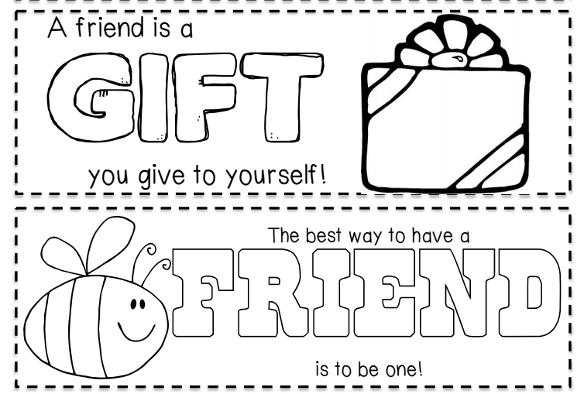
10.45 | Check Out  - Remind the kids about earning their stickers by returning their journal next week with their activities completed.  - When a child leaves and if an opportunity presents itself, say something positive and specific to their family.  - Encourage families to do the journal activities together.

Prep Work

Appendix 1
Print 2 copies for each class.

Appendix 2 & 2a
Print 1 set for each discussion group

Challenge Card
Print and cut 40 copies for JClub @ Newmarket

Colour papers, scissors, ribbons

Appendix 1

