Date: | 27th June 2021
Title: | Peer Relationships Part 2 – How to make friends
Level/Class | Little Cherub & Noah’s Ark
Memory verse: | Proverbs 12:26 (NLT)  “The Godly give good advice to their friends, the wicked lead them astray.”
Bible story: | Matthew 7
Big Idea: | Treasure friends who give good advice but beware of those that lead you astray.
Big Point: | Be choosy when you’re choosing best friends
4M Values: | Mission (Know the right way to make friends so we can take God to many nations)  Ministry Equipping (Know the bible and spend time with God so we can give good Godly advice when needed and we are sensitive to the Holy Spirit guiding us)  Multicultural (How we choose friends is not about culture, the colour of their skin or what they have but by their words and actions)
Learning outcomes: | At the conclusion of this lesson, children will be able to:  - Understand how to be a good friend  - Identify qualities of a good friend  - Be patient when looking for a friend
Influencers:
Location: | ICC Newmarket
LESSON PLAN (LCNA)

7:30am | Set up and lesson run through  SETUP CHECK LIST  ̈ Setup tables and chairs if needed  ̈ Setup the check-in tables and printer  ̈ Mic/Sound/Video setup and test  ̈ Turn on music during check-in for pumped atmosphere. ̈ Craft/Activities/Games resource and props check.  ̈ Journaling sheets & books  ̈ Check class/area for safety and security measures.  ̈ Remove items that are not meant to be there.  Gather to pray at 8:00am

Today at a glance

Time | Activity | Influencers
8.30 | Check in:  - Prep extra tab for newcomers’ sign up  - Collect kids’ journals and pile them according to their respective classes.
9.10 | - Welcome kids and newcomers  - Recap the 3Ls (Listen, Learn & Love)  - To highlight today’s big point
9.15 | Worship:  - Every Move I Make  https://www.youtube.com/watch?v=MPvnZILn6EY  Team leader chooses another 2 songs.
9.30 | Thanksgiving. Invite a child to pray.
Little Cherubs to their room (Red & Blue Room)
Noah’s Ark to stay on or use the yellow room

9.35 | Snack:  Sanitize hands before eating. Invite a child to bless the food.
9.50 | Game: Good fruit, bad fruit (Appendix 1)  LC: Use thumbs up or thumbs down to identify the good or bad fruit.  NA:  To start – kids form a straight line facing the team leader/influencer who will be reading out the “fruit”. Form as many rows as needed. Make sure that each kid leaves a 2 step space between the kid in front and the kid behind.  - Read “fruit” in any order you wish.  - Kids take 1 step towards you when you read out a good fruit.  - Kids take 2 steps away from you when you read out a bad fruit.  Highlight that this game shows us 2 things to think about:  - We are able to identify what is good fruit and bad fruit therefore, we should be able to identify them in our friends or the people we meet.  - However, sometimes we still don’t choose wisely. Why do you think that is? It is something they can think about and take that to their group leaders or an adult they respect to discuss further if they so wish.
Object Lesson: Identify a Good Friend
3 Jars
-1 Main jar that is empty
-1 Jar with clean water
-1 jar with dirty water (use a few drops of food colouring).

Steps
- Fill the main jar with the water from the good friend.
- Say how your good friend can build you up.
- Then fill the main jar with the bad friend.
- Say how when you choose the bad friend jar, you will learn to do bad things as well and you can become dirty.
- So ask them what kind of friend that they want to choose.
10.05 | Memory verse: “The Godly give good advice to their friends, the wicked lead them astray” – Proverbs 12:26 (NLT)  Influencer to learn action beforehand.  - Refer to:  https://open.life.church/items/199725-teaching-segment-mp4  (Verse actions @ 10:23 – 10:43)  - Teach the kids the verse with the actions.  - Repeat it a few times with them.
10.15 | Introduce the lesson video:  - Matthew 7  - Remind the kids that the bible teaches us a lot of things. It’s one of the ways God uses to guide us to make good choices. Let them know that today, they will hear another story from the bible about how they can know that someone can be a good friend and how some are not.  Lesson Video:  https://www.youtube.com/watch?v=6yE-1SoD5m8  Recap/summarise story.  - People are like trees. We can identify a tree by what comes out of it. Likewise, we can know of someone’s heart by their actions. Therefore, we can know of that someone is likely to lead us to make good choices or bad choices by looking at their actions and what they say.
10.25 | Prayer
10.30 | Craft : Bookmark for a good friend (Appendix 3)  Colour the bookmarks in.  Craft items:  - Appendix 3 (bookmark templates printed and cut out)  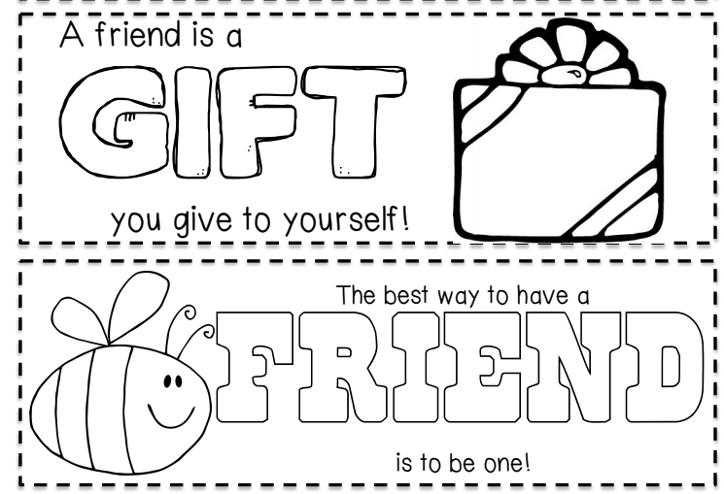  Extension for Noah’s Ark:  Group discussion.  Explain that in the discussion that they will be doing, they will explore more about friendships. The aim is to help them identify people that make good friends and also to guide us to make new friends appropriately. In addition to that, our discussion questions may also be able to help us navigate around “friends” that are not making good choices in their lives.  Discussion cards (Appendix 2 & 2a)  Appendix 2  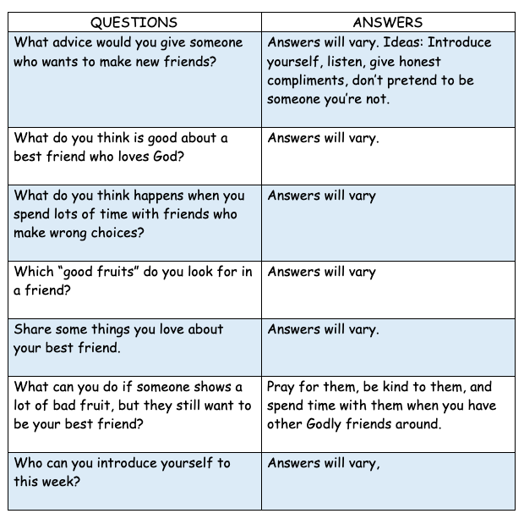  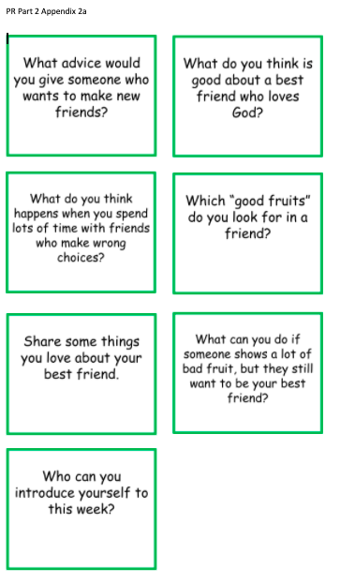  Feel free to pick 2-3 questions to discuss.
10.45 | Check Out  Remember snack bag, journal and today’s craft activity.

Prep work:

Appendix 1
Print 2 copies each for NA and LC

Appendix 2 & 2a
Print and cut out the cards. 1 set for each group (at least 2 sets)

Appendix 3
Print out bookmark templates for 50 pax
Other items needed: Laminator, laminating pouches, ribbons/coloured strings/knitting wool, colouring pen or pencils/crayons.

Challenge Card
Print and cut 50 copies for LCNA @ Newmarket

Appendix 1

