01 Aug 2021 LESSON PLAN Supernatural Part 2– Southside
Date: | 1st August 2021
Title: | Supernatural Part 2 – How to be powerful
Memory verse: | Romans 8:11(NIRV)  The Spirit of God who raised Jesus from the dead is living in you.
Bible story: | Fruit of the Spirit
Big Idea: | The Holy Spirit give us the power to live and love like Jesus
Big Point: | God’s Holy Spirit gives me power!
4M Values: | Mission (The Holy spirit gives us use to equip ourselves with the fruit of the spirit to help others)  Ministry Equipping (The fruit of the spirit that is manifested in us through the holy spirit equips us for when the time we are called into our specific ministry)  Multicultural (To love like Jesus will help us transcend cultural barriers)  Miracles (The power of the Holy Spirit in us helps us live like Jesus and like Jesus we can expect miracles in His name)
Learning outcomes: | At the conclusion of this lesson, children will know that:  - God’s Holy Spirit gives us power  - The Spirit of God lives in us  - The Holy Spirit helps us to live and love like Jesus
Influencers:
Location: | ICC Southside

7:30am | Set up and lesson run through  SETUP CHECK LIST  ̈ Setup tables and chairs  ̈ Setup the 2 check-in tablets and 1 printer  ̈ Mic/Sound/Video setup and test  ̈ Turn on music during check-in for pumped atmosphere. ̈ Craft/Activities/Games resource and props check.  ̈ Journaling sheets & books  ̈ Check class/area for safety and security measures.  ̈ Remove items that are not meant to be there.  Gather to pray at 8:00am  *Note: There is a weekly checklist for Challenge Cards  Leader will assign someone to go through all the Journal book and tick off on the list.

Today at a glance
Time | Activity | Influencers
8.30 | Check in:  - Prep extra tab for newcomers’ sign up  - Collect kids’ journals and pile them according to their respective classes.
9.10 | - Welcome kids and newcomers  - Recap the 3Ls (Listen, Learn & Love)  - Introduce Topic - Share big point
9.15 | Worship:  - There is Power in the blood  https://www.youtube.com/watch?v=ru9I8CCjs8U  Team/worship leader decides on the 3 songs.
9.30 | Thanksgiving.  Ask the children if they have anything they would like to thank God for.  Invite a child to pray.
9.35 | Object lesson:  Compare two types of food healthy (fruits) and unhealthy (cakes/crisps).  Ask the kids which would be better for their body to grow well and strong.  Relate it to the holy spirit helping us feed on the fruit of the spirit to help us to live like Jesus.  What are the fruit of the spirit and how does Jesus live? The story they are going to listen to will give us more information on that. Therefore, it’s important for them to listen.
9.40 | Snack:  Sanitize hands before eating. Invite a child to bless the food.  J Club to finish & go to room - 9.50am

Split into LCNA and J Club

LCNA
9.50 | Game: Frozen ninja  1. Stand in a circle  Say: For our game, I’ll tell you to do a ninja move without touching anyone else. When I say “Freeze!” you have to stop super still without moving.  - Say a ninja move from the suggested list below.  - Kids do the ninja move without touching others.  - Say, “Freeze” and kids freeze.  Say: You are trapped by my frozen super power! You cant get free until I say unfreeze.  - Say, “unfreeze” so kids can unfreeze.  - As time allows, repeat steps 2-5 with different ninja moves from the suggested list below.  Suggested ninja moves:  Ninja air kick  Ninja air punch  Ninja spin  Ninja dance  Ninja jump  Ninja air sword  Ninja sneak  Ninja whisper  Ninja block  Ninja air nunchucks  Ninja tree climb  Ninja throw  Ninja roll  Ninja stretch  Ninja crawl  Ninja pounce  Ninja smoke bomb  Ninja spy
10.05 | Introduce bible verse: “The Spirit of God who raised Jesus from the dead is living in you” – Romans 8:11 (NIRV)  Influencer to learn action beforehand.  - Refer to (Verse actions @ 12:24 – 12:43):  https://open.life.church/items/209311-teaching-segment-mp4  - Teach the kids the verse with the actions.  - Repeat it a few times with them.
10.15 | Object lesson:  Compare two types of food: healthy (fruits) and unhealthy (cakes/crisps).  Ask the kids which would be better for their body to grow well and strong.  Relate it to the holy spirit helping us feed on the fruit of the spirit to help us to live like Jesus.  What are the fruit of the spirit and how does Jesus live? The story they are going to listen to will give us more information on that. Therefore, it’s important for them to listen. | E
10.30 | Introduce the lesson video:  - Fruit of the spirit:  https://www.youtube.com/watch?v=TZrlDT3k84U  Remind the kids that the bible teaches us a lot of things. It’s one of the ways God uses to guide us to make good choices. Let them know that today, they will hear another story from the bible about how they can live and love more like Jesus our ultimate superhero because He saved us from our sins.  Lesson Video: (Start from 5:12 – 8:54)  https://open.life.church/items/209311-teaching-segment-mp4  Recap/summarise story.  - From the story we know that because of sin, humans, no matter how hard they try to do good and help people, their sinful spirit will still make it difficult to do the right thing all the time. However, God had a rescue plan in Jesus. Jesus was the new human and when he died on the cross for our sins, we are forgiven and can be like him if we accept him as our saviour. When we do that, the Holy Spirit helps us develop fruits of the spirit that will help us live and love like Jesus.  - Your craft activity will show you a list of the fruit of the spirit that you can grow and develop. | (Little Cherubs – 2 to 4 yr olds)  (Noah’s Ark 5-7 yrs old)
Craft : Fruit of the spirit colouring sheet

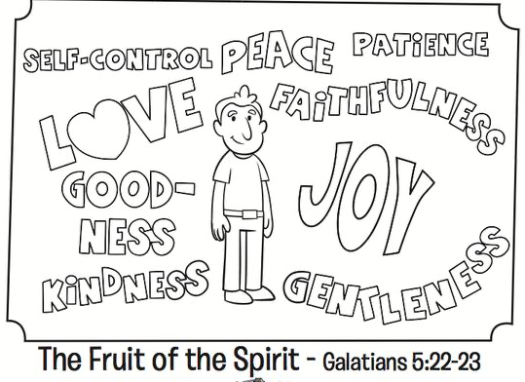

Extension for Noah’s Ark:
Group discussion.
Explain that in the discussion that they will be doing, they will explore more about the Holy Spirit and how it helps us.

Discussion cards (Appendix 2)

Questions | Answers
What do you think happens when we try to be powerful all on our own? | Answers will vary
What do you think happens when we use the power of the Holy Spirit? | Answers will vary
What do you wish you knew about the powers of the Holy Spirit? | Answers will vary
Share some was you think you can live by the power of the Holy Spirit. | Answers will vary.  Ideas: praying, using the gifts and talents HE gave us, letting Him grow the fruit of the Spirit in us, loving God and others as well, etc.
Talk about something that makes you feel weak, powerless, or makes you want to give up. | Answers will vary.
How do you think the power of the Holy Spirit can help you when you feel that way? | Answers will vary.
Idea to make it a little more fun. Number the cards, 1-6. Each child throws a dice and answer the question number that is on the dice.
Reward, good and constructive participation with a bonus sticker.
Prep: bring a die/dice

10.45 | Check Out  J Club comes back to the room.  Remember snack bag, journal and today’s craft activity.  You can play this video while waiting for parents:  https://www.youtube.com/watch?v=E2bhXAR1gCU

Extra activity for NA
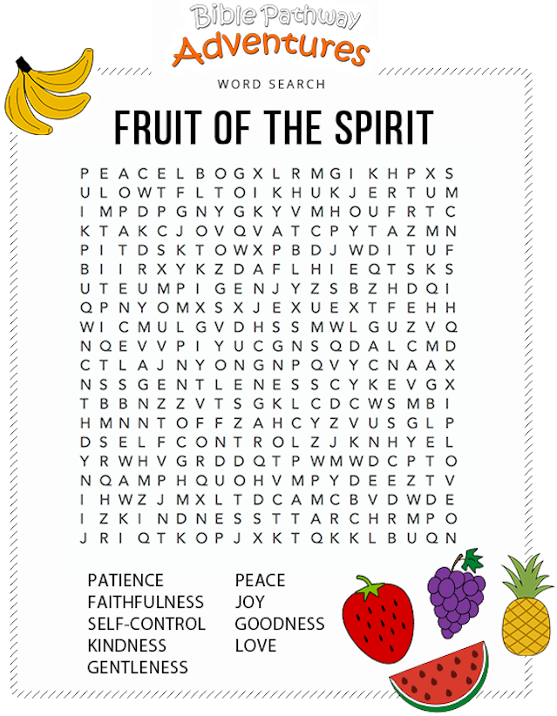

J Club
9.35 | Game: Spirit Bingo (smaller groups)  Items needed:  - Spirit bingo card set (set of 12 cards) Appendix 3  - Coloured pencils or pencils  Say: We’re going to play Bingo to see some ways the Holy Spirit gives us power.  How to play:  - Give each kid a Spirit Bingo card and a coloured pencil.  - Kids cross out or lightly shade the free space on their card.  - Read words one at a time in any order from the Spirit Bingo activity supplement (Appendix 4).  - Each time you read a word, pause to let kids search for it on their card, and shade or cross it out with their coloured pencil.  - Repeat steps 3 and 4 until 1 kid has shaded/crossed out four words in a row vertically, horizontally or diagonally.  - Play again if times allows and perhaps you it can be made more interesting by saying that the first 3 kids who gets bingo will get bonus stickers.
9.50 | Introduce bible verse: “The Spirit of God who raised Jesus from the dead is living in you” – Romans 8:11 (NIRV)  Influencer to learn action beforehand.  - Refer to (Verse actions @ 12:24 – 12:43):  https://open.life.church/items/209311-teaching-segment-mp4  - Teach the kids the verse with the actions.  Repeat it a few times with them.
10:00 | Lesson video (16 minutes 59 seconds):  https://open.life.church/items/209311-teaching-segment-mp4  Infer before playing the video:  From the memory verse today and the game we played, what do you think the video will be about?  Tell the kids that before you play the video there may be some questions they may what to keep in their mind.  - What powers do you think the Holy Spirit will give us?  - What are the fruits of the Spirit and why do we need them?  Play video…  Pause at the 8:54 minute mark:  Can you recall the fruits of the spirit that helps us to live and love like Jesus?  Answer: Love, joy, peace, kindness, patience, goodness, integrity, gentleness and self-control.  Resume playing the video…  Pause at the 9:37 minute mark:  - Why do you think the Holy Spirit give us spiritual gifts that shows the fruit of the spirit?  Idea: Care for everyone and everything in our lives God’s way.  Resume playing the video…  Pause at the 13:23 minute mark:  When we encounter a difficult situation and it’s hard for us to use or display the fruit of the spirit, God doesn’t expect us to do it in our own strength. He is with us and will help us.  How do you ask Him for help?  Resume playing video to the end…  Recap/summarise story.  Reinforce big point – God’s Holy Spirit give me power.  Tie in with lesson objectives.  Tell them that next, they are going into their discussion groups and they will continue to do a discussion on the topic.  Divide kids to smaller groups for discussion. Preferably according to similar age groups.
10.30 | Small group discussion  Group discussion.  Explain that in the discussion that they will be doing, they will explore more about the Holy Spirit and how it helps us.  Discussion cards (Appendix 2)  Questions Answers  What do you think happens when we try to be powerful all on our own? Answers will vary  What do you think happens when we use the power of the Holy Spirit? Answers will vary  What do you wish you knew about the powers of the Holy Spirit? Answers will vary  Share some was you think you can live by the power of the Holy Spirit. Answers will vary. Ideas: praying, using the gifts and talents HE gave us, letting Him grow the fruit of the Spirit in us, loving God and others as well, etc.  Talk about something that makes you feel weak, powerless, or makes you want to give up. Answers will vary.  How do you think the power of the Holy Spirit can help you when you feel that way? Answers will vary.  Idea to make it a little more fun. Number the cards, 1-6. Each child throws a die and answer the question number that is on the die.  Reward, good and constructive participation with a bonus sticker.
10.40 | Prayer (still in small groups):  - Ask kids to share things they’d like to pray about.  - Pray together over their prayer requests.  Pray this too: God, please teach us to rely on the power of Your Holy Spirit in everything we do. In Jesus’ name, amen.
10.45 | Check Out  - Remind the kids about earning their stickers by returning their journal next week with their activities completed.  - When a child leaves and if an opportunity presents itself, say something positive and specific to their family.  - Encourage families to do the journal activities together.

Appendix 2
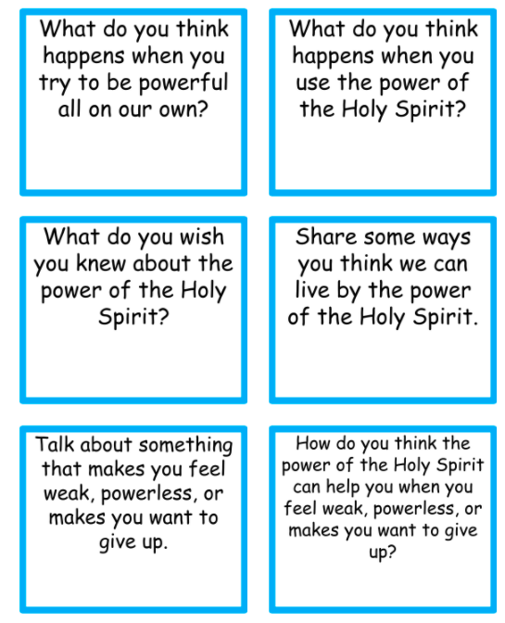

Appendix 3 (Total of 12 cards)

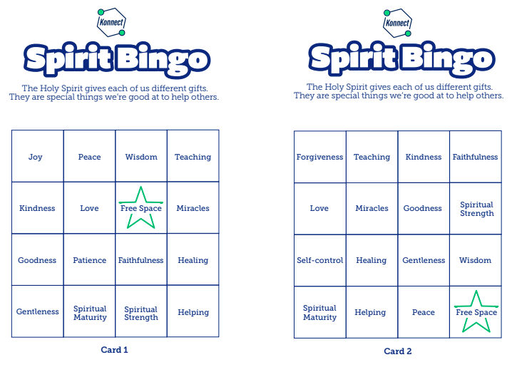

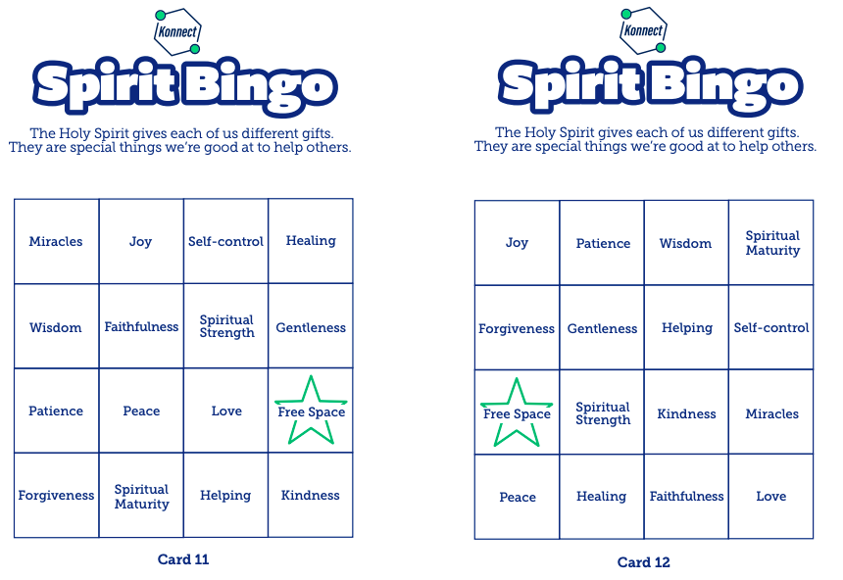

Appendix 4
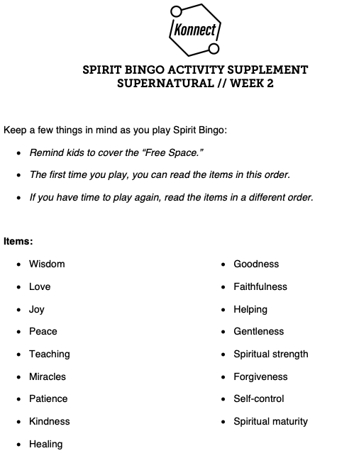

Extra Activity sheet for J Club
