18 July 2021 LESSON PLAN PR Part 3– Southside
Date: | 18th July 2021
Title: | Peer Relationships Part 3 – Who are my real friends?
Memory verse: | Proverbs 17:17 (NLT)  “A friend is always loyal, and a brother is born to help in time of need.”
Bible story: | Ruth and Naomi
Big Idea: | Friends be there for one another
Big Point: | Good friends are loyal.
4M Values: | Missions (We need loyal friends who will be with us and encourage us when we share Jesus with others.)  Ministry Equipping (It’s important to have someone who will work with you and encourage you in the difficult times in your ministry and vice versa)  Multicultural (A loyal friend can come in any shape or size or background.)
Learning outcomes: | At the conclusion of this lesson, children will know that:  - Good friends are loyal  - There are many ways to show loyalty  - Jesus is the perfect example of a loyal friend
Influencers:
Location: | ICC Southside

7:30am | Set up and lesson run through  SETUP CHECK LIST  ̈ Setup tables and chairs  ̈ Setup the 2 check-in tablets and 1 printer  ̈ Mic/Sound/Video setup and test  ̈ Turn on music during check-in for pumped atmosphere. ̈ Craft/Activities/Games resource and props check.  ̈ Journaling sheets & books  ̈ Check class/area for safety and security measures.  ̈ Remove items that are not meant to be there.  Gather to pray at 8:00am

Today at a glance
Time | Activity | Influencers
8.30 | Check in:  - Prep extra tab for newcomers’ sign up  - Collect kids’ journals and pile them according to their respective classes.
9.10 | - Welcome kids and newcomers  - Recap the 3Ls (Listen, Learn & Love)  - Introduce Topic - Share big point
9.15 | Worship:  - Every Move I Make  https://www.youtube.com/watch?v=MPvnZILn6EY  Team leader chooses another 2 songs.  2) another suggestion - Love One Another  https://www.youtube.com/watch?v=LYlkcoAfLU4  motion - https://www.youtube.com/watch?v=xaGTmbLkC5g
9.30 | Thanksgiving. Invite a child to pray.
9.35 | Object Lesson: Trust Fall  Demonstrate with a few teachers that ‘Friends be there for one another’  - catching a friend (being loyal)  - trusting your friends to also catch you (having faith)
9.40 | Snack:  Sanitize hands before eating. Invite a child to bless the food.  J Club to finish & go to room - 9.50am | Zoe, Emily, Ashleigh – help sanitizing of hands
Split into LCNA and J Club

LCNA
9.50 | Game: Loyalty Challenge (Appendix 1)  To start – group the kids in pairs.  Influencers reads out a loyalty challenge card (there are 3 cards)  Kids try to do the challenge.  Repeat with loyalty challenge card 2 and 3  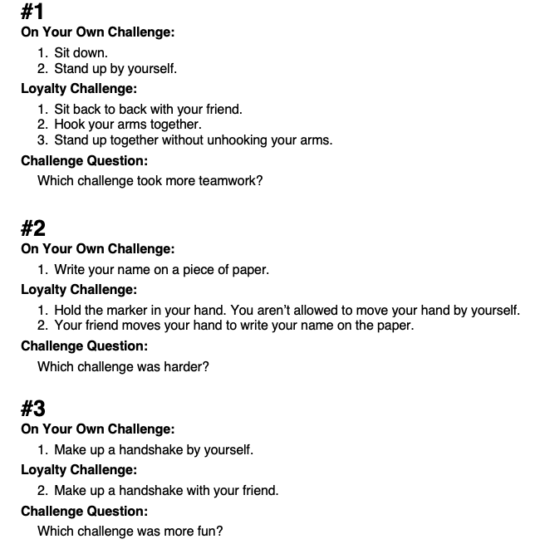  Highlight that this game shows us how sometimes, some things are easier done alone but when one does it with friend it can be harder but if they work together, it can be accomplished. Other times, it’s more fun doing something with a friend than doing it alone.
10.05 | Introduce bible verse: “A friend is always loyal, and a brother is born to help in time of need” – Proverbs 17:17 (NLT)  Influencer to learn actions beforehand.  - Refer to (Verse actions @ 7:15 – 7:31):  https://open.life.church/items/199729-teaching-segment-mp4  - Teach the kids the verse with the actions.  - Repeat it a few times with them.
10.15 | Introduce the lesson video:  - Ruth and Naomi  - Tell the kids that they are going to listen to a bible story about 2 women. Ask them to listen out for the women’s names. One of them was such a loyal friend. What did she do? How did God bless her for being loyal?  Lesson Video (go to Bible Story only @ 9:49 – 12:32):  https://open.life.church/items/199729-teaching-segment-mp4  Second video: https://www.youtube.com/watch?v=pyr3AyI7zVY  Recap/summarise story.  Ruth was a loyal daughter in-law. She listened to Naomi’s advice. Naomi and Ruth worked together and comforted each other when times were difficult. Ruth did not turn her back on Naomi because loyal friends stay together when times are tough.  God also blessed Ruth for being loyal. He made her the great grandmother of Israel’s greatest king, King David.
10.25 | Prayer  Pray this too: God, thank You for showing love and loyalty to us. Please help us show it to others. In Jesus’ name, amen.
10.30 | Craft : Colouring sheet  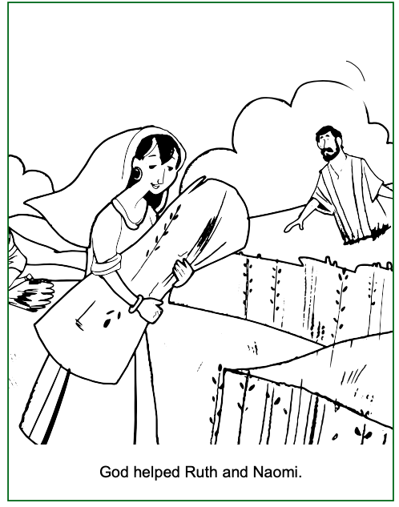  Extension for Noah’s Ark (Appendix 2 & 2a)  Explain that they will have a group discussion as an opportunity for them to explore further on the topic of friendship and loyalty – what they think and if they have had any personal experience to share.  Go through question cards during group discussion  - Face question cards down.  - Each child take turns to pick a card and read it out to the group.  - Feel free to focus on 3 questions only.
10.45 | Check Out  Remember snack bag, journal and today’s craft activity.

J Club
9.35 | Game: Loyalty Challenge (Appendix 1)  To start – group the kids in pairs.  Influencers reads out a loyalty challenge card (there are 3 cards)  You can create your own challenges to make it more challenging:  Eg. #4 blow up 5 balloons and tie them in a bunch  Highlight that this game shows us how sometimes, some things are easier done alone but when one does it with friend it can be harder but if they work together, it can be accomplished. Other times, it’s more fun doing something with a friend than doing it alone.
9.50 | Introduce bible verse: “A friend is always loyal, and a brother is born to help in time of need” – Proverbs 17:17 (NLT)  Influencer to learn actions beforehand.  - Refer to (Verse actions @ 7:15 – 7:31):  https://open.life.church/items/199729-teaching-segment-mp4  - Teach the kids the verse with the actions.  - Repeat it a few times with them.
10:00 | Lesson video (17 minutes 29 seconds):  https://open.life.church/items/199729-teaching-segment-mp4  Infer before playing the video:  From the memory verse today and the game we played, what do you think the video will be about?  Let them know that you will be pausing the video at certain parts for them to identify each point.  Play video…  Pause at the 5:59 minute mark:  Ask the kids if they noticed the difference between how Tony and Dot interacted and communicate with each other as compared to Harper and Jake? Which do they think is a better example of friendship?  *Point – Loyal friends listen to each other and work together  Resume playing the video…  Pause at the 8:00 minute mark:  What do they think is the next point here?  *Point - Loyal friends never turn their backs on the friends.  Who did Tony say was the perfect example of a loyal friend?  Resume playing the video…  Pause at the 14:52 minute mark:  What do they think is the point being made here?  *Point – Friends stay together even when times are tough.  Resume playing video to the end…  Recap/summarise story.  Reinforce big point - Good friends are loyal.  Something to ask the kids - Other than the 3 points mentioned when the videos were paused, today’s video also mention a few things we can do for our friends to show that we are loyal friends. What are they?  - Loyal friends look for ways to be there for their friends.  - Loyal friends provide a listening ear if their friends are sad or upset.  - Loyal friends are there for their friends if bad things are happening to them.  - Loyal friends forgive their friends if their friends have made a mistake or hurt them.  Finally, emphasise the fact that Jesus gave us the best example to follow.  Tell them that next, they are going into their discussion groups and they will continue to do a discussion on the topic of friendship and loyalty.  Divide kids to smaller groups for discussion. Preferably according to similar age groups.
10.30 | Small group discussion.  Prep: Print 4/5 sets of Appendixes 2 & 2a (1 set for each small group).  Go through question cards during group discussion (or you can choose to focus on a few)  - Face question cards down (preferably pick the black bordered cards first and then the red ones).  - Students take turns to pick a card and read it out to the group.  *Team leaders, feel free to come up with ideas that will make this more fun. ☺
10.40 | Prayer (still in small groups):  - Ask kids to share things they’d like to pray about.  - Pray together over their prayer requests.  Pray this too: God, thank You for showing love and loyalty to us. Please help us show it to others. In Jesus’ name, amen.
10.45 | Check Out  - Remind the kids about earning their stickers by returning their journal next week with their activities completed.  - When a child leaves and if an opportunity presents itself, say something positive and specific to their family.  - Encourage families to do the journal activities together.

Appendix 2

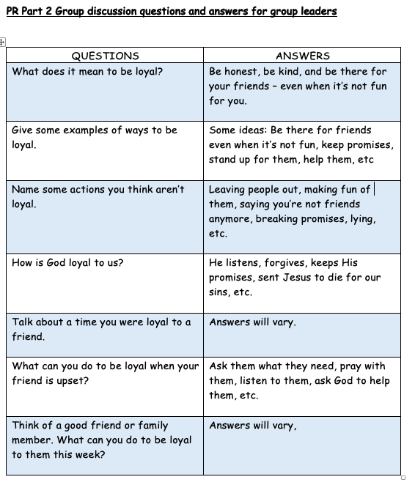

Appendix 2a
