25 July 2021 LESSON PLAN Supernatural Part 1– Southside
Date: | 25th July 2021
Title: | Supernatural Part 1 – Real Miracles
Level/Class | Little Cherub & Noah’s Ark
Memory verse: | Romans 8:28 (NIV)  … In all things, God works for the good of those who love him…
Bible story: | Genesis – Story of Joseph
Big Idea: | God can turn something simple/bad into something great/good
Big Point: | Jesus is working miracles everyday.
4M Values: | Mission - Share God’s gift of eternal life to everyone so they can experience His miracle too.  Miracles – God is a God of miracles
Learning outcomes: | At the conclusion of this lesson, children will know that:  - God is a god of miracles  - He can turn an evil situation into an opportunity for good  - He knows best as things may not work out as we want it to be
Location: | ICC Southside

7:30am | Set up and lesson run through  SETUP CHECK LIST  ̈ Setup tables and chairs  ̈ Setup the 2 check-in tablets and 1 printer  ̈ Mic/Sound/Video setup and test  ̈ Turn on music during check-in for pumped atmosphere. ̈ Craft/Activities/Games resource and props check.  ̈ Journaling sheets & books  ̈ Check class/area for safety and security measures.  ̈ Remove items that are not meant to be there.  Gather to pray at 8:00am  *Note: There is a weekly checklist for Challenge Cards  I will assign someone to go through all the Journal book and tick off on the list.

Today at a glance
Time | Activity | Influencers
8.30 | Check in:  - Prep extra tab for newcomers’ sign up  - Collect kids’ journals and pile them according to their respective classes.
9.10 | - Welcome kids and newcomers  - Recap the 3Ls (Listen, Learn & Love)  - Introduce Topic - Share big point
9.15 | Worship:  - There is Power in the blood  https://www.youtube.com/watch?v=ru9I8CCjs8U  - God of Miracles  https://www.youtube.com/watch?v=cy5eipa_7UU  Team/worship leader decides on the 3 songs.
9.30 | Thanksgiving. Invite a child to pray.  Ask the children if they have anything they would like to thank God for.
9.35 | Object lesson:  Use before or after pictures (or a real sample) to show how something that looks simple or bad can be transformed or moulded into something beautiful.  Eg: a lump of clay into a pot, a plain jar into a decorative vase, a broken telly into a fish tank, a messy run down room into a beautifully decorated room.  Low prep time: Use pictures  Higher prep: Get playdoh or clay to mould and make
9.40 | Snack:  Sanitize hands before eating. Invite a child to bless the food.  J Club to finish & go to room - 9.50am

Split into LCNA and J Club

LCNA
9.50 | Game: Master chef. (do these in smaller groups)  To Do: Create ingredients card (Appendix 3) by cutting on dotted lines of the activity sheet.  Say: Let’s show how a baker takes things that are kind of gross on their own and turn them into something tasty.  Acitivty:  - Pass cards out as evenly as possible and place chef’s hat upside down in the middle of the group. Kids don’t look at their cards yet.  - Each kid takes a turn…  - Flip over a card and show their ingredient(s)  - Describe what it’s like to eat it on its own  - Toss the ingredients into the baker’s hat  Say: A baker mixes ingredients to create something great kind of like how God miraculously works all the bad, good, and just okay things in our lives together for good. What do you think the ingredients in this hat will turn to?  - Let kids guess as you shake the hat to “mix” and “bake” the ingredients. Reveal that it’s a chocolate cake.  - If time allows, continue with an extension of the game.  Game extension:  - Each child contributes 1 ingredient. Team leader records it down on a white board.  - Put the kids in pairs and each pair will need to use some or all of the ingredients on the board to make something delicious.  Finally, present their ideas to their friends.
10.05 | Introduce bible verse: “…in all things God works for the good of those who love him…” Romans 8:28 (NIV)  Influencer to learn action beforehand.  - Refer to:  https://open.life.church/items/209318-teaching-segment-mp4  (Verse actions @ 13:14 – 13:30)  - Teach the kids the verse with the actions.  - Repeat it a few times with them.
10.15 | Introduce the lesson video:  - Genesis  - Remind the kids that the bible teaches us a lot of things. It’s one of the ways God uses to guide us to make good choices and to trust Him. Let them know that today, they will hear another story from the bible about how God turns a really bad situation into something good although it did take many years for it to be revealed.  Lesson Video:@ 4:48 – 8:57  https://open.life.church/items/209318-teaching-segment-mp4  Recap/summarise story.  - Joseph ended up in a very bad situation when he was sold as a slave. However, he trusted God and continued to believe in God and God turned his bad situation into good and at the end of the story, his good situation also helped saved his people. | E
10.30 | Craft : Decorate Joseph’s coat with craft materials (Appendix 1)  Additional – Colouring sheet NA (Appendix 1a)  Craft items:  - Glue/ sticky tape  - Coloured pencils/ crayons/ coloured pens  - Stickers  - Materials from resource cabinet  Joseph colouring sheet (Appendix 1)  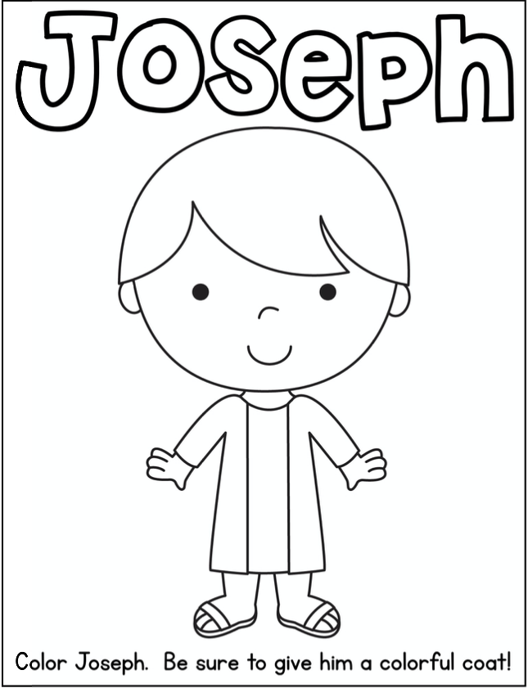  Extension for Noah’s Ark:  Group discussion.  Explain to the kids that they will be discussing about miracles. It’s an opportunity for them to find out more about it and also a good time to ask or reflect on it.  Discussion cards (Appendix 2)  Questions Answers  What do you think a miracle is? Answer will vary Idea: an unusual or a wonderful event caused by the power of God to bring glory to his name.  What is a miracle you are praying for right now? Answers will vary.  A baker can turn runny eggs and tasteless flour into something good: A delicious cake. What are some bad things God can turn into something good? Answers will vary.  Making a cake can take a long time. God taking bad things and making them into something good might take a long time too. What do you think can help you while you wait? Answers will vary  If bad things are happening, you’re worried, and you don’t know what to do, What do you think will help you? Answers will vary  When you see God work miracles right away, or if you’re waiting for a miracle, who do you want to talk to about it? Answers will vary | (Little Cherubs – 2 to 4 yr olds)  (Noah’s Ark 5-7 yrs old)
10.45 | Check Out  J Club comes back to the room.  Remember snack bag, journal and today’s craft activity.

J Club
9.35 | Game: Master chef. (do these in smaller groups)  To Do: Create ingredients card (Appendix 3) by cutting on dotted lines of the activity sheet.  Say: Let’s show how a baker takes things that are kind of gross on their own and turn them into something tasty.  Acitivty:  - Pass cards out as evenly as possible and place chef’s hat upside down in the middle of the group. Kids don’t look at their cards yet.  - Each kid takes a turn…  - Flip over a card and show their ingredient(s)  - Describe what it’s like to eat it on its own  - Toss the ingredients into the baker’s hat  Say: A baker mixes ingredients to create something great kind of like how God miraculously works all the bad, good, and just okay things in our lives together for good. What do you think the ingredients in this hat will turn to?  - Let kids guess as you shake the hat to “mix” and “bake” the ingredients. Reveal that it’s a chocolate cake.  - If time allows, continue with an extension of the game.  Game extension:  - Each child contributes 1 ingredient. Team leader records it down on a white board.  - Put the kids in pairs and each pair will need to use some or all of the ingredients on the board to make something delicious.  Finally, present their ideas to their friends.
9.50 | Introduce bible verse: “…in all things God works for the good of those who love him…” Romans 8:28 (NIV)  Influencer to learn action beforehand.  - Refer to:  https://open.life.church/items/209318-teaching-segment-mp4  (Verse actions @ 13:14 – 13:30)  - Teach the kids the verse with the actions.  - Repeat it a few times with them.
10:00 | Lesson video (18minutes 10seconds):  https://open.life.church/items/209318-teaching-segment-mp4  Infer before playing the video:  From the memory verse today and the game we played, what do you think the video will be about?  Team leader refer to the lesson objectives for guidance.  Play video…  Pause at the 8:30 minute mark:  How do you figure out that someone is a good friend?  Resume playing the video…  Pause @ 2:18 minute mark:  - Looking at Ethan’s problem, how do you think some people think about miracles?  Resume playing the video…  Pause @ 4:11 minute mark:  Can you recall the definition of a miracle?  Answer: It’s God showing His supernatural and incredible power to do something amazing in your life. Something that brings glory to God.  Resume playing video…  Pause @ 8:57 minute mark:  What does Joseph’s story show?  Idea: God can turn a bad situation into something good. God turned the horrible and bad situation Joseph was in into something good for Joseph and he became an instrument God used to safe the people of Israel from famine.  Resume playing video to the end…  Recap/summarise story.  Reinforce big point – Jesus is working miracles every day  Tell them that next, they are going into their discussion groups and they will continue to do a discussion on the topic.  Divide kids to smaller groups for discussion. Preferably according to similar age groups.
10.30 | Small group discussion.  Prep: Print 4/5 sets of Appendix 2 (1 set for each small group). Cut out the cards  Go through question cards during group discussion  - Face question cards down.  - Students take turns to pick a card and read it out to the group.  - Any group member is encouraged to answer the question.  Group discussion.  Explain to the kids that they will be discussing about miracles. It’s an opportunity for them to find out more about it and also a good time to ask or reflect on it.  Discussion cards (Appendix 2)  Questions Answers  What do you think a miracle is? Answer will vary Idea: an unusual or a wonderful event caused by the power of God to bring glory to his name.  What is a miracle you are praying for right now? Answers will vary.  A baker can turn runny eggs and tasteless flour into something good: A delicious cake. What are some bad things God can turn into something good? Answers will vary.  Making a cake can take a long time. God taking bad things and making them into something good might take a long time too. What do you think can help you while you wait? Answers will vary  If bad things are happening, you’re worried, and you don’t know what to do, What do you think will help you? Answers will vary  When you see God work miracles right away, or if you’re waiting for a miracle, who do you want to talk to about it? Answers will vary
10.40 | Prayer (still in small groups):  - Ask kids to share things they’d like to pray about.  - Pray together over their prayer requests.  Pray this too: God, thank You for showing love and loyalty to us. Please help us show it to others. In Jesus’ name, amen.
10.45 | Check Out  - Remind the kids about earning their stickers by returning their journal next week with their activities completed.  - When a child leaves and if an opportunity presents itself, say something positive and specific to their family.  - Encourage families to do the journal activities together.  Can play videos on Joseph while waiting for parents: https://www.youtube.com/watch?v=NQ7wLTBnF84

Game Cards

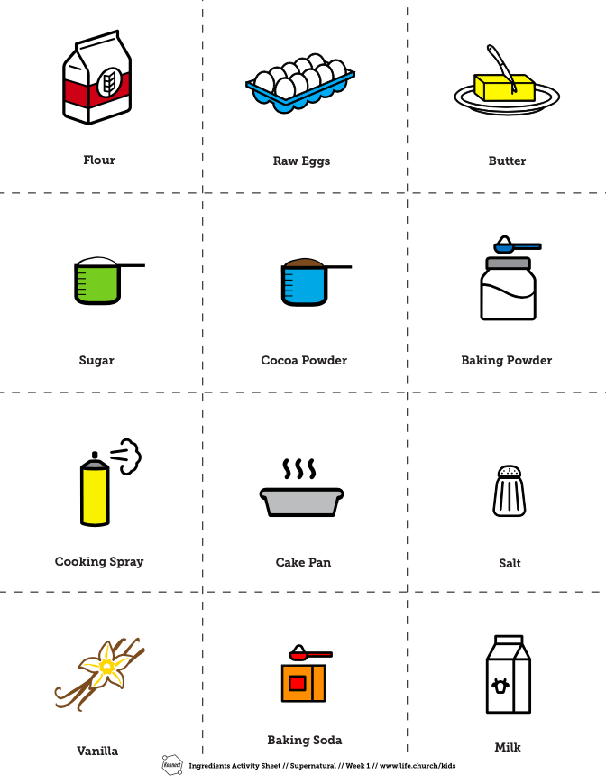

Appendix 1a – additional sheet for colouring
