Date: | 25th July 2021
Title: | Supernatural Part 1 – Real Miracles
Level/Class | Little Cherub & Noah’s Ark
Memory verse: | Romans 8:28 (NIV)  … In all things, God works for the good of those who love him…
Bible story: | Genesis – Story of Joseph
Big Idea: | God can turn something simple/bad into something great/good
Big Point: | Jesus is working miracles everyday.
4M Values: | Mission - Share God’s gift of eternal life to everyone so they can experience His miracle too.  Miracles – God is a God of miracles
Learning outcomes: | At the conclusion of this lesson, children will know that:  - God is a god of miracles  - He can turn an evil situation into an opportunity for good  - He knows best as things may not work out as we want it to be
Influencers:
Location: | ICC Newmarket
LESSON PLAN (LCNA)

7:30am | Set up and lesson run through  SETUP CHECK LIST  ̈ Setup tables and chairs if needed  ̈ Setup the check-in tables and printer  ̈ Mic/Sound/Video setup and test  ̈ Turn on music during check-in for pumped atmosphere. ̈ Craft/Activities/Games resource and props check.  ̈ Journaling sheets & books  ̈ Check class/area for safety and security measures.  ̈ Remove items that are not meant to be there.  Gather to pray at 8:00am

Today at a glance

Time | Activity | Influencers
8.30 | Check in:  - Prep extra tab for newcomers’ sign up  - Collect kids’ journals and pile them according to their respective classes.
9.10 | - Welcome kids and newcomers  - Recap the 3Ls (Listen, Learn & Love)
9.15 | Worship:  - There is Power in the blood  https://www.youtube.com/watch?v=ru9I8CCjs8U  - God of Miracles  https://www.youtube.com/watch?v=cy5eipa_7UU  Team/worship leader decides on the 3 songs.
9.30 | Thanksgiving
Little Cherubs to their room (Red & Blue Room)
Noah’s Ark to stay on or use the yellow room

9.35 | Snack:  Sanitize hands before eating
9.50 | Game: Master chef. (do these in smaller groups)  To Do: Create ingredients card (Appendix 3) by cutting on dotted lines of the activity sheet.  Say: Let’s show how a baker takes things that are kind of gross on their own and turn them into something tasty.  Acitivty:  - Pass cards out as evenly as possible and place chef’s hat upside down in the middle of the group. Kids don’t look at their cards yet.  - Each kid takes a turn…  - Flip over a card and show their ingredient(s)  - Describe what it’s like to eat it on its own  - Toss the ingredients into the baker’s hat  Say: A baker mixes ingredients to create something great kind of like how God miraculously works all the bad, good, and just okay things in our lives together for good. What do you think the ingredients in this hat will turn to?  - Let kids guess as you shake the hat to “mix” and “bake” the ingredients. Reveal that it’s a chocolate cake.  - If time allows, continue with an extension of the game.  Game extension:  - Each child contributes 1 ingredient. Team leader records it down on a white board.  - Put the kids in pairs and each pair will need to use some or all of the ingredients on the board to make something delicious.  - Finally, present their ideas to their friends.
10.05 | Introduce bible verse: “…in all things God works for the good of those who love him…” Romans 8:28 (NIV)  Influencer to learn action beforehand.  - Refer to:  https://open.life.church/items/209318-teaching-segment-mp4  (Verse actions @ 13:14 – 13:30)  - Teach the kids the verse with the actions.  - Repeat it a few times with them.
10:10 | Object lesson:  Use before or after pictures (or a real sample) to show how something that looks simple or bad can be transformed or moulded into something beautiful.  Eg: a lump of clay into a pot, a plain jar into a decorative vase, a broken telly into a fish tank, a messy run down room into a beautifully decorated room.  Low prep time: Use pictures  Higher prep: Get playdoh or clay to mould and make
10.15 | Introduce the lesson video:  - Genesis  - Remind the kids that the bible teaches us a lot of things. It’s one of the ways God uses to guide us to make good choices and to trust Him. Let them know that today, they will hear another story from the bible about how God turns a really bad situation into something good although it did take many years for it to be revealed.  Lesson Video:@ 4:48 – 8:57  https://open.life.church/items/209318-teaching-segment-mp4  Recap/summarise story.  - Joseph ended up in a very bad situation when he was sold as a slave. However, he trusted God and continued to believe in God and God turned his bad situation into good and at the end of the story, his good situation also helped saved his people.
10.25 | Prayer
10.30 | Craft : Create a picture with dried leaves, twigs and scrap paper  Additional – colouring sheet LC (Appendix 1)  - Colouring sheet NA (Appendix 1a)  Craft items:  - Dried leaves, twigs, and scrap paper.  - Coloured A4 paper.  - Glue/ sticky tape  - Coloured pencils/ crayons/ coloured pens  - Joseph colouring sheet (Appendix 1)  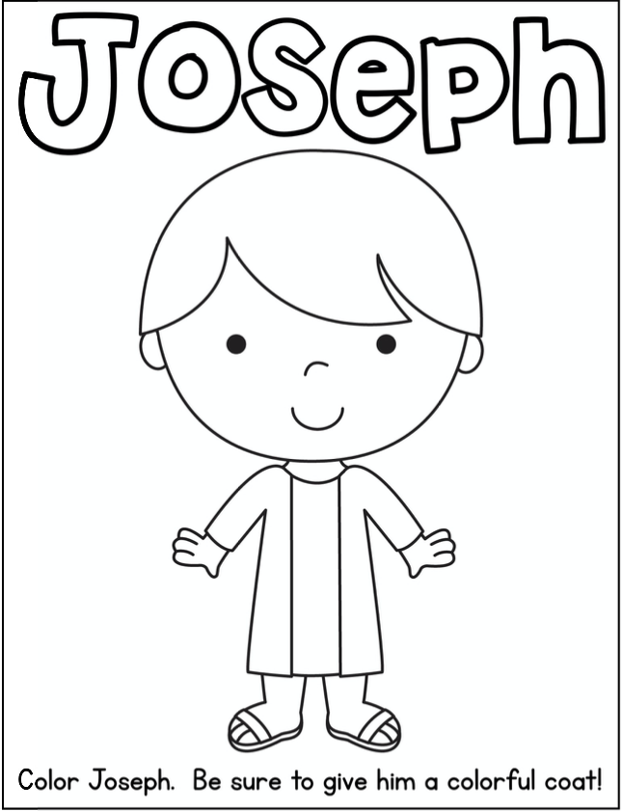  Extension for Noah’s Ark:  Group discussion.  Explain to the kids that they will be discussing about miracles. It’s an opportunity for them to find out more about it and also a good time to ask or reflect on it.  Discussion cards (Appendix 2)  Questions Answers  What do you think a miracle is? Answer will vary Idea: an unusual or a wonderful event caused by the power of God to bring glory to his name.  What is a miracle you are praying for right now? Answers will vary.  A baker can turn runny eggs and tasteless flour into something good: A delicious cake. What are some bad things God can turn into something good? Answers will vary.  Making a cake can take a long time. God taking bad things and making them into something good might take a long time too. What do you think can help you while you wait? Answers will vary  If bad things are happening, you’re worried, and you don’t know what to do, What do you think will help you? Answers will vary  When you see God work miracles right away, or if you’re waiting for a miracle, who do you want to talk to about it? Answers will vary
10.45 | Check Out  Remember snack bag, journal and today’s craft activity.

Prep work:

Appendix 1
Print around 30 sheets

Appendix 2
Print and cut out the cards. 1 set for each group (at least 2 sets)

Appendix 3
Print out at least 4 sets

Challenge Card
Print and cut 50 copies for LCNA @ Newmarket

Appendix 3
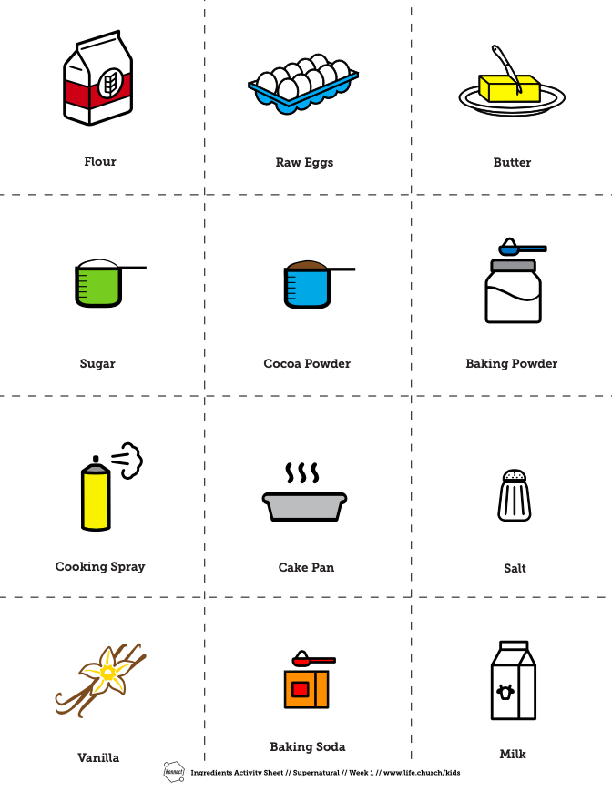

Appendix 1a
