Date: | 1st August 2021
Title: | Supernatural Part 2 – How to be powerful
Level/Class | J Club
Memory verse: | Romans 8:11(NIRV)  The Spirit of God who raised Jesus from the dead is living in you.
Bible story: | Fruit of the Spirit
Big Idea: | The Holy Spirit give us the power to live and love like Jesus
Big Point: | God’s Holy Spirit gives me power!
4M Values: | Mission (The Holy spirit gives us use to equip ourselves with the fruit of the spirit to help others)  Ministry Equipping (The fruit of the spirit that is manifested in us through the holy spirit equips us for when the time we are called into our specific ministry)  Multicultural (To love like Jesus will help us transcend cultural barriers)  Miracles (The power of the Holy Spirit in us helps us live like Jesus and like Jesus we can expect miracles in His name)
Learning outcomes: | At the conclusion of this lesson, children will know that:  - God’s Holy Spirit gives us power  - The Spirit of God lives in us  - The Holy Spirit helps us to live and love like Jesus
Influencers:
Location: | ICC Newmarket
LESSON PLAN (J Club)

7:45am | Set up and lesson run through (Team Leader)

Today at a glance

Time | Activity | Influencers
8.30 | Check in:  - Prep extra tab for newcomers’ sign up.  - Collect kids’ journal and pile them according to their respective classes.  *Note: There is a weekly checklist for Challenge Cards  Leader will assign someone to go through all the Journal book and tick off on the list.
9.10 | - Welcome kids and newcomers  - Recap the 3Ls (Listen, Learn & Love)
9.15 | Worship:  - There is Power in the blood  https://www.youtube.com/watch?v=ru9I8CCjs8U  Team leader chooses another 2 songs.
9.30 | Thanksgiving  Ask the children if they have anything they would like to thank God for.  Invite a child to pray.

9.35 | Game: Spirit Bingo (smaller groups)  Items needed:  - Spirit bingo card set (set of 12 cards) Appendix 3  - Coloured pencils or pencils  Say: We’re going to play Bingo to see some ways the Holy Spirit gives us power.  How to play:  - Give each kid a Spirit Bingo card and a coloured pencil.  - Kids cross out or lightly shade the free space on their card.  - Read words one at a time in any order from the Spirit Bingo activity supplement (Appendix 4).  - Each time you read a word, pause to let kids search for it on their card, and shade or cross it out with their coloured pencil.  - Repeat steps 3 and 4 until 1 kid has shaded/crossed out four words in a row vertically, horizontally or diagonally.  - Play again if times allows and perhaps you it can be made more interesting by saying that the first 3 kids who gets bingo will get bonus stickers.
9.50 | Introduce bible verse: “The Spirit of God who raised Jesus from the dead is living in you” – Romans 8:11 (NIRV)  Influencer to learn action beforehand.  - Refer to (Verse actions @ 12:24 – 12:43):  https://open.life.church/items/209311-teaching-segment-mp4  - Teach the kids the verse with the actions.  Repeat it a few times with them.
9:55 | Object lesson:  Compare two types of food healthy (fruits) and unhealthy (cakes/crisps).  Ask the kids which would be better for their body to grow well and strong.  Relate it to the holy spirit helping us feed on the fruit of the spirit to help us to live like Jesus.  What are the fruit of the spirit and how does Jesus live? The story they are going to listen to will give us more information on that. Therefore, it’s important for them to listen.
10:00 | Lesson video (16 minutes 59 seconds):  https://open.life.church/items/209311-teaching-segment-mp4  Infer before playing the video:  From the memory verse today and the game we played, what do you think the video will be about?  Tell the kids that before you play the video there may be some questions they may what to keep in their mind.  - What powers do you think the Holy Spirit will give us?  - What are the fruits of the Spirit and why do we need them?  Play video…  Pause at the 8:54 minute mark:  Can you recall the fruits of the spirit that helps us to live and love like Jesus?  Answer: Love, joy, peace, kindness, patience, goodness, integrity, gentleness and self-control.  Resume playing the video…  Pause at the 9:37 minute mark:  - Why do you think the Holy Spirit give us spiritual gifts that shows the fruit of the spirit?  Idea: Care for everyone and everything in our lives God’s way.  Resume playing the video…  Pause at the 13:23 minute mark:  When we encounter a difficult situation and it’s hard for us to use or display the fruit of the spirit, God doesn’t expect us to do it in our own strength. He is with us and will help us.  How do you ask Him for help?  Resume playing video to the end…  Recap/summarise story.  Reinforce big point – God’s Holy Spirit give me power.  Tie in with lesson objectives.  Tell them that next, they are going into their discussion groups and they will continue to do a discussion on the topic.  Divide kids to smaller groups for discussion. Preferably according to similar age groups.
10.30 | Small group discussion  Group discussion.  Explain that in the discussion that they will be doing, they will explore more about the Holy Spirit and how it helps us.  Discussion cards (Appendix 2)  Questions Answers  What do you think happens when we try to be powerful all on our own? Answers will vary  What do you think happens when we use the power of the Holy Spirit? Answers will vary  What do you wish you knew about the powers of the Holy Spirit? Answers will vary  Share some was you think you can live by the power of the Holy Spirit. Answers will vary. Ideas: praying, using the gifts and talents HE gave us, letting Him grow the fruit of the Spirit in us, loving God and others as well, etc.  Talk about something that makes you feel weak, powerless, or makes you want to give up. Answers will vary.  How do you think the power of the Holy Spirit can help you when you feel that way? Answers will vary.  Idea to make it a little more fun. Number the cards, 1-6. Each child throws a die and answer the question number that is on the die.  Reward, good and constructive participation with a bonus sticker.
10.40 | Prayer (still in small groups):  - Ask kids to share things they’d like to pray about.  - Pray together over their prayer requests.  Pray this too: God, please teach us to rely on the power of Your Holy Spirit in everything we do. In Jesus’ name, amen.
10.45 | Check Out  - Remind the kids about earning their stickers by returning their journal next week with their activities completed.  - When a child leaves and if an opportunity presents itself, say something positive and specific to their family.  - Encourage families to do the journal activities together.  You can play this video while waiting for parents:  https://www.youtube.com/watch?v=E2bhXAR1gCU

Appendix 3 (Total of 12 cards)

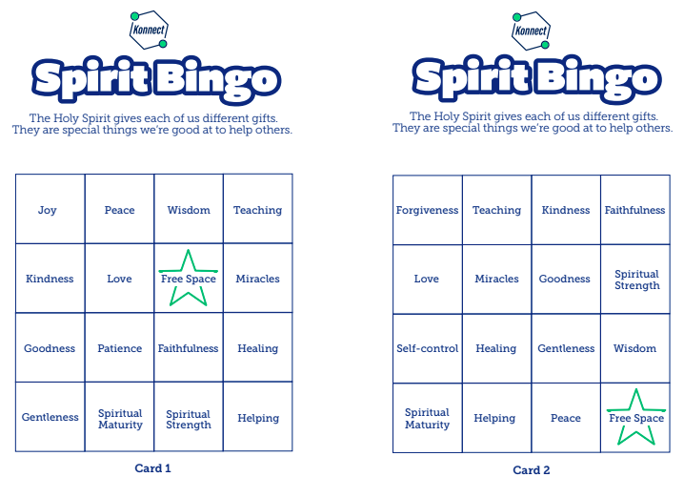
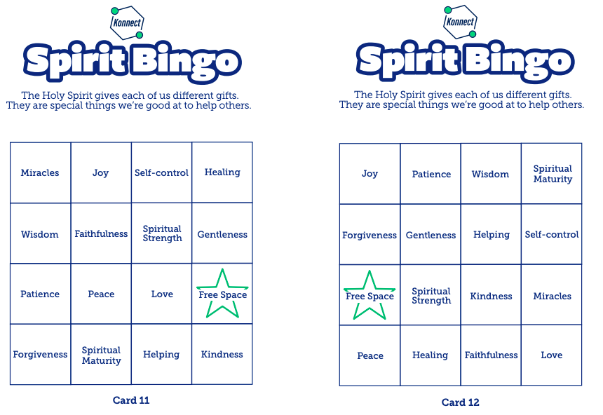

Appendix 4
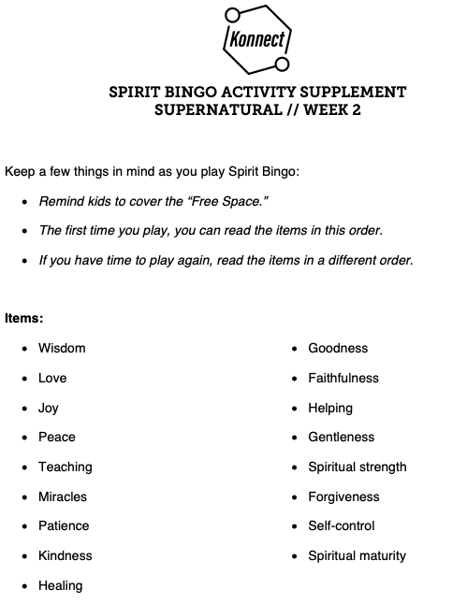

Extra Activity sheet for groups
