Date: | 29th August 2021
Title: | Spread the Word Part 2: Share your love loud
Level/Class | J Club
Memory verse: | 1 Corinthians 13: 1 (NIRV)  … if I don’t have love, I’m only a loud gong or a noisy cymbal
Bible story: | 1 John
Big Idea: | We reach people through kind and loving words
Big Point: | People learn about Jesus when I love them God’s way.
Learning outcomes: | At the conclusion of this lesson, children will know:  - That we need to share Jesus by loving them God’s way  - That God=Love & Love=God  - That it’s important to use the right words.  - That we can love loud and only use words when we have to. (Actions speaks louder than words)
Influencers:
Location: | ICC Newmarket
LESSON PLAN (J Club)

7:45am | Set up and lesson run through (Team Leader)

Today at a glance

Time | Activity | Influencers
8.30 | Check in:  - Prep extra tab for newcomers’ sign up.  - Collect kids’ journal and pile them according to their respective classes.
9.10 | - Welcome kids and newcomers  - Recap the 3Ls (Listen, Learn & Love)
9.15 | Worship:  - This is Amazing Grace  https://www.youtube.com/watch?v=_N4tcQkwens  2. Do It Again https://www.dropbox.com/s/zwiefp04b7o4tqr/DoItAgain_LyricDanceWorship_byEKidz.mp4?dl=0#  Team leader chooses another 1 song.
9.30 | Thanksgiving

9.35 | Game: Loud or love  What you need:  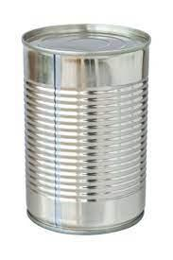  - Drums and cymbals  - To DIY the drum:  If you have empty metal tins (Milo etc.) & a wooden spoon  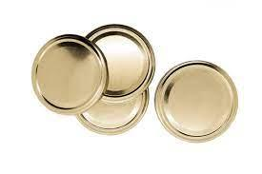  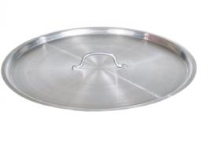  To DIY the cymbals:  -If you have lids of metal tins or pots/pans, have 2 of them  - Loud or love activity supplement sheet (Appendix 1)  How to play the game:  - Get the kids in a circle facing each other.  - Explain to the kids that when we talk about Jesus without love, we’re just making noise. However, when we talk about Him with love, our words sound much better. We’re going to play a game to illustrate that.  - Give a kid at the 12 o’clock position of the circle a cymbal or a drum/gong. Then another cymbal/drum/gong to another child at the opposite position (6 o’clock).  - Read a phrase/example from the activity supplement (Appendix 1).  - If they are loving phrases/examples, everyone gives their neighbour a high 5.  - If they are unloving phrase/examples, the kids with the cymbal/drum/gong bang their instrument loudly and everyone clap their hands as loud as they can.  - Each time a kid gets a chance to clang the cymbal/gong/drum, then it’s time to pass the instrument to another kid.  - If time allows, ask a kid to explain what makes each phrase example loving or unloving.
9.50 | Introduce bible verse: “… if I don’t have love, I am only a loud gong or noisy cymbal.” – 1 Corinthians 13:1 (NIRV)  Influencer to learn action beforehand.  - Refer to:  - https://open.life.church/items/181295-teaching-segment-mp4  - (Verse actions @ 10:50 – 11:12)  - Teach the kids the verse with the actions.  - Repeat it a few times with them.
10:00 | Lesson video (14 minutes 48 seconds):  Infer before playing the video:  From the memory verse today and the game we played, what do you think the video will be about?  Remind the kids that the bible teaches us a lot of things. It’s one of the ways God uses to guide us to make good choices. Let them know that today, they will hear about God’s love for us and how we should love other’s God’s way  Lesson Video:  https://open.life.church/items/181295-teaching-segment-mp4  Recap/summarise story.  - The video gave us a few things to think about, especially on how we speak or communicate with someone so that they will be more receptive to what we are saying to them.  - The story video tells us that love comes from God and that God loves is first.  - He didn’t wait for us to love Him. He came to us first and He sent His son to die for us so we could be with Him in eternity when the time comes.  - Therefore, when we accept Jesus in our hearts, we too can love like God.  - In addition to that, the video emphasises that when we share Jesus without love, all people hear is noise and noise is often perceived as rude and irritating.  - It is also important not to act and think that we’re better than others because we believe in Jesus. That is not love.  Keep all that you have learnt form the video in mind as you may get to share them during your group discussion questions.  Divide kids to smaller groups for discussion. Preferably according to similar age groups.
10.30 | Small group discussion.  Facilitators decide in your own way how you would like to present the questions to your group of children. Feel free to look back at previous lessons for ideas.  Group discussion.  Explain that in the discussion that they will be doing, they will look at why it is sometimes hard for people to listen about God’s Good News.  Questions Answers  When is it hard for people to listen to your words? When my words are rude; when I think I’m better than other people; when I argue angrily; when I lie; etc.  When is it easy for people to listen to your words? When I’m kind, honest, respectful, complimentary, and encouraging; when I listen and pray for them; etc.  What do you think people learn from you when you’re loving toward them? Answers will vary. Ideas: What God’s love is like; they’re important; God loves them; etc.  When is it hard for you to be loving towards someone? Answers will vary.  Who have you used unloving words toward? (It doesn’t have to be talking about Jesus, it could be about anything) Answers will vary.  When you use unloving words, how can you turn it around? Ask forgiveness when I’ve spoken unlovingly to someone; pray for God’s help; ask a friend to help; read the bible so His good words are in my heart; etc.
10.40 | Prayer (still in small groups):  - Ask kids to share things they’d like to pray about.  - Pray together over their prayer requests.  Pray this too: God, please help others learn about You and Your Good News through the loving words we use. In Jesus’ name, amen.
10.45 | Check Out  - Remind the kids about earning their stickers by returning their journal next week with their activities completed.  - When a child leaves and if an opportunity presents itself, say something positive and specific to their family.  - Encourage families to do the journal activities together.

Game – Appendix 1
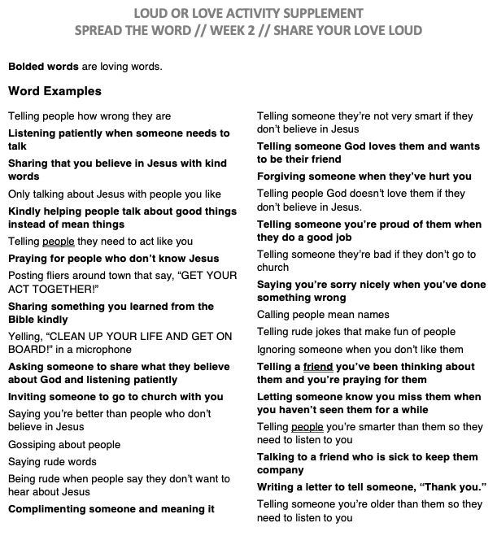

Additional sheet
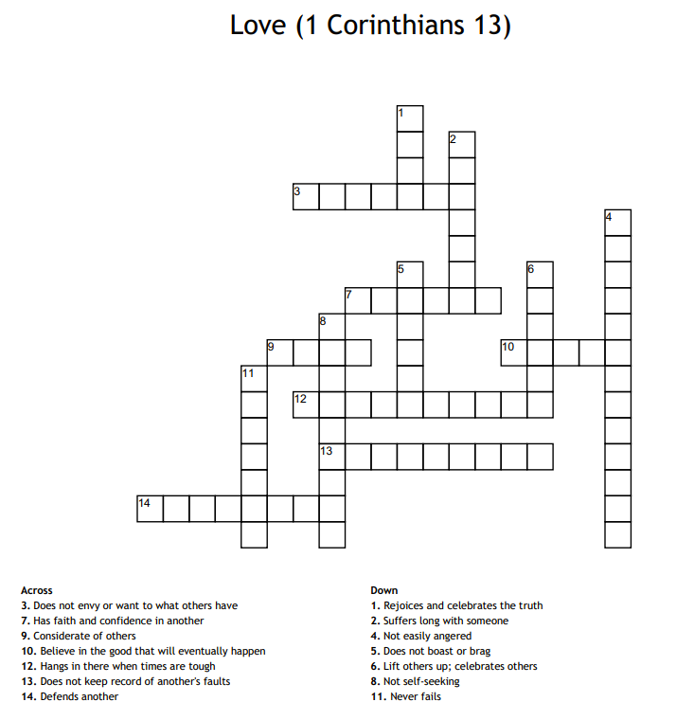
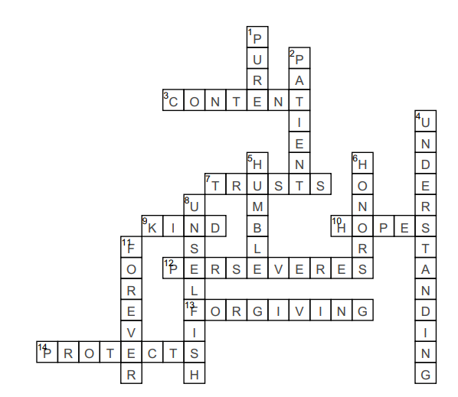

Prep Work

Game:
Cymbals/gongs/drums
Loud or love activity supplement sheet Appendix 1

Challenge Card
Print and cut 40 copies for JClub @ Newmarket

