Date: | 22nd August 2021
Title: | Spread the Word Part 1: The Great Commission
Level/Class | Little Cherub & Noah’s Ark
Memory verse: | Mark 16:15 (NLT)  … “ Go into the world and preach the Good News to everyone”
Bible story: | Matt 28: 19 - 20
Big Idea: | We can teach others to follow Jesus anywhere in the world.
Big Point: | People learn about Jesus when I share God’s good news.
Learning outcomes: | At the conclusion of this lesson, children will know:  - That is our duty to share the Good News of Jesus to everyone.  - That people need to hear the Good News so they have a choice to follow Jesus and be close to God,  - We can share Jesus with anyone.
Influencers:
Location: | ICC Newmarket
LESSON PLAN (LCNA)

7:30am | Set up and lesson run through  SETUP CHECK LIST  ̈ Setup tables and chairs if needed  ̈ Setup the check-in tables and printer  ̈ Mic/Sound/Video setup and test  ̈ Turn on music during check-in for pumped atmosphere. ̈ Craft/Activities/Games resource and props check.  ̈ Journaling sheets & books  ̈ Check class/area for safety and security measures.  ̈ Remove items that are not meant to be there.  Gather to pray at 8:00am

Today at a glance

Time | Activity | Influencers
8.30 | Check in:  - Prep extra tab for newcomers’ sign up  - Collect kids’ journals and pile them according to their respective classes.
9.10 | - Welcome kids and newcomers  - Recap the 3Ls (Listen, Learn & Love)
9.15 | Worship:  Some suggestions:  - Go : https://www.youtube.com/watch?v=ZuVMm3EKSss  Motions -https://www.youtube.com/watch?v=aADUKP0s0xo  Jesus Loves Me  https://www.youtube.com/watch?v=xV7XH2OgOTk  Team leader/Worship leader to decide on 3 songs.
9.30 | Thanksgiving
Little Cherubs to their room (Red & Blue Room)
Noah’s Ark to stay on or use the yellow room

9.35 | Snack:  Sanitize hands before eating
9.50 | Game:  Use this game to teach kids how important it is to support each other as Christians trying to spread the good news about Jesus.  Supplies needed:  - 10 envelopes  - Paper to write a note for the number of stickers they will get as prizes  - Blue tac  Tell kids the object of the game is to reach the envelopes without the help of furniture or other people.  - Let kids try to grab the envelopes. Set 20s timer.  - Once they’ve given up, have them form groups of three and work together to reach.  - Two kids can form a step by locking their hands together and lifting the third person high enough to reach the prize for all three.  Learning point:  Ask kids to compare their first attempt to reach the candy bars with their second.  Ask: What ways do you tell your friends about your faith? Why is it important to work together and support each other as Christians? How can you support a friend this week?
10.00 | Object Lesson  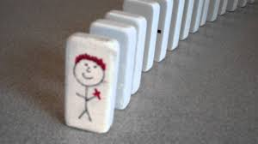  Supplies needed:  A set of Domino, a pen and sticker to paste on the front of the first and last domino  - To illustrate the power of one kid telling another about Jesus  Watch this for more info:  https://www.youtube.com/watch?v=7CFX5f_t6AE
10.05 | Introduce bible verse: “… Go into the world and preach the Good News to everyone.” – Mark 16:15 (NLT)  Influencer to learn action beforehand.  - Refer to:  - https://open.life.church/items/181291-teaching-segment-mp4  - (Verse actions @ 10:53 – 11:10)  - Teach the kids the verse with the actions.  - Repeat it a few times with them.
10.15 | Introduce the lesson video:  - Matthew 28: 19-20  - Remind the kids that the bible teaches us a lot of things. It’s one of the ways God uses to guide us to make good choices. Let them know that today, they will hear what Jesus has asked all those who believe him to do.  Lesson Video 1: https://www.youtube.com/watch?v=IlXFy3zjJh4  Lesson Video 2:  https://open.life.church/items/181291-teaching-segment-mp4  (Video runs from 2:47 – 6:50)  Recap/summarise story.  - Jesus before he ascended to heaven, he left a few instructions for his disciples and because we follow Jesus, we are his disciples too. HE also gave us the power to make disciples.  - Recall the instructions Jesus gave:  1. We must go and make disciples of all nations and teach them to obey everything Jesus has commanded us.  2. We need to spend time with people, teaching them things and praying with them.  3. We need to show the people what God’s love is like.  4. We also need to remember to not be afraid to share the Good News as Jesus is always with us when we tell others about Him.
10.25 | Prayer: God, thank you for giving us your Good News. When we share it, please help people to want to follow You. In Jesus’ name, Amen
10.30 | LC Colouring sheet  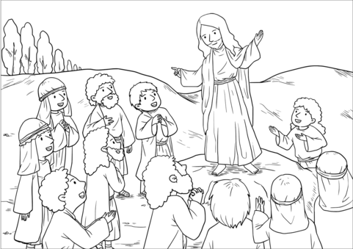  NA Craft : Create an invitation card inviting a friend to Sunday  Craft items:  - Blank cards  - Coloured pen/pencils/crayons  - Pretty stickers  - Craft items (eg: shiny paper, glitter, etc)  - Glue  Extension for Noah’s Ark:  Group discussion.  Explain that in the discussion that they will be doing, they will look at why, when, who and how to spread God’s Good News.  Questions Answers  What is God’s Good News? Jesus makes us friends with God when we choose to trust and follow him.  Whose responsibility is it to share God’s Good News? Everyone who trusts in and follow Jesus.  Who gave us the responsibility of sharing God’s Good news? Jesus  What is important about sharing God’s Good News? It obeys God; People need the Good News so they can be forever friends with God, etc  You might think people around you already follow Jesus. How can you find out if they really do? Ask them; watch their words, actions and choices; talk about Jesus with them, etc  What do you think a kid can do to help a trusted adult learn about Jesus? Answers will vary.  What do you think you can do to share God’s Good News with them? Answers will vary. Ideas: text them, write a letter, talk to them, be kind to them, invite them to church, pray for them, etc
10.45 | Check Out  Remember snack bag, journal and today’s craft activity.
Prep work:
Game:
Inflatable globe/ball

Craft:
Blank cards, craft items to decorate the cards, glue and pretty stickers

Challenge Card
Print and cut 50 copies for LCNA @ Newmarket

